**727721EUIT152**

**SOMA SUNDARI R**

**CA-1**

**1.CODE:**

**package** com.demo.CA1;

**import** org.openqa.selenium.By;

**import** org.openqa.selenium.WebDriver;

**import** org.openqa.selenium.WebElement;

**import** org.openqa.selenium.chrome.ChromeDriver;

**import** org.openqa.selenium.chrome.ChromeOptions;

**import** io.github.bonigarcia.wdm.WebDriverManager;

**public** **class** CA1_01 {

**public** **static** **void** main( String[] args ) **throws** InterruptedException

{

ChromeOptions co=**new** ChromeOptions();

co.addArguments("--remote-allow-origins=*");

WebDriverManager.*chromedriver*().setup();

WebDriver driver=**new** ChromeDriver(co);

driver.get("https://www.amazon.in/gp/cart/view.html?ref_=nav_cart");

driver.manage().window().maximize();

String CurrentTitle=driver.getTitle();

String ExpectedTitle="Amazon.in Shopping Cart";

**if**(CurrentTitle.equals(ExpectedTitle))

{

System.***out***.println("TITLE MATCHED.");

}

**else**

{

System.***out***.println("TITLE NOT MATCHED.");

}

//add to cart

driver.get("https://www.amazon.in/Anne-Diamond-Analog-Womens-Watch-AK3686BKGB/dp/B0968Q7L3M/ref=sr_1_1_sspa?keywords=watch&qid=1681290802&sr=8-1-spons&sp_csd=d2lkZ2V0TmFtZT1zcF9hdGY&psc=1");

WebElement add=driver.findElement(By.*xpath*("//input[@id=\"add-to-cart-button\"]"));

add.click();

//verify

WebElement t=driver.findElement(By.*xpath*("/html/body/div[1]/div[2]/div/div[1]/div[1]/div[2]/div/div/div/div/span"));

String CurrentText=t.getText();

String ExpectedText="Added to Cart";

**if**(CurrentText.equals(ExpectedText))

{

System.***out***.println("Added to the cart successfully");

}

**else**

{

System.***out***.println("Not Added to the cart.");

}

//remove the product from the cart

driver.get("https://www.amazon.in/gp/cart/view.html?ref_=nav_cart");

WebElement del=driver.findElement(By.*xpath*("/html/body/div[1]/div[2]/div[3]/div[5]/div/div[2]/div[1]/div/form/div[2]/div[3]/div[4]/div/div[2]/div[1]/span[2]/span/input"));

del.click();

Thread.*sleep*(6000);

//verify whether the product removed from the cart

WebElement v=driver.findElement(By.*xpath*("/html/body/div[1]/div[2]/div[3]/div[5]/div/div[2]/div[1]/div/div[1]/div/h1"));

String CurrentText1=v.getText();

String ExpectedText1="Your Amazon Cart is empty.";

**if**(CurrentText1.equals(ExpectedText1))

{

System.***out***.println("Removed from the cart successfully");

}

**else**

{

System.***out***.println("Not Removed from the cart");

}

//add to cart

driver.get("https://www.amazon.in/Anne-Diamond-Analog-Womens-Watch-AK3686BKGB/dp/B0968Q7L3M/ref=sr_1_1_sspa?keywords=watch&qid=1681290802&sr=8-1-spons&sp_csd=d2lkZ2V0TmFtZT1zcF9hdGY&psc=1");

WebElement add1=driver.findElement(By.*xpath*("//input[@id=\"add-to-cart-button\"]"));

add1.click();

//updating the quantity

driver.get("https://www.amazon.in/gp/cart/view.html?ref_=nav_cart");

WebElement update=driver.findElement(By.*xpath*("/html/body/div[1]/div[2]/div[3]/div[5]/div/div[2]/div[1]/div/form/div[2]/div[3]/div[4]/div/div[2]/div[1]/span[1]/span/span[1]/span/span/span/span"));

update.click();

WebElement q=driver.findElement(By.*xpath*("/html/body/div[3]/div/div/ul/li[4]/a"));

q.click();

WebElement buy=driver.findElement(By.*xpath*("/html/body/div[1]/div[2]/div[3]/div[5]/div/div[1]/div[1]/div/form/div/div[3]/span/span/span/input"));

buy.click();

driver.navigate().back();

//cost of the product purchased

WebElement li=driver.findElement(By.*xpath*("/html/body/div[1]/div[2]/div[3]/div[5]/div/div[1]/div[1]/div/form/div/div[3]/div[1]/span[2]/span"));

System.***out***.println(li.getText());

}

}

**OUTPUT:**

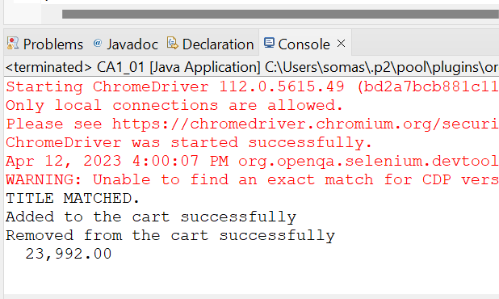

**2.CODE:**

**package** com.demo.CA1;

**import** java.util.List;

**import** org.openqa.selenium.By;

**import** org.openqa.selenium.WebDriver;

**import** org.openqa.selenium.WebElement;

**import** org.openqa.selenium.chrome.ChromeDriver;

**import** org.openqa.selenium.chrome.ChromeOptions;

**import** io.github.bonigarcia.wdm.WebDriverManager;

**public** **class** CA1_02 {

**public** **static** **void** main(String[] args) **throws** InterruptedException {

ChromeOptions co=**new** ChromeOptions();

co.addArguments("--remote-allow-origins=*");

WebDriverManager.*chromedriver*().setup();

WebDriver driver=**new** ChromeDriver(co);

driver.get("https://www.amazon.in/");

driver.manage().window().maximize();

String CurrentTitle=driver.getTitle();

System.***out***.println(CurrentTitle);

String ExpectedTitle="Online Shopping site in India: Shop Online for Mobiles, Books, Watches, Shoes and More - Amazon.in";

**if**(CurrentTitle.equals(ExpectedTitle))

{

System.***out***.println("Title Matched.");

}

**else**

{

System.***out***.println("Title Does not Matched");

}

driver.findElement(By.*xpath*("//*[@id=\"twotabsearchtextbox\"]")).sendKeys("watch");

driver.findElement(By.*xpath*("/html/body/div[1]/header/div/div[1]/div[2]/div/form/div[3]/div/span/input")).click();

List<WebElement> li=driver.findElements(By.*className*("s-line-clamp-1"));

**int** c=0;

**for**(WebElement link:li) {

System.out.println(link.getText());

c++;

**if**(c>5) {

**break**;

}

}

driver.findElement(By.*xpath*("/html/body/div[1]/div[2]/div[1]/div[2]/div/div[3]/span/div[1]/div/div/div[5]/ul/li[2]/span/a/span")).click();

}

}

**OUTPUT:**

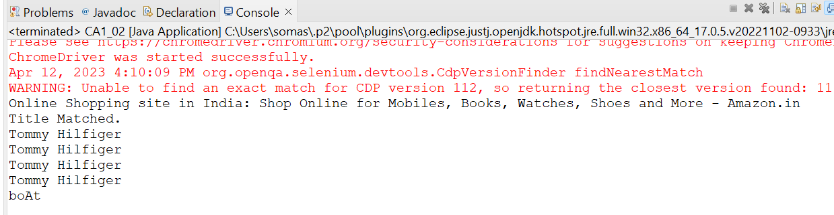

**3.CODE:**

**package** com.demo.CA1;

**import** org.openqa.selenium.By;

**import** org.openqa.selenium.WebDriver;

**import** org.openqa.selenium.chrome.ChromeDriver;

**import** org.openqa.selenium.chrome.ChromeOptions;

**import** io.github.bonigarcia.wdm.WebDriverManager;

**public** **class** CA1_03 {

**public** **static** **void** main(String[] args) {

// **TODO** Auto-generated method stub

ChromeOptions co=**new** ChromeOptions();

co.addArguments("--remote-allow-origins=*");

WebDriverManager.*chromedriver*().setup();

WebDriver driver=**new** ChromeDriver(co);

driver.get("https://www.amazon.in/gp/css/homepage.html?ref_=nav_youraccount_btn");

driver.manage().window().maximize();

String CurrentTitle=driver.getTitle();

System.***out***.println(CurrentTitle);

String ExpectedTitle="Your Account";

**if**(CurrentTitle.equals(ExpectedTitle))

{

System.***out***.println("Title matched.");

}

**else**

{

System.***out***.println("Title does not match.");

}

//login

driver.findElement(By.*xpath*("/html/body/div[1]/header/div/div[1]/div[3]/div/a[2]/div/span")).click();

driver.findElement(By.*xpath*("/html/body/div[1]/div[1]/div[2]/div/div[2]/div/div[1]/form/div/div/div/div[1]/input[1]")).sendKeys("7539932004");

driver.findElement(By.*xpath*("/html/body/div[1]/div[1]/div[2]/div/div[2]/div/div[1]/form/div/div/div/div[2]/span/span/input")).click();

driver.findElement(By.*xpath*("/html/body/div[1]/div[1]/div[2]/div/div[2]/div[1]/div/div/form/div/div[1]/input")).sendKeys("Jesus@0413");

driver.findElement(By.*xpath*("/html/body/div[1]/div[1]/div[2]/div/div[2]/div[1]/div/div/form/div/div[2]/span/span/input")).click();

//your order

driver.findElement(By.*xpath*("/html/body/div[1]/div[2]/div/div[2]/div[1]/a/div/div/div")).click();

String order = driver.findElement(By.*xpath*("//*[@id=\"a-page\"]/section/div[1]/div[4]/form/label")).getText();

System.***out***.println("Your last Order:"+order);

}

}

**OUTPUT:**

