727721EUIT152
SOMA SUNDARI R
CC1
CODE:
package com.CC2;

import org.openqa.selenium.By;
import org.openqa.selenium.WebDriver;
import org.openqa.selenium.chrome.ChromeDriver;
import org.openqa.selenium.chrome.ChromeOptions;
import org.testng.Assert;
import org.testng.annotations.Test;

import io.github.bonigarcia.wdm.WebDriverManager;

public class CC2_01 {
@Test
public void tc() throws InterruptedException{
WebDriverManager.chromedriver().setup();
ChromeOptions co=new ChromeOptions();
co.addArguments("--remote-allow-origins=*");
WebDriver driver=new ChromeDriver(co);
driver.get("https://www.yatra.com/");
driver.manage().window().maximize();
Thread.sleep(4000);
driver.findElement(By.xpath("//*[@id=\"booking_engine_flights\"]")).click();
Thread.sleep(2000);
driver.findElement(By.xpath("//*[@id=\"BE_flight_form_wrapper\"]/div[1]/div[1]/ul[1]/li[2]/a")).click();
Thread.sleep(2000);
driver.findElement(By.xpath("//*[@id=\"BE_flight_origin_city\"]")).click();
Thread.sleep(2000);
driver.findElement(By.xpath("//*[@id=\"BE_flight_form_wrapper\"]/div[1]/div[2]/ul/li[1]/ul/li[1]/div/div/ul/div/div/div/li[3]")).click();
Thread.sleep(2000);
driver.findElement(By.xpath("//*[@id=\"BE_flight_form_wrapper\"]/div[1]/div[2]/ul/li[1]/ul/li[3]/div/div/ul/div/div/div/li[4]")).click();
Thread.sleep(2000);
driver.findElement(By.xpath("//*[@id=\"BE_flight_origin_date\"]")).click();
Thread.sleep(2000);
driver.findElement(By.xpath("//*[@id=\"20/04/2023\"]")).click();
Thread.sleep(2000);
driver.findElement(By.xpath("//*[@id=\"BE_flight_arrival_date\"]")).click();
Thread.sleep(2000);
driver.findElement(By.xpath("//*[@id=\"24/04/2023\"]")).click();
Thread.sleep(2000);
driver.findElement(By.xpath("//*[@id=\"BE_flight_paxInfoBox\"]/i")).click();
Thread.sleep(2000);
driver.findElement(By.xpath("//*[@id=\"BE_flight_passengerBox\"]/div[1]/div[1]/div/div/span[2]")).click();
Thread.sleep(2000);
driver.findElement(By.xpath("//*[@id=\"flight_class_select_child\"]/ul/li[3]")).click();
Thread.sleep(2000);
driver.findElement(By.xpath("//*[@id=\"BE_flight_form_wrapper\"]/div[3]/div[1]/div[1]/a/i")).click();
Thread.sleep(2000);
driver.findElement(By.xpath("//*[@id=\"BE_flight_flsearch_btn\"]")).click();
String actual=driver.findElement(By.xpath("/html/body/h1")).getText();
String expected="Access Denied";
Assert.assertEquals(actual,expected);

}
}

OUTPUT:
CONSOLE:
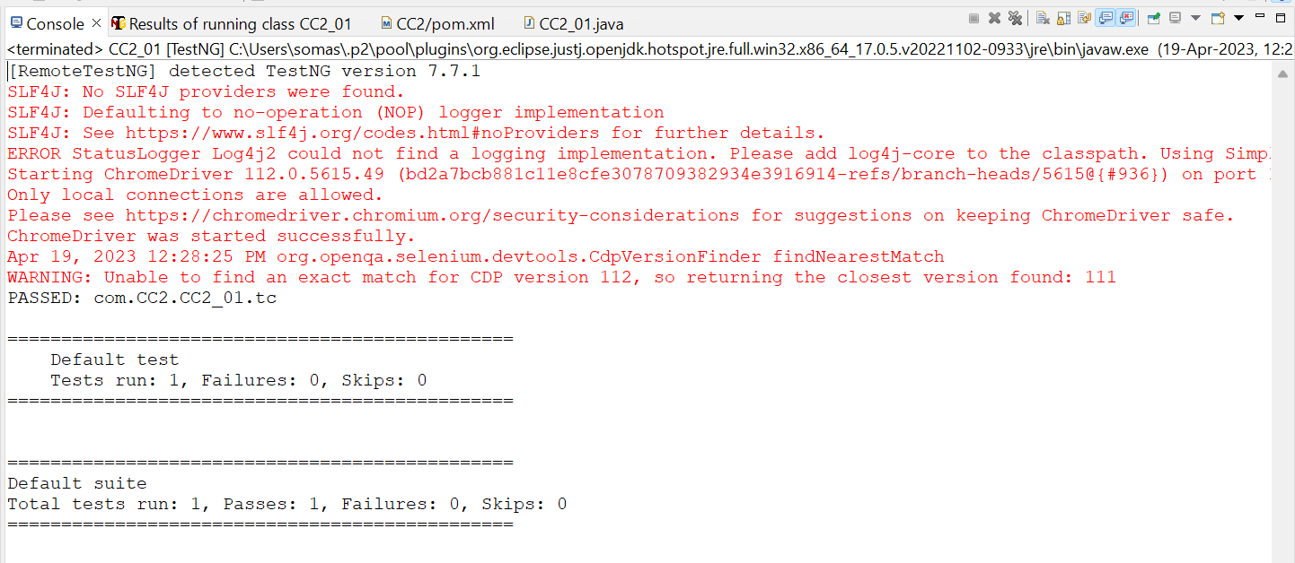
BROWSER:
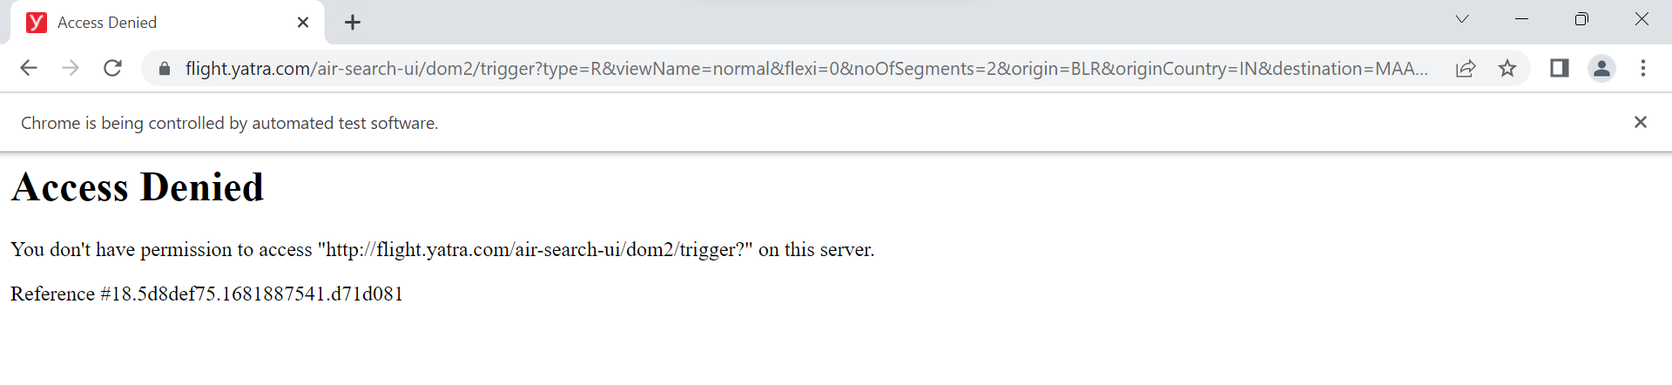

EMAILABLE REPORT:
