727721EUIT152
SOMA SUNDARI R
CA-1

1.CODE:
package com.demo.CA1;

import org.openqa.selenium.By;
import org.openqa.selenium.WebDriver;
import org.openqa.selenium.WebElement;
import org.openqa.selenium.chrome.ChromeDriver;
import org.openqa.selenium.chrome.ChromeOptions;

import io.github.bonigarcia.wdm.WebDriverManager;

public class CA1_01 {
public static void main( String[] args ) throws InterruptedException
{
ChromeOptions co=new ChromeOptions();
co.addArguments("--remote-allow-origins=*");
WebDriverManager.chromedriver().setup();
WebDriver driver=new ChromeDriver(co);

driver.get("https://www.amazon.in/gp/cart/view.html?ref_=nav_cart");
driver.manage().window().maximize();
String CurrentTitle=driver.getTitle();
String ExpectedTitle="Amazon.in Shopping Cart";
if(CurrentTitle.equals(ExpectedTitle))
{
System.out.println("TITLE MATCHED.");
}
else
{
System.out.println("TITLE NOT MATCHED.");
}

//add to cart
driver.get("https://www.amazon.in/Anne-Diamond-Analog-Womens-Watch-AK3686BKGB/dp/B0968Q7L3M/ref=sr_1_1_sspa?keywords=watch&qid=1681290802&sr=8-1-spons&sp_csd=d2lkZ2V0TmFtZT1zcF9hdGY&psc=1");
WebElement add=driver.findElement(By.xpath("//input[@id=\"add-to-cart-button\"]"));
add.click();

//verify
WebElement t=driver.findElement(By.xpath("/html/body/div[1]/div[2]/div/div[1]/div[1]/div[2]/div/div/div/div/span"));
String CurrentText=t.getText();
String ExpectedText="Added to Cart";
if(CurrentText.equals(ExpectedText))
{
System.out.println("Added to the cart successfully");
}
else
{
System.out.println("Not Added to the cart.");
}

//remove the product from the cart
driver.get("https://www.amazon.in/gp/cart/view.html?ref_=nav_cart");
WebElement del=driver.findElement(By.xpath("/html/body/div[1]/div[2]/div[3]/div[5]/div/div[2]/div[1]/div/form/div[2]/div[3]/div[4]/div/div[2]/div[1]/span[2]/span/input"));
del.click();

Thread.sleep(6000);

//verify whether the product removed from the cart
WebElement v=driver.findElement(By.xpath("/html/body/div[1]/div[2]/div[3]/div[5]/div/div[2]/div[1]/div/div[1]/div/h1"));
String CurrentText1=v.getText();
String ExpectedText1="Your Amazon Cart is empty.";
if(CurrentText1.equals(ExpectedText1))
{
System.out.println("Removed from the cart successfully");
}
else
{
System.out.println("Not Removed from the cart");
}

//add to cart
driver.get("https://www.amazon.in/Anne-Diamond-Analog-Womens-Watch-AK3686BKGB/dp/B0968Q7L3M/ref=sr_1_1_sspa?keywords=watch&qid=1681290802&sr=8-1-spons&sp_csd=d2lkZ2V0TmFtZT1zcF9hdGY&psc=1");
WebElement add1=driver.findElement(By.xpath("//input[@id=\"add-to-cart-button\"]"));
add1.click();
//updating the quantity
driver.get("https://www.amazon.in/gp/cart/view.html?ref_=nav_cart");
WebElement update=driver.findElement(By.xpath("/html/body/div[1]/div[2]/div[3]/div[5]/div/div[2]/div[1]/div/form/div[2]/div[3]/div[4]/div/div[2]/div[1]/span[1]/span/span[1]/span/span/span/span"));
update.click();

WebElement q=driver.findElement(By.xpath("/html/body/div[3]/div/div/ul/li[4]/a"));
q.click();

WebElement buy=driver.findElement(By.xpath("/html/body/div[1]/div[2]/div[3]/div[5]/div/div[1]/div[1]/div/form/div/div[3]/span/span/span/input"));
buy.click();

driver.navigate().back();
//cost of the product purchased
WebElement li=driver.findElement(By.xpath("/html/body/div[1]/div[2]/div[3]/div[5]/div/div[1]/div[1]/div/form/div/div[3]/div[1]/span[2]/span"));
System.out.println(li.getText());

}
}
OUTPUT:
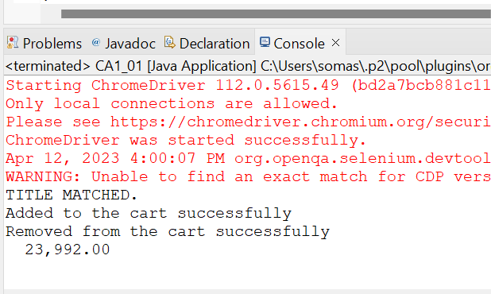

2.CODE:

package com.demo.CA1;

import java.util.List;

import org.openqa.selenium.By;
import org.openqa.selenium.WebDriver;
import org.openqa.selenium.WebElement;
import org.openqa.selenium.chrome.ChromeDriver;
import org.openqa.selenium.chrome.ChromeOptions;

import io.github.bonigarcia.wdm.WebDriverManager;

public class CA1_02 {
public static void main(String[] args) throws InterruptedException {
ChromeOptions co=new ChromeOptions();
co.addArguments("--remote-allow-origins=*");
WebDriverManager.chromedriver().setup();
WebDriver driver=new ChromeDriver(co);

driver.get("https://www.amazon.in/");
driver.manage().window().maximize();
String CurrentTitle=driver.getTitle();
System.out.println(CurrentTitle);
String ExpectedTitle="Online Shopping site in India: Shop Online for Mobiles, Books, Watches, Shoes and More - Amazon.in";
if(CurrentTitle.equals(ExpectedTitle))
{
System.out.println("Title Matched.");
}
else
{
System.out.println("Title Does not Matched");
}

driver.findElement(By.xpath("//*[@id=\"twotabsearchtextbox\"]")).sendKeys("watch");
driver.findElement(By.xpath("/html/body/div[1]/header/div/div[1]/div[2]/div/form/div[3]/div/span/input")).click();

List<WebElement> li=driver.findElements(By.className("s-line-clamp-1"));
for(int i=0;i<5;i++) {
System.out.println(li.get(i).getText());
}

driver.findElement(By.xpath("/html/body/div[1]/div[2]/div[1]/div[2]/div/div[3]/span/div[1]/div/div/div[5]/ul/li[2]/span/a/span")).click();
}
}

OUTPUT:
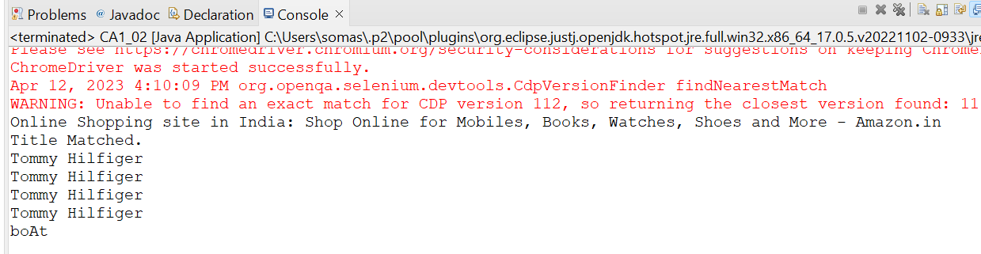

3.CODE:
package com.demo.CA1;

import org.openqa.selenium.By;
import org.openqa.selenium.WebDriver;
import org.openqa.selenium.chrome.ChromeDriver;
import org.openqa.selenium.chrome.ChromeOptions;

import io.github.bonigarcia.wdm.WebDriverManager;

public class CA1_03 {
public static void main(String[] args) {
// TODO Auto-generated method stub
ChromeOptions co=new ChromeOptions();
co.addArguments("--remote-allow-origins=*");
WebDriverManager.chromedriver().setup();
WebDriver driver=new ChromeDriver(co);
driver.get("https://www.amazon.in/gp/css/homepage.html?ref_=nav_youraccount_btn");
driver.manage().window().maximize();
String CurrentTitle=driver.getTitle();
System.out.println(CurrentTitle);
String ExpectedTitle="Your Account";
if(CurrentTitle.equals(ExpectedTitle))
{
System.out.println("Title matched.");
}
else
{
System.out.println("Title does not match.");
}
//login
driver.findElement(By.xpath("/html/body/div[1]/header/div/div[1]/div[3]/div/a[2]/div/span")).click();
driver.findElement(By.xpath("/html/body/div[1]/div[1]/div[2]/div/div[2]/div/div[1]/form/div/div/div/div[1]/input[1]")).sendKeys("7539932004");
driver.findElement(By.xpath("/html/body/div[1]/div[1]/div[2]/div/div[2]/div/div[1]/form/div/div/div/div[2]/span/span/input")).click();
driver.findElement(By.xpath("/html/body/div[1]/div[1]/div[2]/div/div[2]/div[1]/div/div/form/div/div[1]/input")).sendKeys("Jesus@0413");
driver.findElement(By.xpath("/html/body/div[1]/div[1]/div[2]/div/div[2]/div[1]/div/div/form/div/div[2]/span/span/input")).click();
//your order
driver.findElement(By.xpath("/html/body/div[1]/div[2]/div/div[2]/div[1]/a/div/div/div")).click();
String order = driver.findElement(By.xpath("//*[@id=\"a-page\"]/section/div[1]/div[4]/form/label")).getText();
System.out.println("Your last Order:"+order);

}
}
OUTPUT:
