727721EUIT152

SOMA SUNDARI R

CA_2:

Problem-1:

**package** com.Day10.CA_2;

**import** org.openqa.selenium.By;

**import** org.openqa.selenium.WebDriver;

**import** org.openqa.selenium.chrome.ChromeDriver;

**import** org.openqa.selenium.chrome.ChromeOptions;

**import** org.testng.annotations.Test;

**import** io.github.bonigarcia.wdm.WebDriverManager;

**public** **class** CA2_01 {

@Test

**public** **void** f() **throws** InterruptedException{

ChromeOptions co=**new** ChromeOptions();

co.addArguments("--remote-allow-origins=*");

WebDriverManager.*chromedriver*().setup();

WebDriver driver=**new** ChromeDriver(co);

driver.get("https://www.trivago.in/");

driver.manage().window().maximize();

String currtitle=driver.getTitle();

System.***out***.println(currtitle);

String exptitle="trivago.in - Compare hotel prices worldwide";

**if**(currtitle.equals(exptitle)) {

System.***out***.println("Title get Matched");

}

**else** {

System.***out***.println("Title not get Matched");

}

Thread.*sleep*(3000);

driver.findElement(By.*xpath*("//*[@id=\"input-auto-complete\"]")).click();

Thread.*sleep*(3000);

driver.findElement(By.*xpath*("//*[@id=\"suggestion-list\"]/ul/li[3]/div/div")).click();

Thread.*sleep*(3000);

driver.findElement(By.*xpath*("//*[@id=\"__next\"]/div[1]/div[1]/section/div[2]/div[3]/div/div[2]/div/div/div/div[2]/div/div[1]/div[2]/button[24]/time")).click();

Thread.*sleep*(3000);

driver.findElement(By.*xpath*("//*[@id=\"__next\"]/div[1]/div[1]/section/div[2]/div[3]/div/div[2]/div/div/div/div[2]/div/div[1]/div[2]/button[26]/time")).click();

Thread.*sleep*(3000);

driver.findElement(By.*xpath*("//*[@id=\"__next\"]/div[1]/div[1]/section/div[2]/div[3]/div/div[2]/div/div/div[1]/div/div[1]/div[1]/div/button[2]")).click();

Thread.*sleep*(3000);

driver.findElement(By.*xpath*("//*[@id=\"__next\"]/div[1]/div[1]/section/div[2]/div[3]/div/div[2]/div/div/div[1]/div/div[1]/div[3]/div/button[2]")).click();

Thread.*sleep*(3000);

driver.findElement(By.*xpath*("/html/body/div[1]/div[1]/div[1]/section/div[2]/div[3]/div/div[2]/div/div/div[1]/div/div[2]/div[2]/input")).click();

Thread.*sleep*(3000);

driver.findElement(By.*xpath*("//*[@id=\"__next\"]/div[1]/div[1]/section/div[2]/div[3]/div/div[2]/div/div/div[2]/div/button[2]")).click();

}

}

Output:

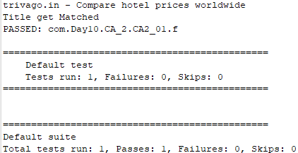

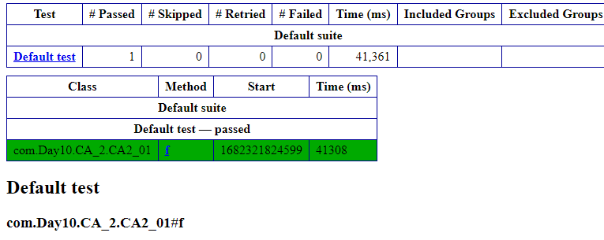

Problem:2:

**package** com.Day10.CA_2;

**import** org.openqa.selenium.By;

**import** org.openqa.selenium.WebDriver;

**import** org.openqa.selenium.chrome.ChromeDriver;

**import** org.openqa.selenium.chrome.ChromeOptions;

**import** org.testng.annotations.Test;

**import** io.github.bonigarcia.wdm.WebDriverManager;

**public** **class** CA2_02 {

@Test

**public** **void** f() **throws** InterruptedException{

ChromeOptions co=**new** ChromeOptions();

co.addArguments("--remote-allow-origins=*");

WebDriverManager.*chromedriver*().setup();

WebDriver driver=**new** ChromeDriver(co);

driver.get("https://www.trivago.in/");

driver.manage().window().maximize();

String currtitle=driver.getTitle();

System.***out***.println(currtitle);

String exptitle="trivago.in - Compare hotel prices worldwide";

**if**(currtitle.equals(exptitle)) {

System.***out***.println("Title Matched");

}

**else** {

System.***out***.println("Title not Matched");

}

Thread.*sleep*(3000);

driver.findElement(By.*xpath*("//*[@id=\"input-auto-complete\"]")).click();

Thread.*sleep*(3000);

driver.findElement(By.*xpath*("//*[@id=\"suggestion-list\"]/ul/li[1]/div/div")).click();

Thread.*sleep*(3000);

driver.findElement(By.*xpath*("//*[@id=\"__next\"]/div[1]/div[1]/section/div[2]/div[3]/div/div[2]/div/div/div/div[2]/div/div[1]/div[2]/button[24]/time")).click();

Thread.*sleep*(3000);

driver.findElement(By.*xpath*("//*[@id=\"__next\"]/div[1]/div[1]/section/div[2]/div[3]/div/div[2]/div/div/div/div[2]/div/div[1]/div[2]/button[26]/time")).click();

Thread.*sleep*(3000);

driver.findElement(By.*xpath*("//*[@id=\"__next\"]/div[1]/div[1]/section/div[2]/div[3]/div/div[2]/div/div/div[1]/div/div[1]/div[1]/div/button[2]")).click();

Thread.*sleep*(3000);

driver.findElement(By.*xpath*("//*[@id=\"__next\"]/div[1]/div[1]/section/div[2]/div[3]/div/div[2]/div/div/div[1]/div/div[1]/div[3]/div/button[2]")).click();

Thread.*sleep*(3000);

driver.findElement(By.*xpath*("/html/body/div[1]/div[1]/div[1]/section/div[2]/div[3]/div/div[2]/div/div/div[1]/div/div[2]/div[2]/input")).click();

Thread.*sleep*(3000);

driver.findElement(By.*xpath*("//*[@id=\"__next\"]/div[1]/div[1]/section/div[2]/div[3]/div/div[2]/div/div/div[2]/div/button[2]")).click();

Thread.*sleep*(3000);

driver.findElement(By.*xpath*("//*[@id=\"sorting-selector\"]")).click();

Thread.*sleep*(3000);

driver.findElement(By.*xpath*("//*[@id=\"sorting-selector\"]/option[3]")).click();

Thread.*sleep*(3000);

String name=driver.findElement(By.*xpath*("//*[@id=\"__next\"]/div[1]/main/div[5]/section/div/div/ol/li[1]/div/article/div[2]/div[1]/section/h2/button/span")).getText();

Thread.*sleep*(3000);

String price=driver.findElement(By.*xpath*("//*[@id=\"__next\"]/div[1]/main/div[5]/section/div/div/ol/li[1]/div/article/div[2]/div[2]/div[1]/div/div[3]/div[1]/div/p")).getText();

System.***out***.println("Name: "+name);

System.***out***.println("Price: "+price);

Thread.*sleep*(3000);

driver.findElement(By.*xpath*("//*[@id=\"sorting-selector\"]/option[6]")).click();

Thread.*sleep*(3000);

String name1=driver.findElement(By.*xpath*("//*[@id=\"__next\"]/div/div[1]/main/div[3]/div[1]/div/div[3]/div/div/ol/li[1]/div/article/div[2]/div[1]/section/h2/button/span")).getText();

Thread.*sleep*(3000);

String price1=driver.findElement(By.*xpath*("//*[@id=\"__next\"]/div/div[1]/main/div[3]/div[1]/div/div[3]/div/div/ol/li[1]/div/article/div[2]/div[2]/div[1]/div/div[4]/div[1]/div/p")).getText();

System.***out***.println("Name: "+name1);

System.***out***.println("Price: "+price1);

Thread.*sleep*(3000);

String numofStays=driver.findElement(By.*xpath*("//*[@id=\"__next\"]/div/div[1]/main/div[3]/div[1]/div/div[2]/div[1]/div[2]/div[2]/div/div/div[1]/span[2]/strong")).getText();

Thread.*sleep*(3000);

String numofBookings=driver.findElement(By.*xpath*("//*[@id=\"__next\"]/div/div[1]/main/div[3]/div[1]/div/div[2]/div[1]/div[2]/div[2]/div/div/div[2]/span[2]/strong")).getText();

System.***out***.println("Number of Stays:"+numofStays);

System.***out***.println("Number of Booking sites searched:"+numofBookings);

}

}

Output:

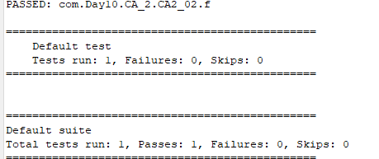

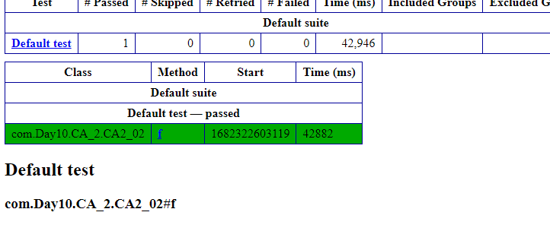

Problem-3:

**package** com.Day10.CA_2;

**import** org.openqa.selenium.By;

**import** org.openqa.selenium.WebDriver;

**import** org.openqa.selenium.WebElement;

**import** org.openqa.selenium.chrome.ChromeDriver;

**import** org.openqa.selenium.chrome.ChromeOptions;

**import** org.testng.annotations.Test;

**import** io.github.bonigarcia.wdm.WebDriverManager;

**public** **class** CA2_03 {

@Test

**public** **void** f() {

ChromeOptions co=**new** ChromeOptions();

co.addArguments("--remote-allow-origins=*");

WebDriverManager.*chromedriver*().setup();

WebDriver driver=**new** ChromeDriver(co);

driver.get("https://www.trivago.in/");

driver.manage().window().maximize();

String currtitle=driver.getTitle();

System.***out***.println(currtitle);

String exptitle="trivago.in - Compare hotel prices worldwide";

**if**(currtitle.equals(exptitle)) {

System.***out***.println("Title get Matched");

}

**else** {

System.***out***.println("Title not get Matched");

}

String txt1=driver.findElement(By.*xpath*("//*[@id=\"search\"]/div[1]/div[1]/div/span[1]/div[1]/div[3]/div/div/div/div/div/div/div/div[2]/div/div/div[1]/h2/a/span")).getText();

System.***out***.println(txt1);

String txt2=driver.findElement(By.*xpath*("//*[@id=\"search\"]/div[1]/div[1]/div/span[1]/div[1]/div[4]/div/div/div/div/div/div/div/div[2]/div/div/div[1]/h2/a/span")).getText();

System.***out***.println(txt2);

String txt3=driver.findElement(By.*xpath*("//*[@id=\"search\"]/div[1]/div[1]/div/span[1]/div[1]/div[5]/div/div/div/div/div/div[2]/div/div/div[1]/h2/a/span")).getText();

System.***out***.println(txt3);

String txt4=driver.findElement(By.*xpath*("//*[@id=\"search\"]/div[1]/div[1]/div/span[1]/div[1]/div[6]/div/div/div/div/div/div[2]/div/div/div[1]/h2/a/span")).getText();

System.***out***.println(txt4);

String txt5=driver.findElement(By.*xpath*("//*[@id=\"search\"]/div[1]/div[1]/div/span[1]/div[1]/div[7]/div/div/div/div/div/div[2]/div/div/div[1]/h2/a/span")).getText();

System.***out***.println(txt5);

driver.findElement(By.*xpath*("//*[@id=\"sorting-selector\"]/option[3]")).click();

String currentprice=driver.findElement(By.*xpath*("//*[@id=\"__next\"]/div/div[1]/main/div[3]/div[1]/div/div[3]/div/div/ol/li/div/article/div[2]/div[2]/div[1]/div/div[3]/div[1]/div/p")).getText();

String expectedprice="trivago.in - Compare hotel prices worldwide";

System.***out***.println(currentprice);

**if**(currentprice.equals(expectedprice)) {

System.***out***.println("price Matched");

}

**else** {

System.***out***.println("price not Matched");

}

driver.findElement(By.*xpath*("//*[@id=\"__next\"]/div/div[1]/main/div[3]/div[1]/div/div[3]/div/div/ol/li/div/article/div[2]/div[2]/div[1]/div/div[3]/div[2]/button/span/span[1]")).click();

driver.findElement(By.*xpath*("//*[@id=\"contentContainer\"]/div[3]/ol/li[1]/div[2]/a/div/div[2]/div")).click();

driver.findElement(By.*xpath*("//*[@id=\"hotelNavBar\"]/div/ul/li[2]/button/span")).click();

driver.findElement(By.*xpath*("//*[@id=\"ChildRoom-Ch8I2vnABhACIA4ojuUhMARAAUoJN0QxTl8xMDBQUJgFEgIIARoGEAIoBDAB\"]/div/div[4]/div[2]/div/div[1]/button/div")).click();

WebElement txtBoxl=driver.findElement(By.*xpath*("//*[@id=\"Fullname\"]"));

txtBoxl.sendKeys("Arun");

}

}

Output:



