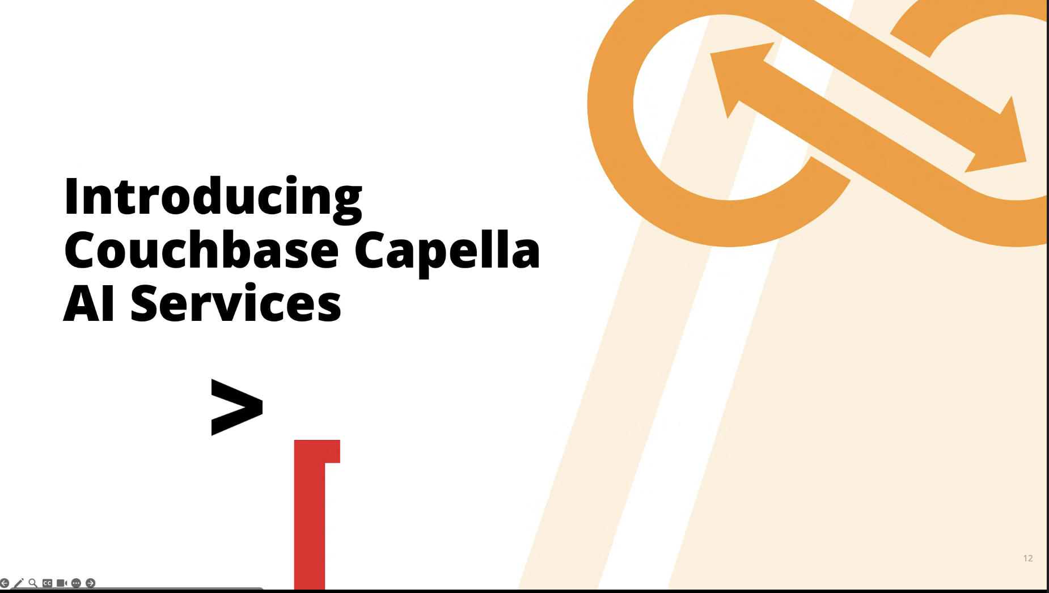

* SDK maintains all the prompts and models – Control Flow / Langgraph / Langchain
* Vectorizing data
* Multiple tool calling and prompts
* Embeddings for the tools and prompts
  + Providers 🡪 Provides the information
  + Auditor 🡪 traceability
* Analytical Data Set 🡪 Indexes for the

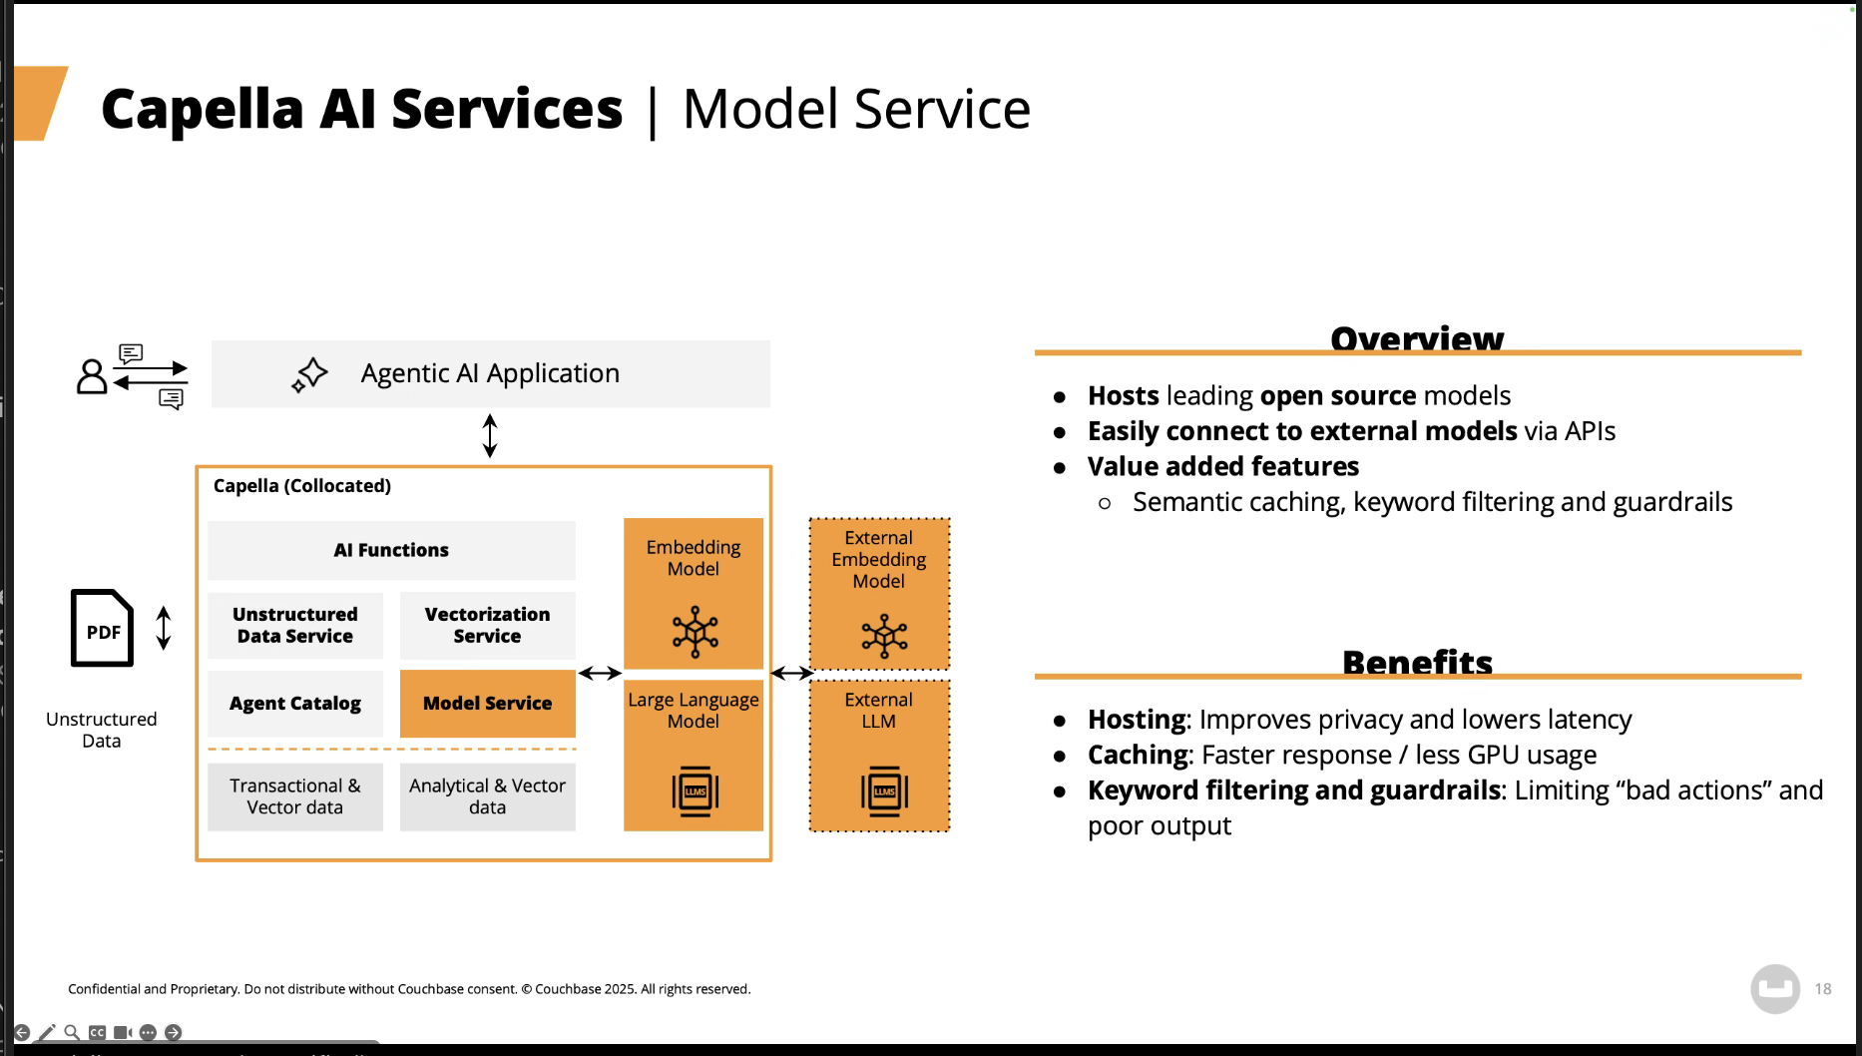

* AI Governance - Certification

Model services:

* Capella Columnar
* LLM Models / Embedding Models
  + Vectorizing the data
    - Caching
    - Guardrails

* As Data keep changing in the mutations 🡪 Vectorization service re-vectorizes automatically.

* + Summarization
  + PII masking
  + Classification
  + Information Extraction

**🡪 Use Cloud model platforms**

* **WatsonX**

**🡪 Data must be hosted in Capella**

**🡪 S3 bucket (Vectorization)**

**🡪 Columnar (AI Capabilities)**

***🡪 CDC Tool 🡪 ETL tool 🡪***