🚨 DispatchIQ — AI-Powered Emergency Response & Police Dispatch System

Project Title
DispatchIQ: Intelligent Emergency Response & Real-Time Police Dispatch Coordination Platform

Brief Project Description (200–500 words)
DispatchIQ is a full-stack, AI-augmented web platform designed to revolutionize how law enforcement agencies receive, prioritize, and respond to emergency incidents. In a world where every second counts, traditional dispatch systems — reliant on manual radio calls, paper logs, and human intuition — create dangerous delays. DispatchIQ replaces this fragmented workflow with a unified, real-time digital command center.
At its core, the platform enables citizens to report emergencies directly through a web or mobile interface, automatically capturing their GPS coordinates and incident details. These reports flow instantly into a live control room dashboard — a dynamic map overlay showing every active incident, available patrol unit, and ongoing response in real time via WebSocket (Socket.IO) connections.
The system's intelligence lies in its automated dispatch engine. Using geospatial algorithms, DispatchIQ identifies the nearest available patrol unit to any new incident and recommends or auto-assigns deployment — cutting the critical gap between "call received" and "unit enroute." Incidents are automatically triaged and prioritized using an AI scoring model that weighs factors such as incident type (violent crime vs. noise complaint), number of people affected, weapon involvement, repeat-location history, and caller distress indicators.
Beyond dispatch, the platform provides escalation monitoring: if a unit hasn't acknowledged an assignment within a configurable window, or if a response is taking longer than the statistical norm for that incident type, supervisors are alerted instantly. This ensures no incident falls through the cracks.
For strategic decision-making, DispatchIQ offers an analytics suite — historical response-time trends, incident density heatmaps, peak-hour analysis, and unit performance metrics. These insights allow police leadership to optimize patrol routes, allocate resources during high-crime windows, and demonstrate measurable improvements to civic stakeholders.
The entire system is built on a modern stack — React for the frontend dashboards, Express.js as the API layer, MongoDB for flexible incident and unit data storage, and Socket.IO for sub-second real-time communication. Role-based access control ensures that citizens, dispatchers, field officers, and administrators each see exactly what they need — and nothing they shouldn't.
DispatchIQ is a pure-software solution with zero hardware or ML-training dependencies, making it immediately deployable, highly scalable, and demonstrably impactful.

Problem Statement Explanation
How can technology reduce emergency response times, eliminate dispatch bottlenecks, and improve coordination between citizens, dispatchers, and police field units — ultimately saving lives?
Current emergency response systems in most Indian cities (and many globally) suffer from critical inefficiencies:
Problem | Impact
Manual call intake | Dispatchers transcribe verbal reports, introducing delays and transcription errors
No real-time unit tracking | Control rooms don't know exact positions of patrol vehicles, leading to suboptimal assignments
Flat prioritization | All calls are treated near-equally; a noise complaint can queue ahead of an assault report
No escalation alerts | If a unit doesn't respond or a situation worsens, nobody is automatically notified
Zero analytics | Departments cannot measure response times, identify hotspots, or optimize patrol allocation with data
Citizen disconnect | Callers have no visibility into whether help is actually coming or how far away it is
These aren't theoretical shortcomings — they are documented contributors to delayed responses, resource misallocation, and preventable harm. The National Crime Records Bureau (NCRB) data consistently highlights urban areas where response times exceed 15–30 minutes for Priority-1 calls, against a global best-practice target of under 7 minutes.

Proposed Solution — How AI Addresses the Problem
DispatchIQ applies AI and intelligent automation at every stage of the emergency response pipeline:
1. 🧠 Smart Incident Triage (AI Prioritization)
When a citizen submits an emergency report, the system runs it through an AI priority scoring engine:
Priority Score = f(incident_type, severity_keywords, weapon_flag,
people_affected, location_history, time_of_day)
- Critical (P1): Active shooter, assault in progress, medical emergency → Immediate dispatch
- High (P2): Robbery, domestic violence, accident with injuries → Rapid dispatch
- Medium (P3): Theft, vandalism, suspicious activity → Queued dispatch
- Low (P4): Noise complaint, parking violation → Logged for patrol
This replaces subjective human judgment with consistent, data-driven triage.
2. 📍 Nearest Unit Allocation (Geospatial AI)
Using the Haversine formula and real-time GPS positions of patrol units:
$$d=2r⋅arcsin⁡\left(\sqrt{{sin⁡}^{2}\left(\frac{Δϕ}{2}\right)+cos⁡(ϕ_{1})cos⁡(ϕ_{2}){sin⁡}^{2}\left(\frac{Δλ}{2}\right)}\right)$$
The system calculates distances from all available units to the incident location and auto-recommends the closest unit. Dispatchers can accept the recommendation or override manually.
3. ⏱️ Escalation Monitoring
A background engine continuously monitors:
- Acknowledgment timeout: Unit hasn't accepted dispatch within 2 minutes → Alert supervisor + re-assign
- Response time anomaly: Unit is taking 2× the average response time for that zone → Flag for check-in
- Incident escalation: Citizen updates report with new severity (e.g., "they now have a weapon") → Auto-upgrade priority and notify all assigned units
4. 📊 Predictive Analytics
Historical incident data feeds a trend analysis engine that provides:
- Heatmaps showing crime density by zone and time window
- Response time dashboards per unit, zone, and incident type
- Predictive patrol suggestions — recommending where to position units based on historical patterns
5. 🔄 Real-Time Coordination (Socket.IO)
Every status change — new incident, unit dispatched, unit arrived, incident resolved — is broadcast in real time to all relevant dashboards. No polling. No refresh. Instant situational awareness.

Expected Impact
For Law Enforcement
Metric | Current State | With DispatchIQ
Average dispatch time | 5–10 minutes (manual) | < 30 seconds (automated)
Priority accuracy | Subjective / inconsistent | Algorithmic & auditable
Unit utilization | Untracked | Real-time tracking + analytics
Missed escalations | Common (no alerts) | Zero (automated monitoring)
Data for decisions | Minimal / paper-based | Full analytics suite
For Society & Citizens
- Faster help: Reduced response time directly correlates with lives saved, especially in medical emergencies and violent crime
- Transparency: Citizens can see that their report was received and a unit is en route — building trust in law enforcement
- Equitable coverage: Data-driven patrol allocation ensures all neighborhoods receive proportional attention, reducing bias
- Accountability: Every action is logged with timestamps — creating an auditable chain of custody for every incident
For City Administration
- Cost optimization: Better resource utilization means the same number of units can cover more ground effectively
- Evidence-based policy: Heatmaps and trend data inform decisions about where to add patrols, install streetlights, or invest in community programs
- Measurable KPIs: City leaders can track and report on response times, resolution rates, and citizen satisfaction

Features Antigravity Can Build
TIP
The following features align perfectly with proven full-stack patterns — role-based dashboards, real-time Socket.IO, CRUD operations, geospatial queries, and chart-driven analytics.
🟢 Core Features (Full Build)
Feature | Tech | Description
Citizen Emergency Reporting Portal | React + Geolocation API | Web form with auto GPS capture, incident type selection, photo/description upload
Live Control Room Dashboard | React + Leaflet/Mapbox + Socket.IO | Real-time map showing all active incidents (color-coded by priority), patrol unit positions, and dispatch status
Smart Dispatch Engine | Express.js + MongoDB Geospatial | Auto-calculate nearest available unit using $geoNear queries, recommend assignment
AI Priority Scoring | Express.js middleware | Rule-based + weighted scoring algorithm for automatic incident triage
Role-Based Dashboards | React + JWT Auth | Separate views for Citizens, Dispatchers, Field Officers, and Admins
Real-Time Notifications | Socket.IO | Instant alerts for new incidents, dispatch assignments, escalations, status changes
Incident CRUD & Timeline | Express + MongoDB | Full lifecycle management — create, update status, add notes, resolve, archive
Escalation Engine | Node.js background workers | Auto-detect unacknowledged dispatches, overtime responses, and priority upgrades
Analytics Dashboard | React + Chart.js / Recharts | Response time trends, incident volume charts, unit performance metrics
Incident Heatmap | Leaflet.heat | Density visualization of incidents by zone and time period
Unit Management | CRUD + Status tracking | Register patrol units, track availability (available / dispatched / off-duty)
Dispatch History & Audit Log | MongoDB + Express | Timestamped log of every action for accountability and review
🟡 Impressive Add-Ons (Wow Factor)
Feature | Description
Animated Dispatch Tracking | Show the dispatched unit moving toward the incident on the live map
SOS Quick Report | One-tap emergency button that sends location + generic distress signal
Citizen Status Tracker | After reporting, citizens see a live status page ("Unit dispatched → En route → Arrived")
Dark Mode Command Center UI | Glassmorphism-styled, military-grade dark UI for the control room
Sound Alerts | Audio notifications in the control room for P1 incidents
Shift Handoff Reports | Auto-generated summary of pending/active incidents for shift changes
🔴 Out of Scope (Not Required)
Item | Reason
CCTV / Video feeds | Requires hardware integration
Voice call transcription | Requires telephony + speech-to-text ML
Predictive crime modeling | Requires trained ML models + historical crime datasets
Mobile native apps | Web-responsive is sufficient for demonstration

Architecture Overview
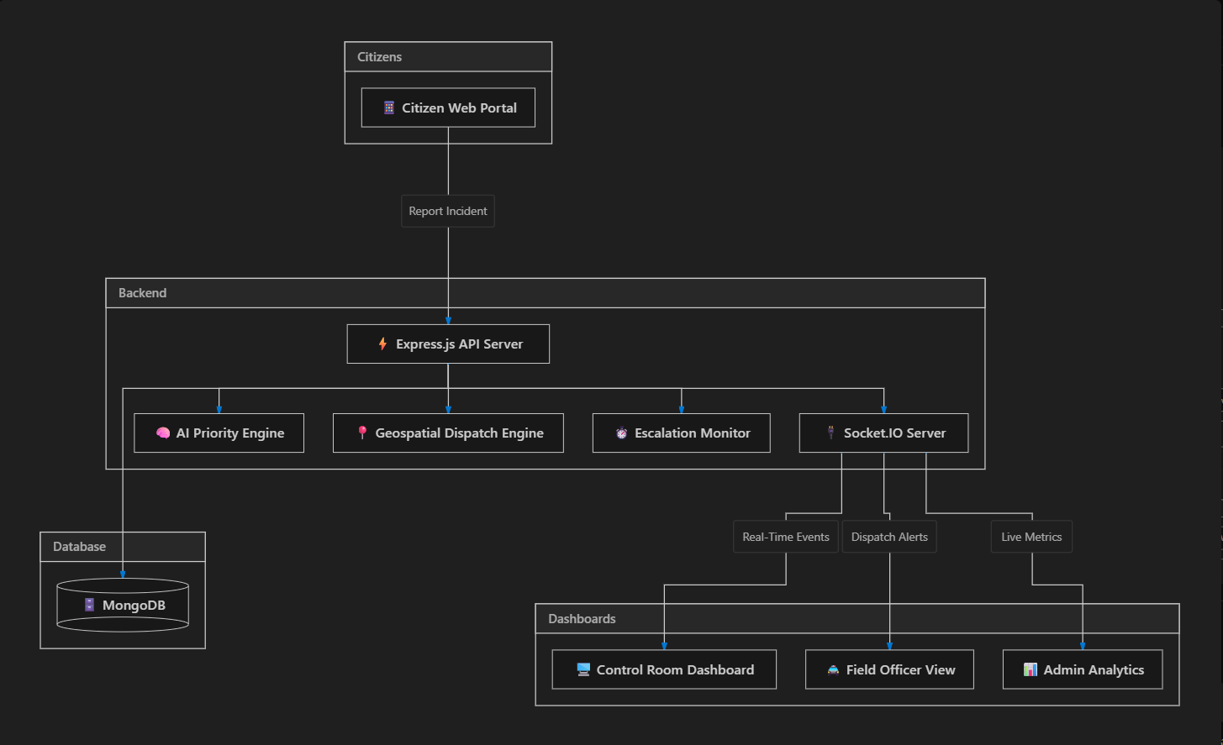

Summary
Dimension | Value
Project Title | DispatchIQ: AI-Powered Emergency Response & Police Dispatch
Stack | React + Express.js + MongoDB + Socket.IO
AI Components | Priority scoring, geospatial nearest-unit, escalation detection
Key Differentiator | Pure software, zero hardware dependency, real-time everything
Target Users | Citizens, Police Dispatchers, Field Officers, Administrators
Wow Factor | Live map with incident markers, animated dispatch tracking, dark mode command center, heatmaps, analytics charts
IMPORTANT
This project is a direct match for a full-stack build — it reuses proven patterns (role-based auth, CRUD, Socket.IO real-time, chart dashboards) while delivering a visually stunning, judge-impressing final product.

