Food Delivery Data Analysis and Statistical Visualization
Soma Pramanik 2505101270169 Div:I
2026-09-18
Table of Contents
1. Introduction 3
2. Aim 3
3. Objectives 3
4. Software and Packages 3
5. Load Required Libraries 4
6. Read the CSV File 4
7. Data Exploration 4
Number of Rows and Columns 4
Column Names 4
Structure 5
Summary 5
8. Dataset Description 5
9. Data Cleaning 6
Missing Values 6
Duplicate Records 6
Remove Duplicate Records 6
Verify Cleaning 6
10. Descriptive Statistical Analysis 7
Mean 7
Median 7
Mode 8
Minimum and Maximum 8
Range 9
Variance 9
Standard Deviation 9
Quartiles 10
Interquartile Range 10
11. Statistical Summary Table 11
12. Frequency Analysis 12
Food Category 12
Payment Method 12
Order Status 13
City 13
13. Bar Graph – Orders by Food Category 13
Interpretation 14
14. Pie Chart – Payment Method 14
Interpretation 15
15. Histogram – Order Value 15
Interpretation 16
16. Scatter Plot – Distance vs Delivery Time 16
Interpretation 17
17. Correlation Analysis 17
Distance and Delivery Time 17
Delivery Time and Rating 17
Order Value and Discount 17
Interpretation 18
18. Group-wise Analysis 18
Average Order Value by Food Category 18
Average Delivery Time by City 18
Average Rating by Food Category 19
19. Findings 19
20. Conclusion 19
21. References 20

1. Introduction
Food delivery services generate large amounts of data about customers, orders, food categories, delivery times, distances, payment methods, ratings, discounts, and order status. Analyzing this information can help identify customer and delivery patterns.
This project uses R Programming and R Markdown to import a CSV file, explore and clean the data, perform statistical analysis, and visualize important findings.

2. Aim
To analyze food delivery data using R Programming and R Markdown and present the results using statistical methods and graphical visualizations.

3. Objectives
- To read a CSV file into R.
- To understand the structure and characteristics of the dataset.
- To check missing and duplicate values.
- To calculate descriptive statistical measures.
- To analyze food categories, payment methods, and order status.
- To create bar charts and pie charts.
- To create a histogram and scatter plot.
- To study relationships between numerical variables.
- To interpret the results and draw a conclusion.

4. Software and Packages
- R
- RStudio
- R Markdown
- ggplot2
- dplyr
- knitr
If packages are not installed, run this once in the R Console:
install.packages(c("rmarkdown", "ggplot2", "dplyr", "knitr"))

5. Load Required Libraries
library(rmarkdown)
library(ggplot2)
library(dplyr)
library(knitr)
options(scipen = 999)

6. Read the CSV File
Keep food_delivery_data.csv in the same folder as this R Markdown file.
food <- read.csv("food_delivery_data.csv", stringsAsFactors = FALSE)
head(food)
## Order_ID Customer_Age Gender City Food_Category Order_Value
## 1 O001 60 Female Ahmedabad Fast Food 229
## 2 O002 27 Female Surat Chinese 496
## 3 O003 48 Female Delhi Indian 353
## 4 O004 42 Female Vadodara Chinese 443
## 5 O005 48 Male Surat Beverages 255
## 6 O006 36 Female Delhi Beverages 243
## Delivery_Time Distance Payment_Method Rating Discount Order_Status
## 1 40 5.1 Credit Card 5.0 11 Delivered
## 2 27 5.1 Debit Card 4.3 74 Delivered
## 3 30 2.4 Credit Card 4.7 18 Delivered
## 4 40 5.0 Credit Card 4.9 22 Delivered
## 5 44 11.9 UPI 4.3 26 Delivered
## 6 30 6.8 Credit Card 4.2 12 Delivered

7. Data Exploration

Number of Rows and Columns
dim(food)
## [1] 300 12
The dataset contains 300 orders and 12 variables.

Column Names
names(food)
## [1] "Order_ID" "Customer_Age" "Gender" "City"
## [5] "Food_Category" "Order_Value" "Delivery_Time" "Distance"
## [9] "Payment_Method" "Rating" "Discount" "Order_Status"

Structure
str(food)
## 'data.frame': 300 obs. of 12 variables:
## $ Order_ID : chr "O001" "O002" "O003" "O004" ...
## $ Customer_Age : int 60 27 48 42 48 36 60 51 23 19 ...
## $ Gender : chr "Female" "Female" "Female" "Female" ...
## $ City : chr "Ahmedabad" "Surat" "Delhi" "Vadodara" ...
## $ Food_Category : chr "Fast Food" "Chinese" "Indian" "Chinese" ...
## $ Order_Value : int 229 496 353 443 255 243 446 361 520 362 ...
## $ Delivery_Time : int 40 27 30 40 44 30 29 25 29 54 ...
## $ Distance : num 5.1 5.1 2.4 5 11.9 6.8 4.3 4.9 9 13.8 ...
## $ Payment_Method: chr "Credit Card" "Debit Card" "Credit Card" "Credit Card" ...
## $ Rating : num 5 4.3 4.7 4.9 4.3 4.2 5 4.5 4.8 4.3 ...
## $ Discount : int 11 74 18 22 26 12 67 36 52 54 ...
## $ Order_Status : chr "Delivered" "Delivered" "Delivered" "Delivered" ...

Summary
summary(food)
## Order_ID Customer_Age Gender City
## Length :300 Min. :18.00 Length :300 Length :300
## N.unique :300 1st Qu.:28.00 N.unique : 2 N.unique : 6
## N.blank : 0 Median :39.00 N.blank : 0 N.blank : 0
## Min.nchar: 4 Mean :38.78 Min.nchar: 4 Min.nchar: 4
## Max.nchar: 4 3rd Qu.:49.00 Max.nchar: 6 Max.nchar: 9
## Max. :60.00
## Food_Category Order_Value Delivery_Time Distance
## Length :300 Min. :137.0 Min. :10.0 Min. : 0.90
## N.unique : 6 1st Qu.:281.5 1st Qu.:29.0 1st Qu.: 4.55
## N.blank : 0 Median :356.0 Median :37.0 Median : 7.70
## Min.nchar: 5 Mean :367.8 Mean :37.1 Mean : 7.84
## Max.nchar: 9 3rd Qu.:448.2 3rd Qu.:46.0 3rd Qu.:11.43
## Max. :664.0 Max. :65.0 Max. :14.90
## Payment_Method Rating Discount Order_Status
## Length :300 Min. :3.300 Min. : 0.00 Length :300
## N.unique : 5 1st Qu.:4.200 1st Qu.: 11.00 N.unique : 2
## N.blank : 0 Median :4.500 Median : 32.00 N.blank : 0
## Min.nchar: 3 Mean :4.509 Mean : 34.63 Min.nchar: 9
## Max.nchar: 11 3rd Qu.:4.900 3rd Qu.: 52.00 Max.nchar: 9
## Max. :5.000 Max. :107.00

8. Dataset Description
Variable | Description
Order_ID | Unique order identification number
Customer_Age | Age of customer
Gender | Gender of customer
City | Customer city
Food_Category | Category of food ordered
Order_Value | Total order value
Delivery_Time | Delivery time in minutes
Distance | Delivery distance in kilometres
Payment_Method | Method used for payment
Rating | Customer rating from 1 to 5
Discount | Discount applied to the order
Order_Status | Delivered or cancelled

9. Data Cleaning

Missing Values
colSums(is.na(food))
## Order_ID Customer_Age Gender City Food_Category
## 0 0 0 0 0
## Order_Value Delivery_Time Distance Payment_Method Rating
## 0 0 0 0 0
## Discount Order_Status
## 0 0

Duplicate Records
sum(duplicated(food))
## [1] 0

Remove Duplicate Records
food <- food[!duplicated(food), ]

Verify Cleaning
dim(food)
## [1] 300 12
colSums(is.na(food))
## Order_ID Customer_Age Gender City Food_Category
## 0 0 0 0 0
## Order_Value Delivery_Time Distance Payment_Method Rating
## 0 0 0 0 0
## Discount Order_Status
## 0 0

10. Descriptive Statistical Analysis

Mean
Mean is the average value of a variable.
mean(food$Customer_Age)
## [1] 38.78
mean(food$Order_Value)
## [1] 367.76
mean(food$Delivery_Time)
## [1] 37.1
mean(food$Distance)
## [1] 7.839667
mean(food$Rating)
## [1] 4.509333
mean(food$Discount)
## [1] 34.63333

Median
Median is the middle value after arranging observations in ascending order.
median(food$Customer_Age)
## [1] 39
median(food$Order_Value)
## [1] 356
median(food$Delivery_Time)
## [1] 37
median(food$Distance)
## [1] 7.7
median(food$Rating)
## [1] 4.5
median(food$Discount)
## [1] 32

Mode
get_mode <- function(x) {
ux <- unique(x)
ux[which.max(tabulate(match(x, ux)))]
}
get_mode(food$Customer_Age)
## [1] 45
get_mode(food$Delivery_Time)
## [1] 29
get_mode(food$Rating)
## [1] 5

Minimum and Maximum
min(food$Order_Value)
## [1] 137
max(food$Order_Value)
## [1] 664
min(food$Delivery_Time)
## [1] 10
max(food$Delivery_Time)
## [1] 65
min(food$Distance)
## [1] 0.9
max(food$Distance)
## [1] 14.9

Range
Range is calculated as maximum minus minimum.
diff(range(food$Order_Value))
## [1] 527
diff(range(food$Delivery_Time))
## [1] 55
diff(range(food$Distance))
## [1] 14

Variance
Variance measures the spread of observations around their mean.
var(food$Customer_Age)
## [1] 147.0016
var(food$Order_Value)
## [1] 13106.53
var(food$Delivery_Time)
## [1] 148.8863
var(food$Distance)
## [1] 16.43297
var(food$Rating)
## [1] 0.1701467

Standard Deviation
Standard deviation measures the amount of variation in the data.
sd(food$Customer_Age)
## [1] 12.12442
sd(food$Order_Value)
## [1] 114.4838
sd(food$Delivery_Time)
## [1] 12.2019
sd(food$Distance)
## [1] 4.05376
sd(food$Rating)
## [1] 0.4124884

Quartiles
quantile(food$Order_Value)
## 0% 25% 50% 75% 100%
## 137.00 281.50 356.00 448.25 664.00
quantile(food$Delivery_Time)
## 0% 25% 50% 75% 100%
## 10 29 37 46 65
quantile(food$Distance)
## 0% 25% 50% 75% 100%
## 0.900 4.550 7.700 11.425 14.900
quantile(food$Rating)
## 0% 25% 50% 75% 100%
## 3.3 4.2 4.5 4.9 5.0

Interquartile Range
IQR = Q3 - Q1.
IQR(food$Order_Value)
## [1] 166.75
IQR(food$Delivery_Time)
## [1] 17
IQR(food$Distance)
## [1] 6.875
IQR(food$Rating)
## [1] 0.7

11. Statistical Summary Table
statistical_summary <- data.frame(
Variable = c(
"Customer Age",
"Order Value",
"Delivery Time",
"Distance",
"Rating",
"Discount"
),
Mean = c(
mean(food$Customer_Age),
mean(food$Order_Value),
mean(food$Delivery_Time),
mean(food$Distance),
mean(food$Rating),
mean(food$Discount)
),
Median = c(
median(food$Customer_Age),
median(food$Order_Value),
median(food$Delivery_Time),
median(food$Distance),
median(food$Rating),
median(food$Discount)
),
Variance = c(
var(food$Customer_Age),
var(food$Order_Value),
var(food$Delivery_Time),
var(food$Distance),
var(food$Rating),
var(food$Discount)
),
Standard_Deviation = c(
sd(food$Customer_Age),
sd(food$Order_Value),
sd(food$Delivery_Time),
sd(food$Distance),
sd(food$Rating),
sd(food$Discount)
),
IQR = c(
IQR(food$Customer_Age),
IQR(food$Order_Value),
IQR(food$Delivery_Time),
IQR(food$Distance),
IQR(food$Rating),
IQR(food$Discount)
)
)
kable(
statistical_summary %>%
mutate(
Mean = round(Mean, 2),
Median = round(Median, 2),
Variance = round(Variance, 2),
Standard_Deviation = round(Standard_Deviation, 2),
IQR = round(IQR, 2)
),
caption = "Descriptive Statistical Summary"
)
Descriptive Statistical Summary
Variable | Mean | Median | Variance | Standard_Deviation | IQR
Customer Age | 38.78 | 39.0 | 147.00 | 12.12 | 21.00
Order Value | 367.76 | 356.0 | 13106.53 | 114.48 | 166.75
Delivery Time | 37.10 | 37.0 | 148.89 | 12.20 | 17.00
Distance | 7.84 | 7.7 | 16.43 | 4.05 | 6.88
Rating | 4.51 | 4.5 | 0.17 | 0.41 | 0.70
Discount | 34.63 | 32.0 | 786.87 | 28.05 | 41.00

12. Frequency Analysis

Food Category
table(food$Food_Category)
##
## Beverages Chinese Dessert Fast Food Indian Pizza
## 45 55 23 62 70 45

Payment Method
table(food$Payment_Method)
##
## Cash Credit Card Debit Card UPI Wallet
## 38 57 43 137 25

Order Status
table(food$Order_Status)
##
## Cancelled Delivered
## 15 285

City
table(food$City)
##
## Ahmedabad Delhi Mumbai Pune Surat Vadodara
## 59 53 58 34 43 53

13. Bar Graph – Orders by Food Category
ggplot(food, aes(x = Food_Category)) +
geom_bar() +
labs(
title = "Number of Orders by Food Category",
x = "Food Category",
y = "Number of Orders"
) +
theme_minimal()
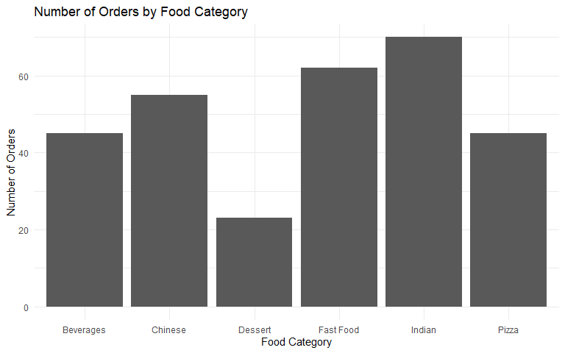

Interpretation
The bar chart compares the number of orders placed in each food category. It helps identify which food categories have relatively more or fewer orders in the dataset.

14. Pie Chart – Payment Method
payment_data <- food %>%
count(Payment_Method) %>%
mutate(
Percentage = n / sum(n) * 100,
Label = paste0(Payment_Method, " (", round(Percentage, 1), "%)")
)
ggplot(payment_data, aes(x = "", y = n, fill = Payment_Method)) +
geom_col(width = 1) +
coord_polar(theta = "y") +
labs(
title = "Payment Method Distribution",
fill = "Payment Method"
) +
theme_void()
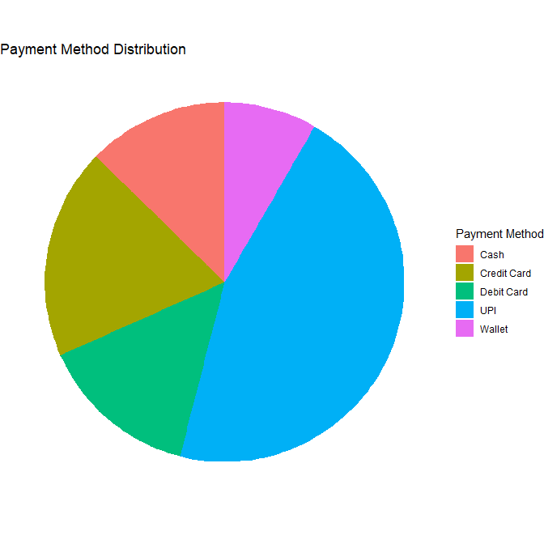

Interpretation
The pie chart shows the proportion of orders made using different payment methods such as UPI, cards, cash, and wallets.

15. Histogram – Order Value
ggplot(food, aes(x = Order_Value)) +
geom_histogram(bins = 20) +
labs(
title = "Distribution of Order Values",
x = "Order Value",
y = "Number of Orders"
) +
theme_minimal()
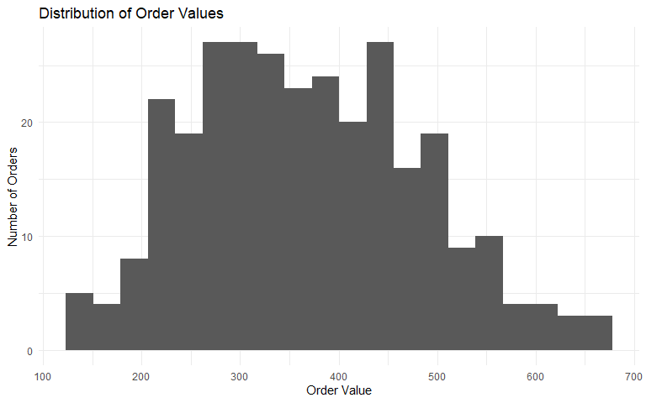

Interpretation
The histogram shows the distribution of order values and helps understand the range and concentration of customer spending.

16. Scatter Plot – Distance vs Delivery Time
ggplot(food, aes(x = Distance, y = Delivery_Time)) +
geom_point() +
labs(
title = "Delivery Distance vs Delivery Time",
x = "Distance (km)",
y = "Delivery Time (minutes)"
) +
theme_minimal()
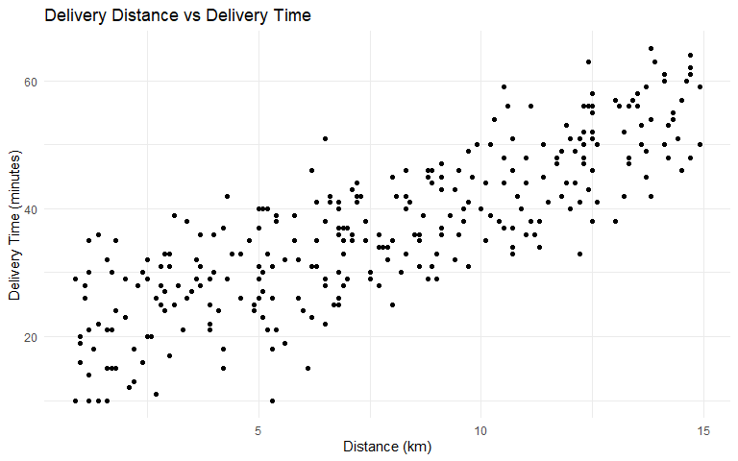

Interpretation
The scatter plot is used to examine the relationship between delivery distance and delivery time.

17. Correlation Analysis
Correlation measures the strength and direction of a linear relationship between two numerical variables.

Distance and Delivery Time
cor(food$Distance, food$Delivery_Time)
## [1] 0.8277375

Delivery Time and Rating
cor(food$Delivery_Time, food$Rating)
## [1] -0.371039

Order Value and Discount
cor(food$Order_Value, food$Discount)
## [1] 0.4506146

Interpretation
The correlation coefficient ranges from -1 to +1.
- A value close to +1 indicates a strong positive linear relationship.
- A value close to -1 indicates a strong negative linear relationship.
- A value close to 0 indicates a weak or no linear relationship.
The calculated values should be interpreted using the actual output generated by R.

18. Group-wise Analysis

Average Order Value by Food Category
food %>%
group_by(Food_Category) %>%
summarise(
Average_Order_Value = mean(Order_Value),
Average_Rating = mean(Rating),
Average_Delivery_Time = mean(Delivery_Time)
)
## # A tibble: 6 × 4
## Food_Category Average_Order_Value Average_Rating Average_Delivery_Time
## <chr> <dbl> <dbl> <dbl>
## 1 Beverages 226. 4.45 37.6
## 2 Chinese 440. 4.47 38.1
## 3 Dessert 269. 4.44 37.1
## 4 Fast Food 319. 4.58 36.0
## 5 Indian 382. 4.54 36.5
## 6 Pizza 517. 4.50 37.7

Average Delivery Time by City
food %>%
group_by(City) %>%
summarise(
Average_Delivery_Time = mean(Delivery_Time)
)
## # A tibble: 6 × 2
## City Average_Delivery_Time
## <chr> <dbl>
## 1 Ahmedabad 38.8
## 2 Delhi 35.9
## 3 Mumbai 34.5
## 4 Pune 34.8
## 5 Surat 39.0
## 6 Vadodara 39.1

Average Rating by Food Category
food %>%
group_by(Food_Category) %>%
summarise(
Average_Rating = mean(Rating)
)
## # A tibble: 6 × 2
## Food_Category Average_Rating
## <chr> <dbl>
## 1 Beverages 4.45
## 2 Chinese 4.47
## 3 Dessert 4.44
## 4 Fast Food 4.58
## 5 Indian 4.54
## 6 Pizza 4.50

19. Findings
The analysis provides information about:
- Distribution of orders across food categories.
- Payment method usage.
- Customer age and spending patterns.
- Delivery time and distance.
- Customer ratings.
- Discounts applied to orders.
- Order status.
- Relationships between distance, delivery time, rating, order value, and discount.
The exact numerical findings should be reported from the values generated when this R Markdown file is knitted.

20. Conclusion
This project demonstrates how R Programming can be used for practical food delivery data analysis. A CSV dataset was imported into R and examined using data exploration and cleaning techniques. Descriptive statistical methods including mean, median, mode, variance, standard deviation, quartiles, and IQR were applied. Bar charts, pie charts, histograms, and scatter plots were used to visualize the data. Correlation analysis was also performed to study relationships between numerical variables. R Markdown combines the code, output, visualizations, and explanations into a single report, making the analysis easy to present and document.

21. References
- R Programming documentation
- RStudio / Posit documentation
- ggplot2 documentation
- dplyr documentation
- R Markdown documentation

