Requirements Specification
for

Security Analysis of Autonomous Cyber -Physical Systems Using Deep- Learning

Jan 2026
Version 0.1

Prepared By

YAMANI KAVYA SRI - 22BQ1A12H2
SOMA INDU - 22BQ1A12F1
SANKURI SRAVANI - 22BQ1A12E1
TADIBOYINA PRANAVI - 22BQ1A12F5

Change History

Date | Version | Description | Updated By
24 Mar 2010 | 0.1 | Initial Draft | J2Lite Software

Document Approvals

Name | Role | Signature

Table of Contents

1 Introduction 4
1.1 Purpose 4
1.2 Document Conventions 4
1.3 Project Scope 4
1.4 References 4
2 System Description 4
3 Functional Requirements 4
3.1 System Features 4
3.1.1 System Feature 1 5
3.1.2 System Feature 2 5
3.2 Use Cases 5
3.2.1 Use Case Diagrams 5
3.2.2 Use Case 1 5
3.2.3 Use Case 2 5
3.3 Entity Relationship Diagrams 5
3.4 Data Dictionary 6
3.4.1 Entity 1 6
3.4.2 Entity 2 6
4 External Interface Requirements 6
5 Technical Requirements (Non functional) 6
5.1 Performance 6
5.2 Scalability 6
5.3 Security 6
5.4 Maintainability 6
5.5 Usability 6
5.6 Multi lingual Support 6
5.7 Auditing and Logging 6
5.8 Availability 6
6 Open Issues 7

Introduction

Purpose
The purpose of this document is to provide a detailed description of the functional and non-functional requirements of the proposed CPS security analysis system. It defines the system’s capabilities, constraints, and expected behavior to guide development. Functional requirements describe the essential operations the system must perform, while non-functional requirements specify quality factors such as performance, reliability, and usability.
This document serves as a common reference for developers, supervisors, and evaluators to ensure consistent understanding throughout the system development lifecycle. It supports validation and testing, reduces misunderstandings, and provides a structured framework for future improvements and maintenance, ensuring the system meets real-world security needs.

Document Conventions
This document follows standard Software Requirements Specification (SRS) conventions to ensure the requirements are presented clearly and systematically. All major sections are numbered hierarchically for better readability and traceability throughout the development process. This structure helps stakeholders locate information easily and maintain consistency. It also supports effective communication between developers, supervisors, and evaluators.
The document uses terminology related to cybersecurity, deep learning models, and Cyber-Physical Systems (CPS) consistently to avoid ambiguity and improve technical understanding. UML-based use case diagrams are included wherever required to represent system interactions, and Crow’s Foot notation is used to illustrate data relationships within the system. Overall, the document remains precise, standardized, and easy to interpret.

Project Scope
The scope of this project is limited to software-level security analysis of autonomous Cyber-Physical Systems (CPS). The system focuses on detecting and analyzing cyber intrusions by monitoring CPS network traffic and identifying potential malicious activities. It emphasizes improving cybersecurity through intelligent threat detection rather than controlling the physical components of the CPS.
The project includes key processes such as data preprocessing, deep learning–based intrusion detection, GAN-based data augmentation, and the application of explainable AI techniques to enhance transparency and trust. However, hardware-level security measures, physical system control mechanisms, and real-time actuation are beyond the scope of this work, as the focus remains strictly on software-based intrusion analysis.

References
- [1] G. Lampropoulos and K. Siakas, “Enhancing and securing cyber-physical systems and Industry 4.0 through digital twins: A critical review,” Journal of software: evolution and process, vol. 35, no. 7, p. e2494, 2023.

System Description
<This section can contain a detailed overview of the software system being built. It can contain a subsection detailing the existing system followed by the proposed system details. If relevent, this section can also contain business details such as organizational hierarchy. Basically provide everything that is necessary to understand the Fuctional Requirements section which follows this.>

Functional Requirements
<This section contains system requirements followed by various requirement models which can be used for detailed design. In addition to the following sections, you can also add process flow diagrams, data flow diagrams, flowcharts and decision tables if required.>

System Features
<This section specifies the high level system features required in the software product. Each requirement given below has a unique tag that can be referred in the traceability matrix.>

System Feature 1

System Feature 2

Use Cases

Use Case Diagrams
<One or more diagrams depicting how various actors interact with the software system.>

Use Case 1
<This provides a detailed description of the use case. Usually it is captured in the following table format. Add more rows or removing rows depending on your specific requirement.>
ID | <unique use case id>
Description | <Detailed description of the use case>
Actors | <Specify various actors who will invoke this use case>
Preconditions | <An example for a purchase item use case would be - user must be logged in to invoke purchase item.>
Basic Steps | <Usual flow of the use case indicating the various steps in it>
Alternate Steps
Exceptions | <Exceptions indicate what should happen if a rare unexpected condition occurs. For example, if the use case is purchase item, what happens when the the stock runs out during purchase?>
Business validations/Rules | <If business rules are already specified in the system features section, provide a link. Otherwise specify the rules.>
Postconditions

Use Case 2

Entity Relationship Diagrams
<One or diagrams to depict all the entities in the system and their relationships. You can use different notations for ER diagrams. Following is a very simple ER diagram in Crow's notation.>
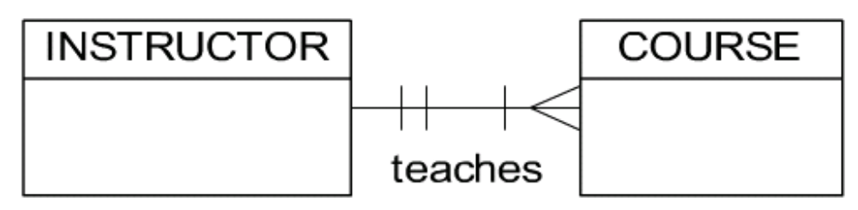

Data Dictionary

Entity 1
<A brief description of the entity followed by a table containing all its attributes as shown below. >
Attribute | Type | Optional? | Notes
<Attribute Name> | <Data type of the attribute> | <Y or N> | <Explain any specific restrictions or rules applcable on this attribute>

Entity 2

External Interface Requirements
<Provide sub sections for each external interface. Identify all the input and ouput from the external interfaces.>

Technical Requirements (Non functional)
<Please note that all the following subsections may not be applicable for a system. Sometimes you will have to add additional sections (for example, Legal requirements)>

Performance
<For example, What is the response time required?>

Scalability
<For example, how many users the system should support after two years of operation?>

Security
<For example, is data encryption required?>

Maintainability

Usability

Multi lingual Support
<What are the languages that software system should support?>

Auditing and Logging

Availability
<For example, Is any kind of downtime acceptable or required?>

Open Issues
<There could be open issues even at the end of the requirements elicitation. List of all of them here so it can be tracked and closed later. Some of these issues may later become project risks as well.>

