# Create a new service

To create a new adapter in TU Delft, it is necessary to create a new Windows service; otherwise, the adapter won't be visible to the orchestrator. Python processes will be terminated when you disconnect. Therefore, we have created a MOTER service: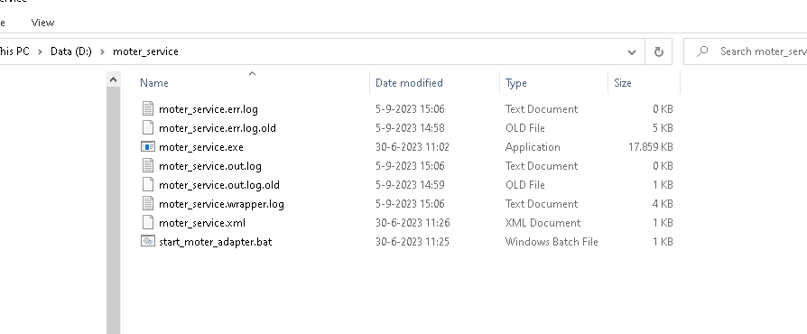

This service is the service that needs to be stopped/started in the steps described in other parts of this document. Therefore, one can create a .bat file similar to the one below:  
D:  
call D:\MOTER\moter-adapter\.venv\Scripts\activate.bat  
cd D:\MOTER\moter-adapter  
set PYTHONPATH=D:\MOTER\moter-adapter  
python.exe tno\aimms_adapter\main.py  
REM pause

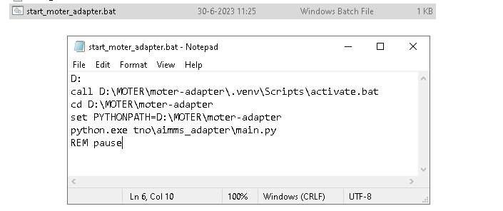

After the creation of this .bat file. One can create a service with this using WinSW:

[https://github.com/winsw/winsw](https://eur01.safelinks.protection.outlook.com/?url=https%3A%2F%2Fgithub.com%2Fwinsw%2Fwinsw&data=05%7C01%7CHarmen.Dijkstra%40dnv.com%7C203f00562a4346175ffa08db77df56b5%7Cadf10e2bb6e941d6be2fc12bb566019c%7C0%7C0%7C638235573352406402%7CUnknown%7CTWFpbGZsb3d8eyJWIjoiMC4wLjAwMDAiLCJQIjoiV2luMzIiLCJBTiI6Ik1haWwiLCJXVCI6Mn0%3D%7C3000%7C%7C%7C&sdata=yeolLYtb0HsNF%2BYiAJKt36CZrYbVErcCx0jWw0iQClw%3D&reserved=0)  
Following these steps, we used the following moter_service.xml:

<service>

<id>PythonMOTERAdapterService</id>

<name>MMviB Python MOTER Adapter service</name>

<description>This service runs the MOTER Adapter for MMVIB continuous integration system.</description>

<env name="PYTHONPATH" value="D:\MOTER\moter-adapter"/>

<workingdirectory>D:\Moter\MOTER-adapter</workingdirectory>

<startmode>Automatic</startmode>

<interactive/>

<executable>D:\moter_service\start_moter_adapter.bat</executable>

<log mode="roll"></log>

</service>