Car Part Factories Owned By

Vintage Car Parts

Table of content

1. Summary 3

**Table of Figures**

Figure 1 : 3

# Summary

Table 1 lists the car part factories owned by Vintage Car Parts:

**Table 1 : The** list of car part factories owned by Vintage Car Parts:

|  |  |  |  |  |
| --- | --- | --- | --- | --- |
| Name | Address | Dimensions (meters) | Employees | Products Made |
| Fuzzy Wheels Berlin | 0 | 30 X 30 | Brand, Mark  Hänsel, Kerstin  John, Johnson  Vogel, Sophie | Trabant 601 Wheel  Volvo Amazon Wheel |
| Safe Brake Parts | 0 | 0 X 0 | Großt, Sona  Lebrun, Henri  Peel, Masha  Shield, John  Twain, Mark  Vogel, Sophie | Volvo Amazon Brake Caliper  Volvo Amazon Brake Disk |

Each factory is described in details in the following sections.

# Fuzzy Wheels Berlin

The diagram of Figure 1 shows an overview of the factory and its working employees.

## Trabant 601 Wheel

### Overview

An exploded view of a Trabant 601 Wheel for the Trabant 601 is shown in Figure 2. It is compatible with the 800 RS, DeLuxe, Hycomat, Kübel, S, Standart, and TRAMP model variants.

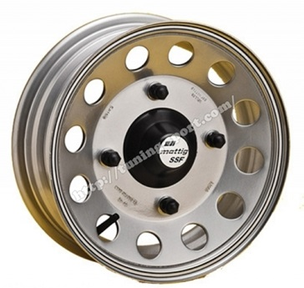

Figure 2 : Exploded view of a Trabant 601 Wheel for the Trabant 601

### Production Schemata

Figure 3 shows the production schemata Trabant_601_Wheel_Production for Trabant 601 Wheel produced at Fuzzy Wheels Berlin.

## Volvo Amazon Wheel

### Overview

An exploded view of a Volvo Amazon Wheel for the Volvo Amazon is shown in Figure 2. It is compatible with the 121, 122, and 123 model variants.

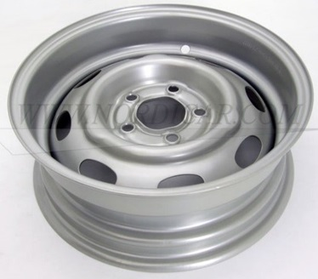

Figure 2 : Exploded view of a Volvo Amazon Wheel for the Volvo Amazon

### Production Schemata

Figure 3 shows the production schemata Amazon Wheel Production for Volvo Amazon Wheel produced at Fuzzy Wheels Berlin.

# Safe Brake Parts

The diagram of Figure 1 shows an overview of the factory and its working employees.

## Volvo Amazon Brake Caliper

### Overview

An exploded view of a Volvo Amazon Brake Caliper for the Volvo Amazon is shown in Figure 2. It is compatible with the 121, and 122 model variants.

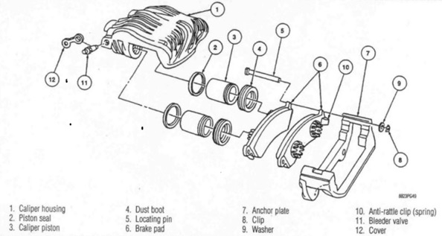

Figure 2 : Exploded view of a Volvo Amazon Brake Caliper for the Volvo Amazon

### Production Schemata

Figure 3 shows the production schemata Brake Caliper Production for Volvo Amazon Brake Caliper produced at Safe Brake Parts.

## Volvo Amazon Brake Disk

### Overview

An exploded view of a Volvo Amazon Brake Disk for the Volvo Amazon is shown in Figure 2. It is compatible with the 121, and 122 model variants.

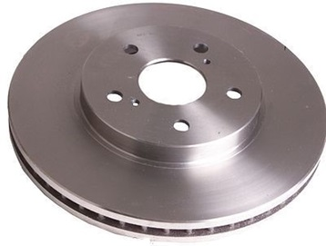

Figure 2 : Exploded view of a Volvo Amazon Brake Disk for the Volvo Amazon

### Production Schemata

Figure 3 shows the production schemata Brake Disk Production for Volvo Amazon Brake Disk produced at Safe Brake Parts.

# Car Models

This section presents the car models for which parts are produced by the factories owned by Vintage Car Parts.

## Trabant 601

Figure 1 shows a car of the Trabant 601 series that was produced between 0 and 0 in 7 different versions:

* 800 RS ((rally version, 1986–1988))
* DeLuxe
* Hycomat ((P601 H, 1965–1990))
* Kübel ((added in 1966))
* S ((Sonderwunsch - Special Edition) )
* Standart ((as Limousine and Universal))
* TRAMP ((added in 1978) )

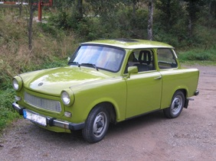

Figure  : A car of the Trabant 601 series

## Volvo Amazon

Figure 1 shows a car of the Volvo Amazon series that was produced between 0 and 0 in 3 different versions:

* 121 ((66 HP Engine))
* 122 ((85 HP Engine))
* 123 ((115 HP Engine))

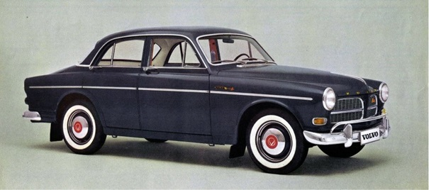

Figure  : A car of the Volvo Amazon series