Car Part Factories Owned By

Vintage Car Parts

Table of content

1. Summary 3

**Table of Figures**

Figure 1 : 3

# Summary

Table 1 lists the car part factories owned by Vintage Car Parts:

**Table 1 : The** list of car part factories owned by Vintage Car Parts

|  |  |  |  |  |
| --- | --- | --- | --- | --- |
| Name | Address | Dimensions (meters) | Employees | Products Made |
| **Fuzzy Wheels Berlin** | 32 HeerStr.  14052 Berlin  Germany | 30 X 30 | Brand, Mark  Hänsel, Kerstin  John, Johnson  Vogel, Sophie | Trabant 601 Wheel  Volvo Amazon Wheel |
| **Safe Break Parts** | 2 PuschkinalleeStr.  14469 Potsdam  Germany | 15 X 20 | Großt, Sona  Lebrun, Henri  Peel, Masha  Shield, John  Twain, Mark  Vogel, Sophie | Volvo Amazon Brake Caliper  Volvo Amazon Brake Disk |

Each factory is described in details in the following sections.

# Fuzzy Wheels Berlin

Fuzzy Wheels Berlin produces wheels for the Volvo Amazon and Trabant 601 series. The diagram of Figure 1 shows an overview of the factory and its working employees.

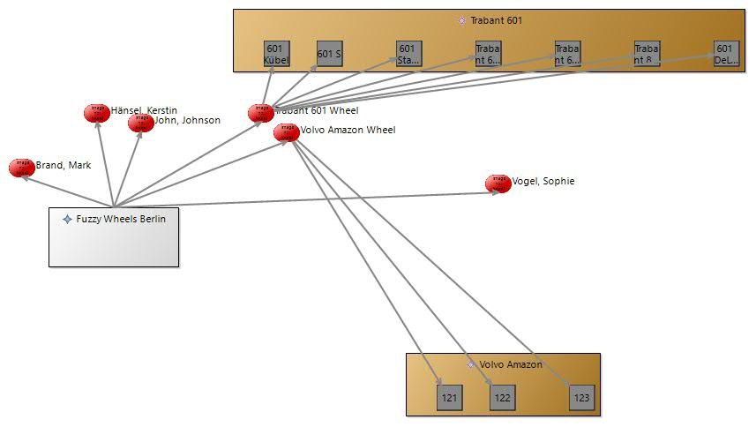

Figure 1 : Overview of Fuzzy Wheels Berlin

## Trabant 601 Wheel

### Overview

An exploded view of a Trabant 601 Wheel for the Trabant 601 is shown in Figure 2. It is compatible with the 601 DeLuxe, 601 Kübel, 601 S, 601 Standard, Trabant 601 Hycomat, Trabant 601 TRAMP, and Trabant 800 RS model variants.

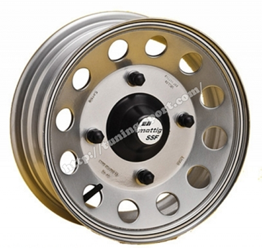

Figure 2 : Exploded view of a Trabant 601 Wheel for the Trabant 601

### Production Schemata

Figure 3 shows the production schemata Trabant 601 Wheel Production for Trabant 601 Wheels produced at Fuzzy Wheels Berlin.

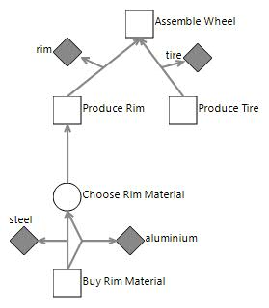

Figure 3 : The production schemata for Trabant 601 Wheel produced at Fuzzy Wheels Berlin

## Volvo Amazon Wheel

### Overview

An exploded view of a Volvo Amazon Wheel for the Volvo Amazon is shown in Figure 2. It is compatible with the 121, 122, and 123 model variants.

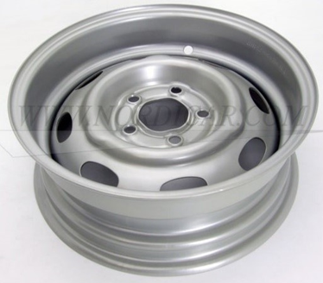

Figure 2 : Exploded view of a Volvo Amazon Wheel for the Volvo Amazon

### Production Schemata

Figure 3 shows the production schemata Amazon Wheel Production for Volvo Amazon Wheels produced at Fuzzy Wheels Berlin.

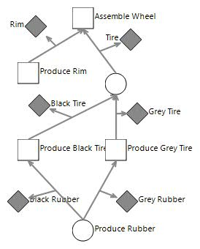

Figure 3 : The production schemata for Volvo Amazon Wheel produced at Fuzzy Wheels Berlin

# Safe Break Parts

Safe Break Parts produces parts for braking systems of the Volvo Amazon series. The diagram of Figure 1 shows an overview of the factory and its working employees.

## Volvo Amazon Brake Caliper

### Overview

An exploded view of a Volvo Amazon Brake Caliper for the Volvo Amazon is shown in Figure 2. It is compatible with the 121, and 122 model variants.

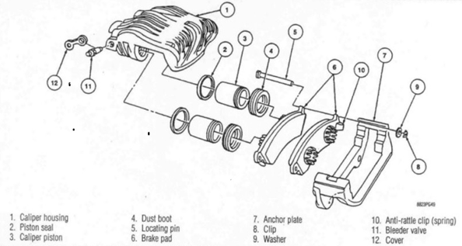

Figure 2 : Exploded view of a Volvo Amazon Brake Caliper for the Volvo Amazon

### Production Schemata

Figure 3 shows the production schemata Brake Caliper Production for Volvo Amazon Brake Calipers produced at Safe Break Parts.

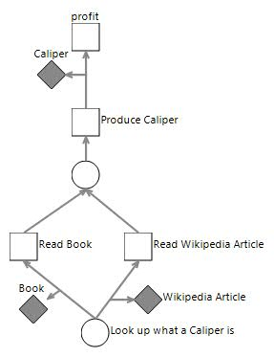

Figure 3 : The production schemata for Volvo Amazon Brake Caliper produced at Safe Break Parts

The production of the Caliper Housing, Bleeder Valve and Cover, Dust Boot and Piston Seal parts is outsourced. The Caliper Piston, Anchor Plate and Locating Pin parts are produced at the factory out of raw steel material with dedicated machines. Three other machines assemble the caliper sequentially starting from assembling the housing and bleeder valve, then the piston and finally the anchor plate and location pin. Brake pads are not produced in the factory and delivered separately from the calipers.

## Volvo Amazon Brake Disk

### Overview

An exploded view of a Volvo Amazon Brake Disk for the Volvo Amazon is shown in Figure 2. It is compatible with the 121, and 122 model variants.

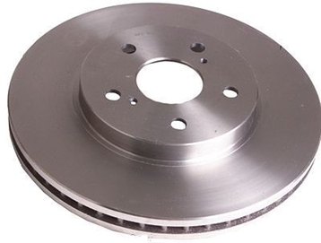

Figure 2 : Exploded view of a Volvo Amazon Brake Disk for the Volvo Amazon

### Production Schemata

Figure 3 shows the production schemata Brake Disc Production for Volvo Amazon Brake Disks produced at Safe Break Parts.

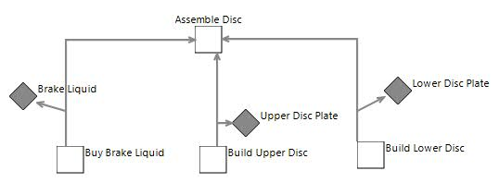

Figure 3 : The production schemata for Volvo Amazon Brake Disk produced at Safe Break Parts

# Car Models

This section presents the car models for which parts are produced by the factories owned by Vintage Car Parts.

## Trabant 601

Figure 1 shows a car of the Trabant 601 series that was produced between 1963 and 1990 in 7 different versions:

* 601 DeLuxe
* 601 Kübel (added in 1966)
* 601 S (Sonderwunsch - Special Edition)
* 601 Standard (as Limousine and Universal)
* Trabant 601 Hycomat (P601 H, 1965–1990)
* Trabant 601 TRAMP (added in 1978)
* Trabant 800 RS (rally version, 1986–1988)

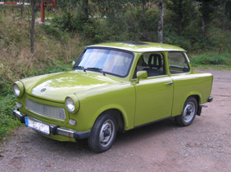

Figure 1 : A car of the Trabant 601 series

## Volvo Amazon

Figure 1 shows a car of the Volvo Amazon series that was produced between 1956 and 1970 in 3 different versions:

* 121 (66 HP Engine)
* 122 (85 HP Engine)
* 123 (115 HP Engine)

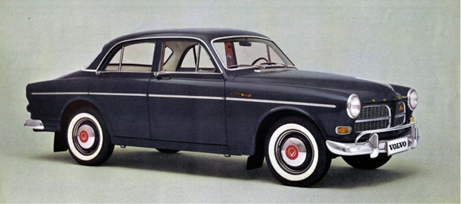

Figure 1 : A car of the Volvo Amazon series