Creating new repository

Open git bash

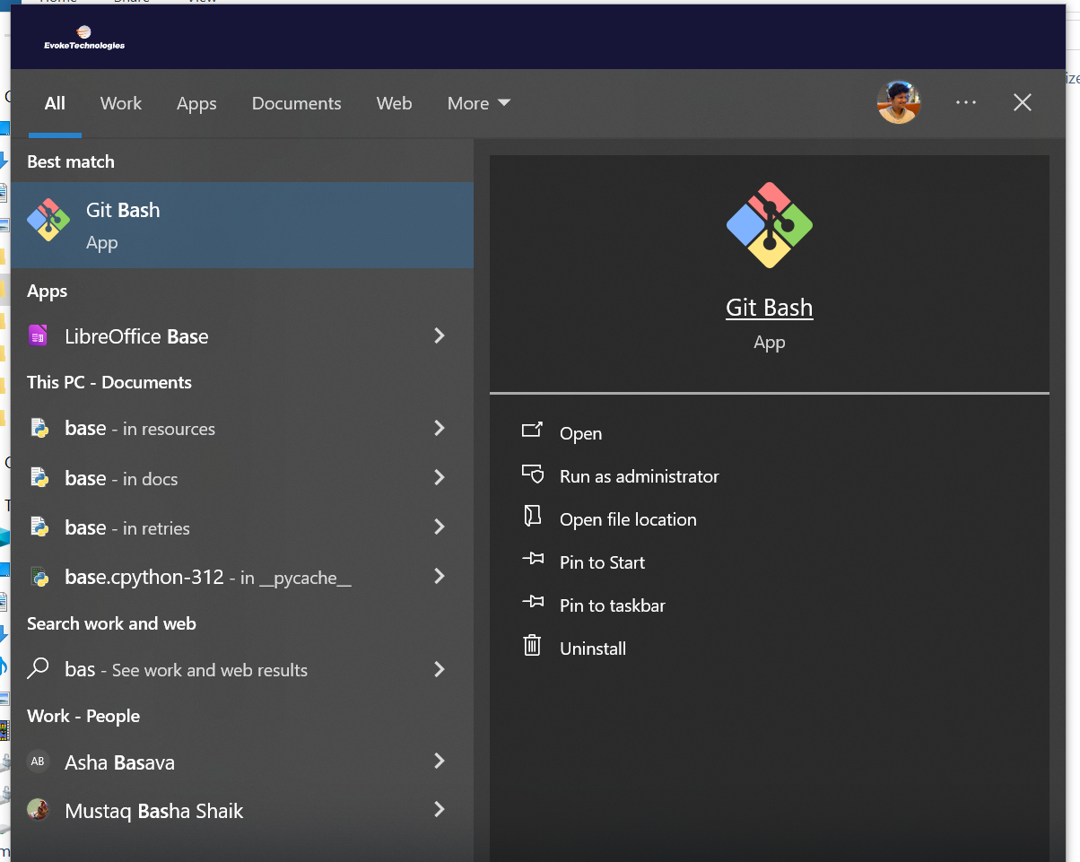

If you want to clone existing repository – get the url from here

Command : Git clone https://github.com/Somaganeshbabu/sample2.git

Creating simple file

Command git add filename and git status

