GitLab –
Part 1-
What is GitLab
Create an account on GitLab
Create a new project on GitLab

Git - version control system
to locally track changes in your project/folder and push & pull changes from remote repositories like GitHub, BitBucket, GitLab

GitLab, GitHub, BitBucket
Services that allow to host your project on a remote repo & have additional features to help in SDLC and CI, CD
e.g
Managing
Sharing
Wiki
Bug tracking
CI & CD

Step 1: Goto GitLab.com and create an account
Step 2: Sign in to GitLab
Step 3: Create a new project on GitLab

https://gitlab.com/RaghavPal/my-first...

*****************************************************
Part 2-
Download and install Git
Add a project/folder to git
Commit and Push project to GitLab

Step 1: Download git from https://git-scm.com/ and install git

Step 2: Check git is installed on your system
git --version

Step 3: Run following git commands
git config --global user.name “xxxx”
git config --global user.name

git config --global user.email “xxxx”
git config --global user.email

git config --global --list

Step 4: Create a demo project/folder & add to git

Step 5: Goto cmd OR terminal OR git bash
CD to the location of the folder and run following commands
git init
git status
git add .
git commit -m “msg”
git push -u “url” master

Step 6: Check project (files) added on GitLab
***************************************************
Part 3-
What is fork
How to fork a project

A fork is a copy of a project
Forking a pro/repo allows you to make changes without affecting the original project

Step 1: Login to GitLab and goto your project

Step 2: Click on Fork button

If you get a message
No available namespaces to fork the project.

After making changes to the fork project you can merge the changes to the original project using Merge Request.
***********************
Git –
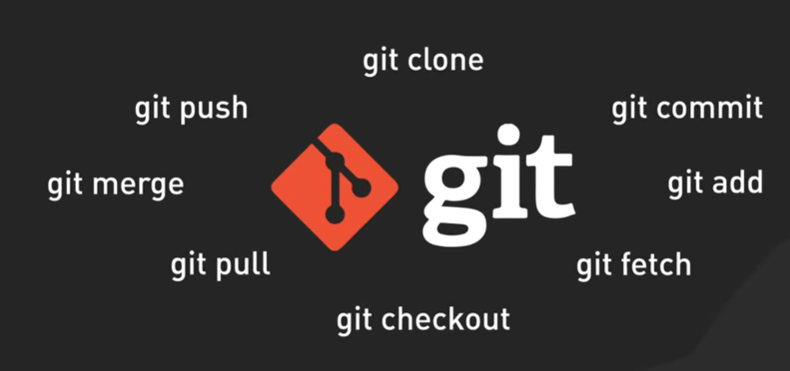
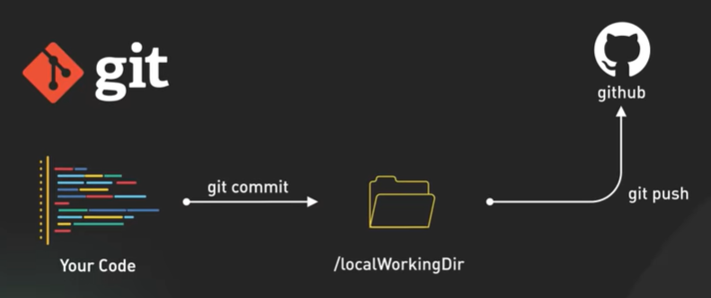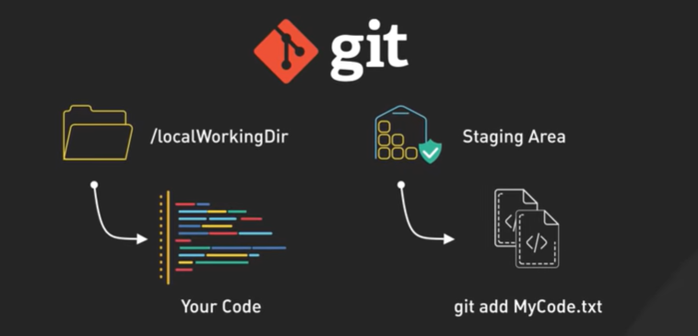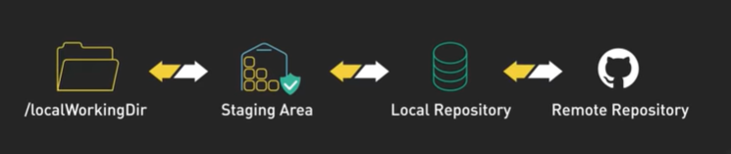
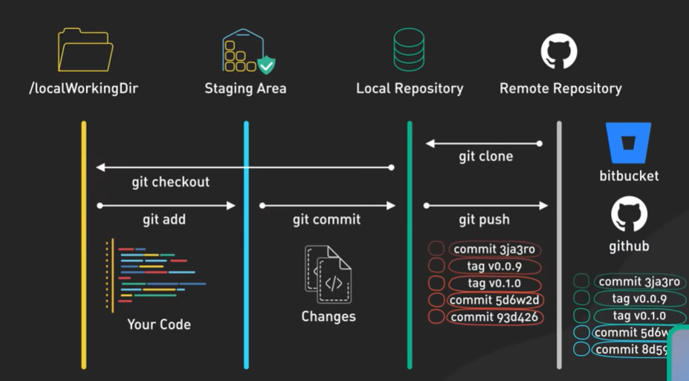
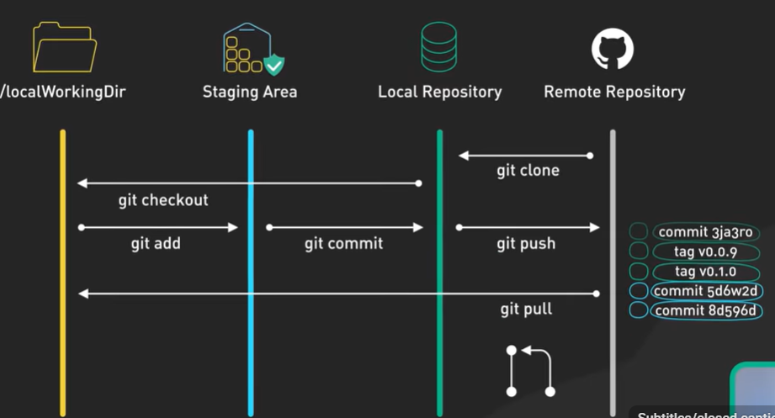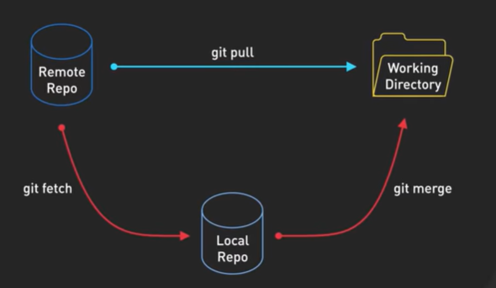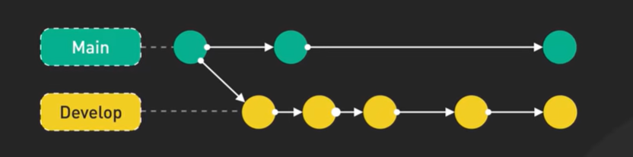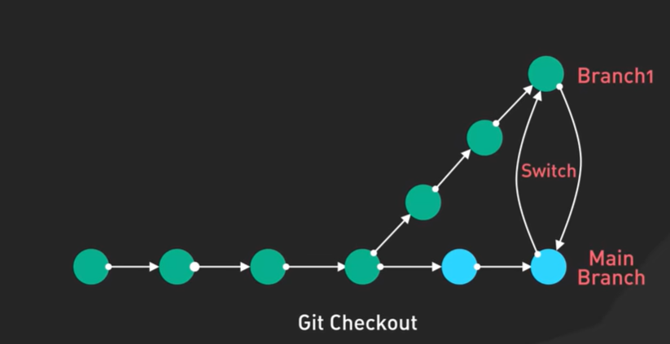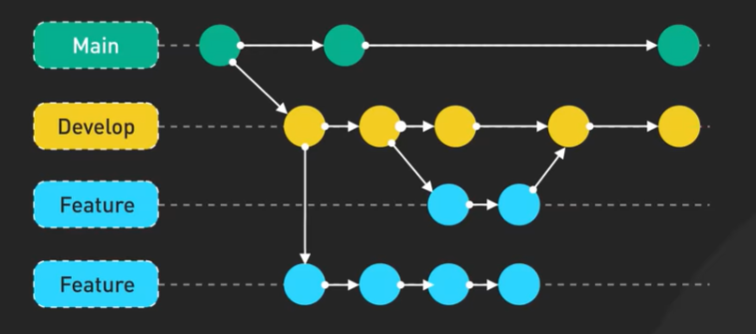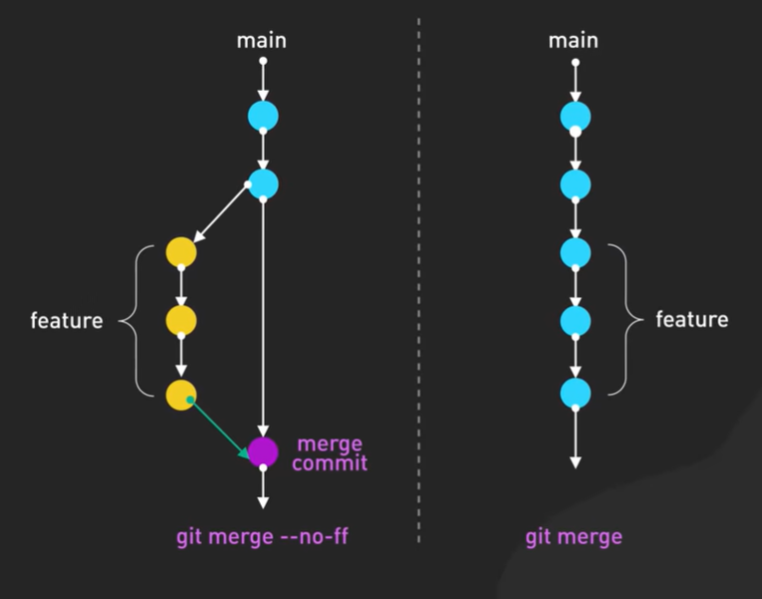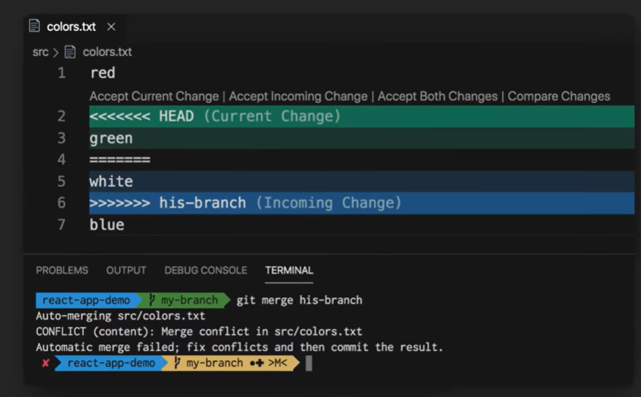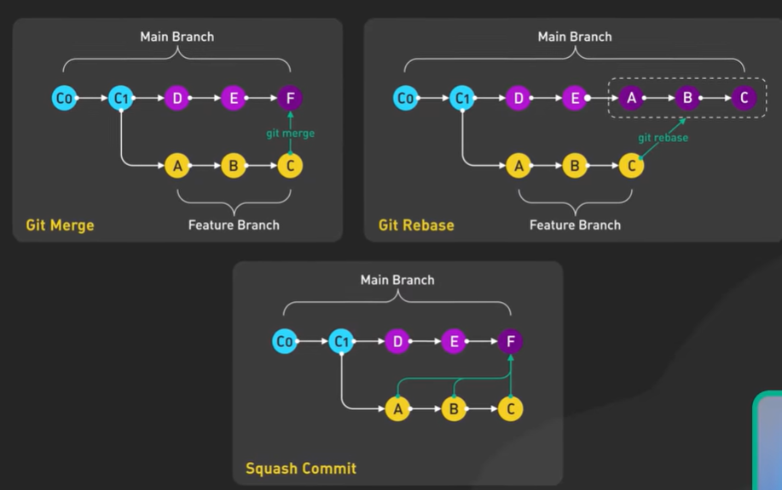

APT –
