Name: Jadhav Somnath Pandurang

Class: BCA – III Sem – V Roll No: 86

Subject – Java Programming

**LAB EXERCISE 1**

Ques**.** Java programs based on branching and looping statements.

Code:

import java.util.Scanner;

public class PrimeCheck {

public static void main(String[] args) {

System.out.println("Name : Somnath Pandurang Jadhav | Roll No : 86");

System.out.println("Class : BCA-III SEM-V | Subject : Java Programming");

Scanner sc = new Scanner(System.in);

System.out.print("Enter a number: ");

int num = sc.nextInt();

boolean isPrime = true;

if (num <= 1) {

isPrime = false;

} else {

for (int i = 2; i <= num / 2; i++) { // Looping

if (num % i == 0) { // Branching

isPrime = false;

break;

}

}

}

if (isPrime)

System.out.println(num + " is a Prime Number.");

else

System.out.println(num + " is not a Prime Number.");

}

}

Output:

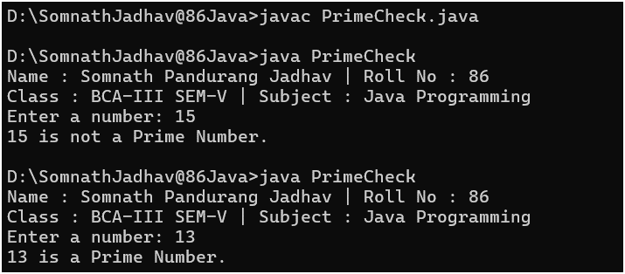

Name: Jadhav Somnath Pandurang

Class: BCA – III Sem – V Roll No: 86

Subject – Java Programming

**LAB EXERCISE 2**

Ques. Java programs based Type Casting

Code:

public class TypeCastingDemo {

public static void main(String[] args) {

System.out.println("Name : Somnath Pandurang Jadhav | Roll No : 86");

System.out.println("Class : BCA-III SEM-V | Subject : Java Programming");

System.out.println("\nImplicit Casting --");

int num = 50;

double d = num;

System.out.println("Original int value: " + num);

System.out.println("After casting to double: " + d);

System.out.println("\nExplicit Casting --");

double x = 99.75;

int y = (int) x;

System.out.println("Original double value: " + x);

System.out.println("After casting to int: " + y);

}

}

Output:

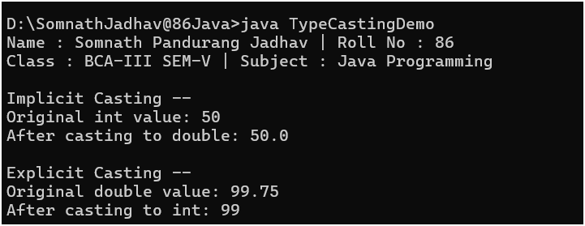

Name: Jadhav Somnath Pandurang

Class: BCA – III Sem – V Roll No: 86

Subject – Java Programming

**LAB EXERCISE 3**

Ques**.** Java programs based on command line arguments

Code:

public class OddEvenCLI {

public static void main(String[] args) {

System.out.println("Name : Somnath Pandurang Jadhav | Roll No : 86");

System.out.println("Class : BCA-III SEM-V | Subject : Java Programming");

for(int i = 0; i < args.length; i++) {

int num = Integer.parseInt(args[i]);

if(num % 2 == 0) {

System.out.println("\n" + num + " is Even");

} else {

System.out.println("\n" + num + " is Odd");

}

}

}

}

Output:

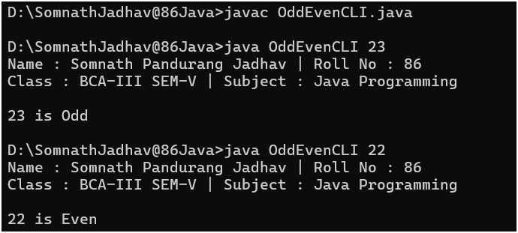

Name: Jadhav Somnath Pandurang

Class: BCA – III Sem – V Roll No: 86

Subject – Java Programming

**LAB EXERCISE 4**

Ques**.** Java programs based on constructors

Code:

class Student {

String name;

int age;

// Default Constructor

Student() {

name = "Somnath Jadhav";

age = 20;

System.out.println("Default Constructor Called");

}

// Parameterized Constructor

Student(String n, int a) {

name = n;

age = a;

System.out.println("Parameterized Constructor Called");

}

// Copy Constructor

Student(Student s) {

name = s.name;

age = s.age;

System.out.println("Copy Constructor Called");

}

void display() {

System.out.println("Name: " + name + ", Age: " + age);

}

}

public class ConstructorDemo {

public static void main(String[] args) {

System.out.println("Name : Somnath Pandurang Jadhav | Roll No : 86");

System.out.println("Class : BCA-III SEM-V | Subject : Java Programming \n");

// Default Constructor

Student s1 = new Student();

s1.display();

System.out.println();

// Parameterized Constructor

Student s2 = new Student("Rohit", 20);

s2.display();

System.out.println();

// Copy Constructor

Student s3 = new Student(s2);

s3.display();

}

}

Output:

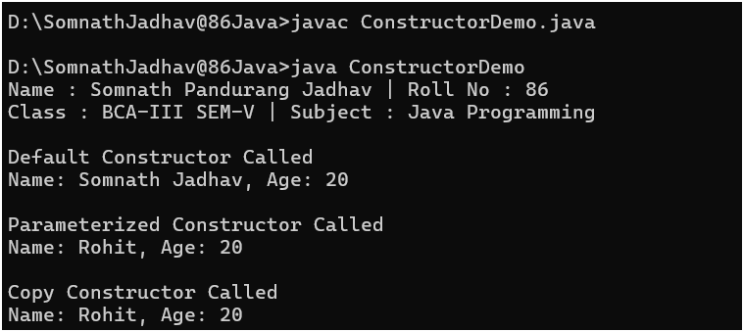

Name: Jadhav Somnath Pandurang

Class: BCA – III Sem – V Roll No: 86

Subject – Java Programming

**LAB EXERCISE 5**

Ques**.** Java programs based on inheritance

Code:

//Single & Multilevel Inheritance

class A {

void displayA() {

System.out.println("Class A called");

}

}

class B extends A {

void displayB() {

System.out.println("Class B called");

}

}

class C extends B {

void displayC() {

System.out.println("Class C called");

}

}

// Interfaces for Multiple Inheritance

interface X {

void displayX();

}

interface Y {

void displayY();

}

// Class implementing Multiple Inheritance

class D implements X, Y {

public void displayX() {

System.out.println("Class X called");

}

public void displayY() {

System.out.println("Class Y called");

}

}

// Hybrid Inheritance

class E extends A implements X {

public void displayX() {

System.out.println("Class X called");

}

}

public class AllInheritanceDemo {

public static void main(String[] args) {

System.out.println("Name : Somnath Pandurang Jadhav | Roll No : 86");

System.out.println("Class : BCA-III SEM-V | Subject : Java Programming");

System.out.println("\nSingle Inheritance-");

B objB = new B();

objB.displayB();

System.out.println("\nMultilevel Inheritance-");

C objC = new C();

objC.displayA();

objC.displayB();

objC.displayC();

System.out.println("\nHierarchical Inheritance-");

B hB = new B();

C hC = new C();

hB.displayB();

hC.displayC();

System.out.println("\nMultiple Inheritance (Interfaces) -");

D objD = new D();

objD.displayX();

objD.displayY();

System.out.println("\nHybrid Inheritance-");

E objE = new E();

objE.displayA();

objE.displayX();

}

}

Output:

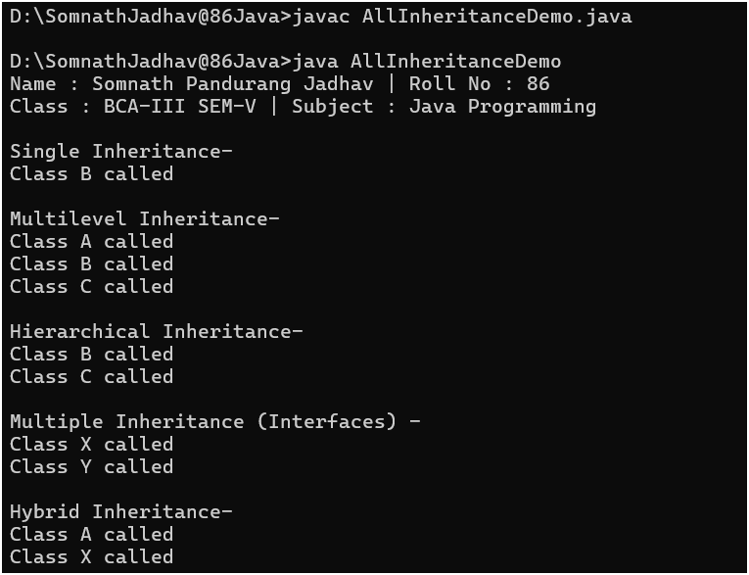

Name: Jadhav Somnath Pandurang

Class: BCA – III Sem – V Roll No: 86

Subject – Java Programming

**LAB EXERCISE 6**

Ques**.** Java programs based on method overloading

Code:

class Calculator {

int add(int a, int b) {return a + b;}

int add(int a, int b, int c) {return a + b + c;}

double add(double a, double b) {return a + b;}

}

public class MethodOverloadingDemo {

public static void main(String[] args) {

System.out.println("Name : Somnath Pandurang Jadhav | Roll No : 86");

System.out.println("Class : BCA-III SEM-V | Subject : Java Programming");

Calculator calc = new Calculator();

System.out.println("Add two integers: " + calc.add(10, 20));

System.out.println("Add three integers: " + calc.add(5, 10, 15));

System.out.println("Add two doubles: " + calc.add(2.5, 3.5));

}

}

Output:

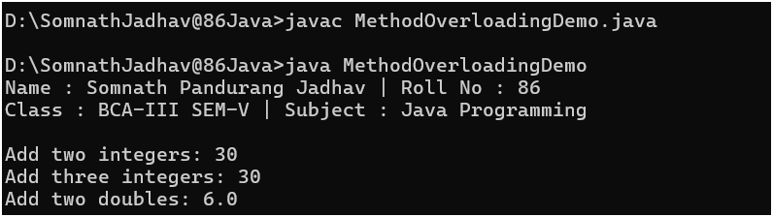

Name: Jadhav Somnath Pandurang

Class: BCA – III Sem – V Roll No: 86

Subject – Java Programming

**LAB EXERCISE 7**

Ques**.** Java programs based on method overriding

Code:

class Animal {

void sound() {System.out.println("Animal makes a sound");}

}

class Dog extends Animal {

// Overriding method

void sound() {System.out.println("Dog barks");}

}

class Cat extends Animal {

// Overriding method

void sound() {System.out.println("Cat meows");}

}

public class MethodOverridingDemo {

public static void main(String[] args) {

System.out.println("Name : Somnath Pandurang Jadhav | Roll No : 86");

System.out.println("Class : BCA-III SEM-V | Subject : Java Programming");

Animal a1 = new Animal();

Animal a2 = new Dog();

Animal a3 = new Cat();

a1.sound();

a2.sound();

a3.sound();

}

}

Output:

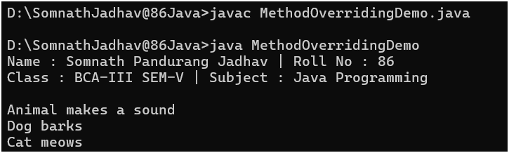

Name: Jadhav Somnath Pandurang

Class: BCA – III Sem – V Roll No: 86

Subject – Java Programming

**LAB EXERCISE 8**

Ques**.** Java programs based on interfaces

Code:

// Simple Interface

interface A {void displayA();}

// Multiple Interface

interface X {void displayX();}

interface Y {void displayY();}

class B implements A {

public void displayA() {

System.out.println("Class B implementing A");

}

}

class C implements X, Y {

public void displayX() {

System.out.println("Class C implementing X");

}

public void displayY() {

System.out.println("Class C implementing Y");

}

}

public class InterfaceDemo {

public static void main(String[] args) {

System.out.println("Name : Somnath Pandurang Jadhav | Roll No : 86");

System.out.println("Class : BCA-III SEM-V | Subject : Java Programming\n");

System.out.println("Simple Interface-");

B objB = new B();

objB.displayA();

System.out.println("\nMultiple Interface-");

C objC = new C();

objC.displayX();

objC.displayY();

}

}

Output:

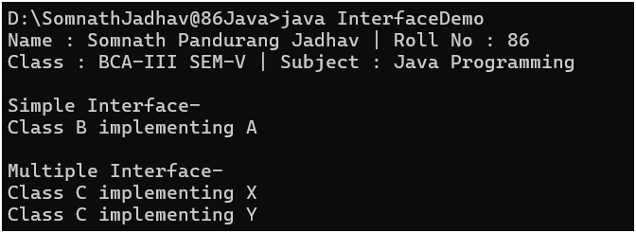

Name: Jadhav Somnath Pandurang

Class: BCA – III Sem – V Roll No: 86

Subject – Java Programming

**LAB EXERCISE 9**

Ques**.** Java programs based on packages

Code:

Welcome.java –

package cimdr;

public class Welcome {

public void sayHello() {

System.out.println("Welcome to CIMDR");

}

}

UseCIMDR.java -

import cimdr.Welcome;

public class UseCIMDR {

public static void main(String[] args) {

System.out.println("Name : Somnath Pandurang Jadhav | Roll No : 86");

System.out.println("Class : BCA-III SEM-V | Subject : Java Programming\n");

Welcome obj = new Welcome();

obj.sayHello();

}

}

Output:

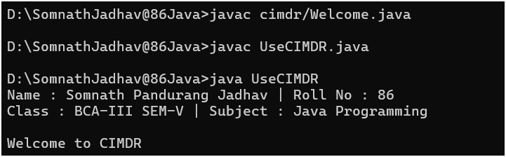

Name: Jadhav Somnath Pandurang

Class: BCA – III Sem – V Roll No: 86

Subject – Java Programming

**LAB EXERCISE 10**

Ques. Java programs based on multithreading

Code:

public class TSleep extends Thread {

public static void main(String argv[]) {

TSleep t = new TSleep();

t.start();

}

public void run() {

try {

int count = 0;

while (!stopRequested && count < 5) {

Thread.sleep(1000);

System.out.println("looping while: " + (count + 1));

count++;

}

} catch (InterruptedException ie) {

System.out.println("Thread interrupted!");

}

}

private volatile boolean stopRequested = false;

public void runStopExample() {

while (!stopRequested) {

// ...

}

}

public void requestStop() {

stopRequested = true;

}

}

Output:

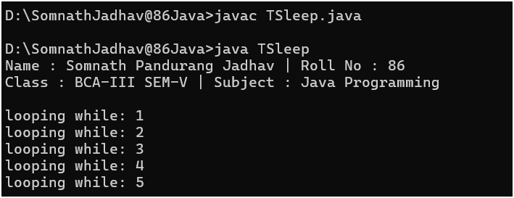

Name: Jadhav Somnath Pandurang

Class: BCA – III Sem – V Roll No: 86

Subject – Java Programming

**LAB EXERCISE 11**

Ques**.** Java programs based on exception handling

Code:

public class ExceptionDemo1 {

public static void main(String[] args) {

try {

int a = 10 / 0;

} catch (ArithmeticException e) {

System.out.println("Name : Somnath Pandurang Jadhav | Roll No : 86 ");

System.out.println("Class : BCA-III SEM-V | Subject : Java Programming\n");

System.out.println("Cannot divide by zero");

}

}

}

Output:

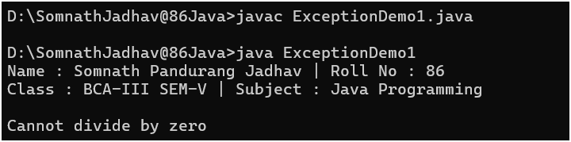

Name: Jadhav Somnath Pandurang

Class: BCA – III Sem – V Roll No: 86

Subject – Java Programming

**LAB EXERCISE 12**

Ques**.** Demonstrate AWT

Code:

import java.awt.*;

public class AwtApp extends Frame {

AwtApp() {

Label firstName = new Label("First Name");

firstName.setBounds(20, 50, 80, 20);

Label lastName = new Label("Last Name");

lastName.setBounds(20, 80, 80, 20);

Label dob = new Label("Date of Birth");

dob.setBounds(20, 110, 80, 20);

TextField firstNameTF = new TextField();

firstNameTF.setBounds(120, 50, 100, 20);

TextField lastNameTF = new TextField();

lastNameTF.setBounds(120, 80, 100, 20);

TextField dobTF = new TextField();

dobTF.setBounds(120, 110, 100, 20);

Button sbmt = new Button("Submit");

sbmt.setBounds(20, 160, 100, 30);

Button reset = new Button("Reset");

reset.setBounds(120, 160, 100, 30);

add(firstName);

add(lastName);

add(dob);

add(firstNameTF);

add(lastNameTF);

add(dobTF);

add(sbmt);

add(reset);

setSize(300, 300);

setLayout(null);

setVisible(true);

}

public static void main(String[] args) {

System.out.println("Name : Somnath Pandurang Jadhav | Roll No : 86");

System.out.println("Class : BCA-III SEM-V | Subject : Java Programming\n");

new AwtApp();

}

}

Output:

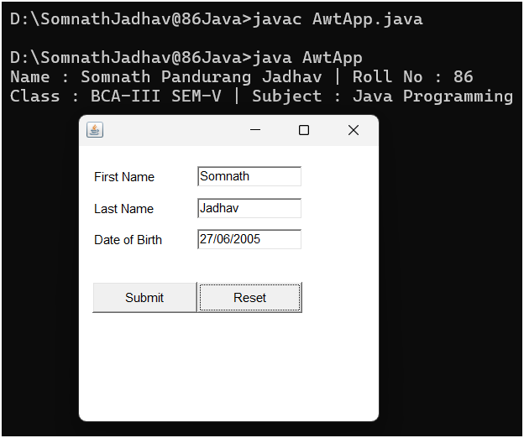

Name: Jadhav Somnath Pandurang

Class: BCA – III Sem – V Roll No: 86

Subject – Java Programming

**LAB EXERCISE 13**

Ques**.** Demonstrate Swing

Code:

import javax.swing.*;

public class SwingApp {

SwingApp() {

JFrame f = new JFrame();

JLabel firstName = new JLabel("First Name");

firstName.setBounds(20, 50, 80, 20);

JLabel lastName = new JLabel("Last Name");

lastName.setBounds(20, 80, 80, 20);

JLabel dob = new JLabel("Date of Birth");

dob.setBounds(20, 110, 100, 20);

JTextField firstNameTF = new JTextField();

firstNameTF.setBounds(120, 50, 100, 20);

JTextField lastNameTF = new JTextField();

lastNameTF.setBounds(120, 80, 100, 20);

JTextField dobTF = new JTextField();

dobTF.setBounds(120, 110, 100, 20);

JButton sbmt = new JButton("Submit");

sbmt.setBounds(20, 160, 100, 30);

JButton reset = new JButton("Reset");

reset.setBounds(120, 160, 100, 30);

f.add(firstName);

f.add(lastName);

f.add(dob);

f.add(firstNameTF);

f.add(lastNameTF);

f.add(dobTF);

f.add(sbmt);

f.add(reset);

f.setSize(300, 300);

f.setLayout(null);

f.setVisible(true);

f.setDefaultCloseOperation(JFrame.EXIT_ON_CLOSE);

}

public static void main(String[] args) {

System.out.println("Name : Somnath Pandurang Jadhav | Roll No : 86");

System.out.println("Class : BCA-III SEM-V | Subject : Java Programming\n");

new SwingApp();

}

}

Output:

