  - Introduction to Project Theme:
The project Aabha Dental Clinic – Appointment & Reminder System is a web-based application created to make the daily work of a dental clinic easier and more organized. The main purpose of this system is to help patients book appointments online and to help the clinic manage appointments and patient information digitally.
In many clinics, appointments are still handled using phone calls or notebooks. This method is time-consuming and can cause problems like lost records, missed appointments, and no proper reminders for patients. This project solves these problems by providing an online system where patients can book appointments easily and receive automatic email reminders.
The system is designed to:
- Save time by reducing manual work.
- Improve patient experience with online appointment booking.
- Help the clinic manage data in a simple and organized way.
This project uses modern web technologies to build a simple and useful system that improves communication between patients and the clinic while making clinic operations more efficient.

  - Working of System:
The Dental Clinic Management System is designed to simplify the process of managing appointments, patient records, and automated reminders. The system works through different modules that interact with each other to ensure smooth clinic operations.

1.2.1 Patient Side Working
- The patient visits the website.
- The patient can:
  - View available dental services.
  - Book an appointment by filling in personal details, preferred date, and time.
  - Submit contact or inquiry forms.
- After submitting the appointment form:
  - The system stores the details in the database.
  - A confirmation message is shown to the patient.
- Before the appointment:
  - The system automatically sends reminder emails (24 hours and 4 hours before the appointment).

1.2.2 Admin Side Working
- The admin logs into the admin panel using secure credentials.
- After login, the admin can:
  - View all appointments.
  - Filter appointments by date or status.
  - Update appointment status (Pending, Confirmed, Completed, Cancelled).
  - Manage services offered by the clinic.
  - View contact messages and patient inquiries.
- All updates made by the admin are stored in the database instantly.

  - Need & Scope of Proposed System:

Need of the Proposed System –

The need for the proposed system arises from the increasing demand for digital solutions in healthcare services. Managing a dental clinic using manual methods is time-consuming, inefficient, and prone to errors. Therefore, there is a strong need for a system that can automate appointment booking, improve patient communication, and manage clinic data in a structured and reliable manner.
The proposed system provides an online platform that allows patients to book appointments easily without visiting the clinic or making phone calls. This saves time for both patients and clinic staff. The system also generates a unique appointment ID for every booking, which helps patients track their appointment status and access reports.
One of the major needs of this system is to introduce automation in daily clinic operations. By using automated email reminders, the system ensures that patients are informed about their appointments in advance. This reduces missed appointments and improves overall clinic efficiency.
The proposed system is designed to fulfil the following needs:
- Reduce manual work for clinic staff
- Provide easy online appointment booking
- Improve communication with patients
- Maintain digital and secure patient records
- Send automatic appointment reminders
- Improve time management and service quality

Scope of the Proposed System -
The scope of the proposed system defines what the system can do and what features are included in the project. This system focuses on the core functionalities required for a dental clinic.

The scope includes:
- Online appointment booking system
- Service selection by patients
- Unique appointment ID generation
- Admin panel for clinic staff
- Email-based reminder system
- Contact and feedback management
- Uploading and viewing patient reports
- Basic clinic settings management
The proposed system is mainly designed for small and medium dental clinics. It is scalable and can be extended in the future by adding features such as SMS reminders, online payments, and patient login system.
Overall, the proposed system aims to improve efficiency, accuracy, and patient satisfaction by providing a modern digital solution for dental clinic management.

  - Organization Profile:
The Aabha Dental Clinic is a healthcare organization that provides professional dental care services to patients. The clinic is committed to delivering high-quality treatment, maintaining hygiene standards, and ensuring patient comfort and satisfaction.
The clinic offers various dental services such as general check-ups, teeth cleaning, cavity treatment, root canal treatment, tooth extraction, cosmetic dentistry, and other specialized dental procedures. The clinic is managed by qualified dental professionals and supported by trained staff to ensure smooth operations.
The main objective of the clinic is to provide safe, affordable, and reliable dental care while maintaining proper patient records and appointment scheduling. The clinic focuses on improving patient experience through timely service and clear communication.
With the increasing number of patients and appointments, the clinic requires a digital system to manage appointments, patient information, and reminders efficiently. The Dental Clinic Management System helps the organization reduce manual work, improve accuracy, and enhance overall productivity.
The organization believes in adopting modern technology to streamline operations and provide better healthcare services to patients.

  - Objectives of the System
The main objectives of the Dental Clinic Management System are:
- To automate appointment booking and reduce manual paperwork.
- To manage patient records efficiently in a secure digital database.
- To provide an easy interface for admin to view, update, and manage appointments.
- To send automatic reminders (24 hours and 4 hours before appointment) to reduce missed appointments.
- To improve communication between patients and the clinic through email notifications.
- To allow filtering and reporting of appointments based on date and status.
- To ensure data accuracy and security using proper authentication and database management.
- To reduce time consumption and human errors in scheduling and record maintenance.
- To enhance overall clinic efficiency and patient satisfaction.

  - Software Requirement Specification:

2.2.1 Patient Module
- The system shall allow patients to view available dental services.
- The system shall allow patients to book an appointment.
- The system shall store patient details such as name, contact number, email, date, and time.
- The system shall display confirmation after booking.

2.2.2 Admin Module
- The system shall allow admin login using secure authentication.
- The system shall allow admin to view all appointments.
- The system shall allow filtering appointments by date and status.
- The system shall allow admin to update appointment status (Pending, Confirmed, Completed, Cancelled).
- The system shall allow admin to manage services (Add, Edit, Delete).

2.2.3 Reminder System
- The system shall automatically send reminder emails 24 hours before the appointment.
- The system shall automatically send reminder emails 4 hours before the appointment.
- The system shall prevent duplicate reminders.

2.2.4 Contact Module
- The system shall allow patients to send messages or inquiries.
- The system shall store contact messages in the database.
- The admin shall be able to view submitted messages.

  - Context Level diagram:

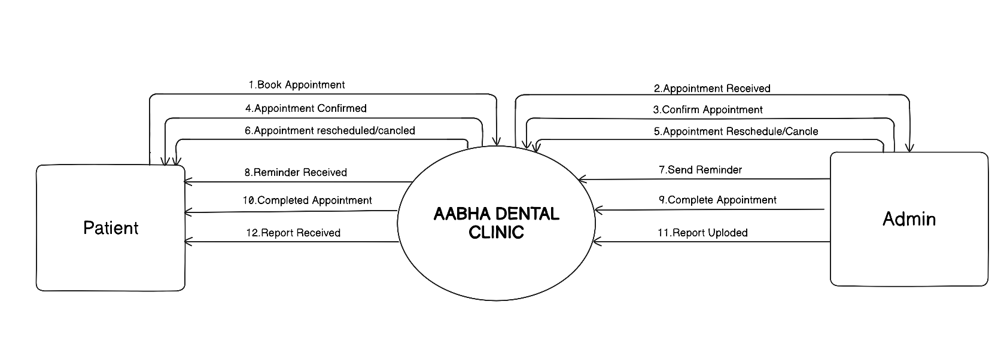

  - DFD
Patient:
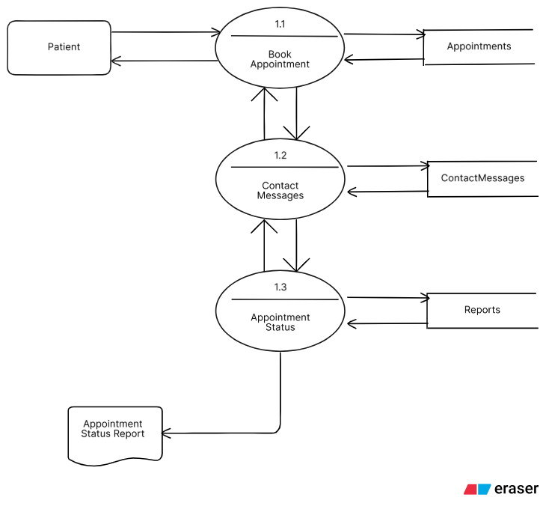

Admin:
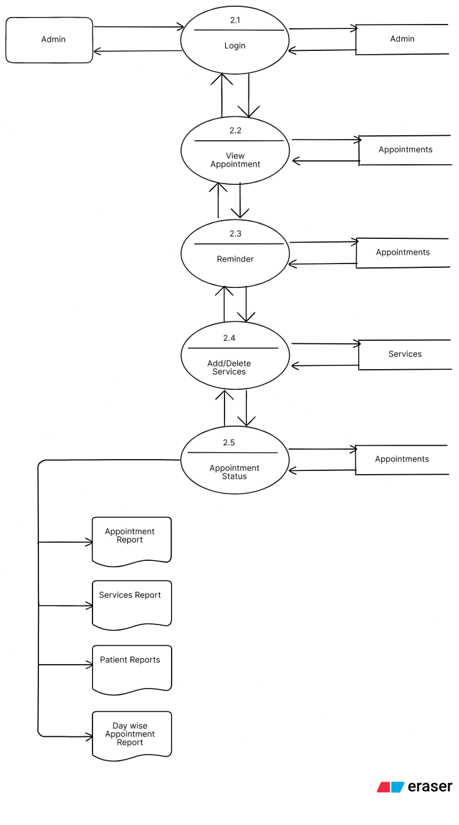

  - ERD:

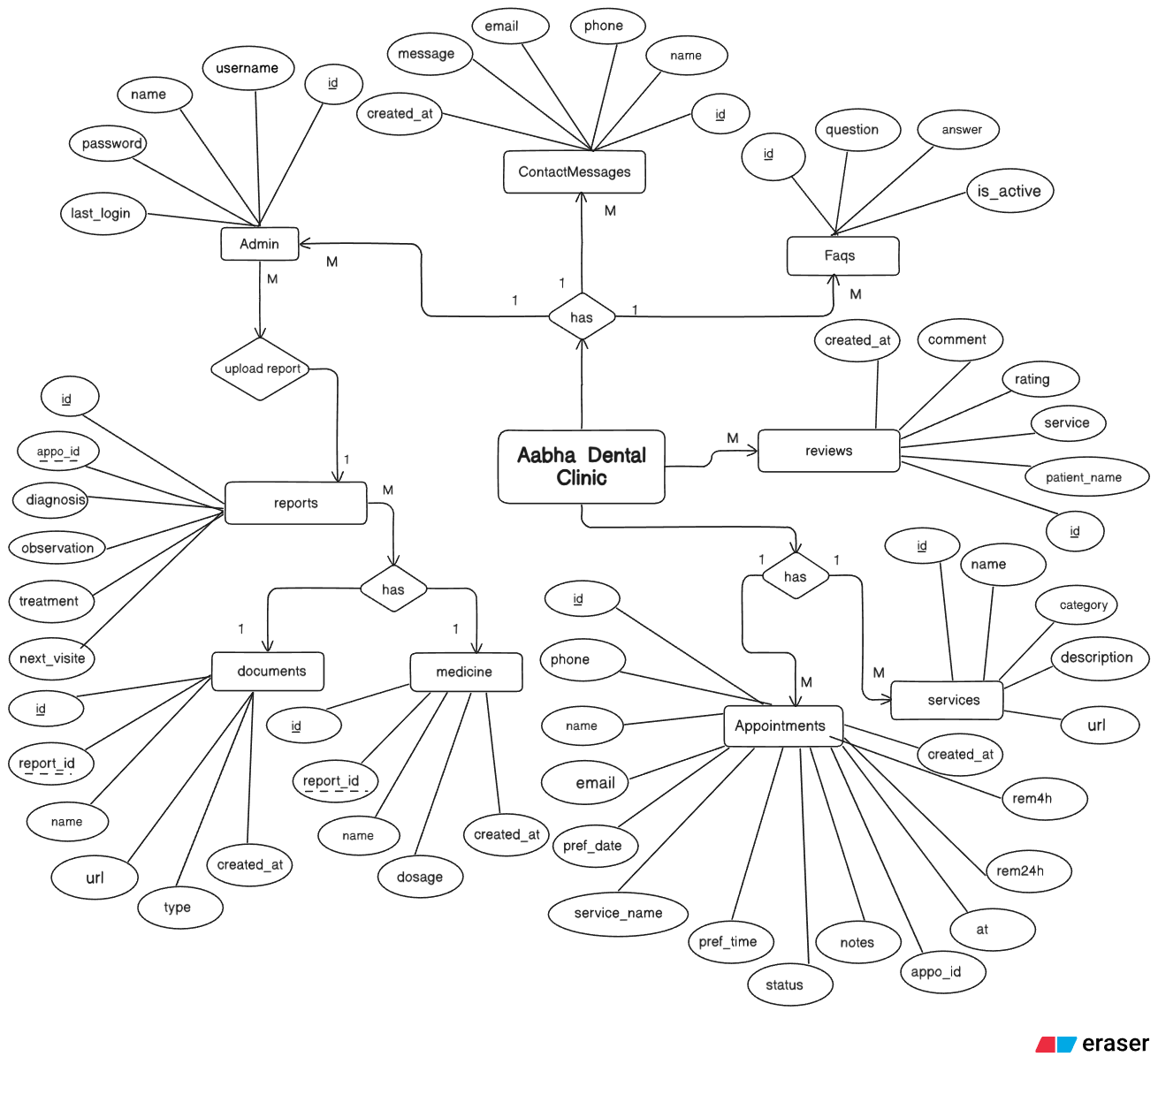

  - System Requirements:
    - Hardware Requirement:
Component | Minimum Requirement
Processor | Intel Core i3 or above
RAM | 4 GB or more
Hard Disk | 128 GB free space
Monitor | 1024x768 resolution minimum
Network | Internet connection for online access(must)

    - Software Requirements:

Component | Requirement
Operating System | Windows/Linux/MacOS
Front-End Technologies | React.js, Next.js
Back-End Language | Node.js (Next.js API Routes)
Web Server | Vercel (Cloud hosting) / Localhost
Database | PostgreSQL
Browser | Chrome, Firefox
Email Service | Nodemailer (Gmail SMTP)
Development Tools | VS Code, Git, GitHub

jaksdd
  - Database Design (Data Dictionary):

- Table Name: Admin

Sr_No | Field Name | Data Type | Description
1 | Id(PK) | serial | Store admin id
2 | Username | varchar(25) | Store username
3 | Password_hash | varchar(255) | Store password
4 | Last_login | timestamp | Store last login time

- Table Name: Appointments

Sr_No | Field Name | Data Type | Description
1 | id(PK) | serial | Store record id
2 | name | varchar(255) | Store patient name
3 | phone | varchar(11) | Store patient phone no
4 | email | varchar(255) | Store patient email
5 | service_name | varchar(255) | Store service name
6 | preferred_date | varchar(255) | Store Appointment date
7 | preferred_time | varchar(255) | Store Appointment time
8 | status | varchar(50) | Store appointment status
9 | notes | varchar(255) | Store extra notes
10 | created_at | timestamp | Store creation date
11 | appointment_id | varchar(255) | Store appointment id
12 | at | varchar(255) | Store clinic location
13 | reminder24h | Boolean | Store reminder sent or not
14 | reminder4h | Boolean | Store reminder sent or not

- Table Name: contactmessages

Sr_No | Field Name | Data Type | Description
1 | id(PK) | Int(series) | Store contact id
2 | name | varchar(255) | Store name
3 | phone | varchar(20) | Store phone
4 | email | varchar(255) | Store email
5 | status | varchar(50) | Store contact status
6 | created_at | timestamp | Store creation time

- Table Name: Documents

Sr_No | Field Name | Data Type | Description
1 | id(PK) | Int(serial) | Store document id
2 | report_id(FK) | varchar(255) | Store report id
3 | name | varchar(255) | Store document name
5 | url | text | Store document url
6 | type | varchar(50) | Store document type
7 | created_at | timestamp | Store creation time

- Table Name: Faq

Sr_No | Field Name | Data Type | Description
1 | id(PK) | int(serial) | Store faq id
2 | question | text | Store faq question
3 | answer | text | Store faq answer
4 | display order | integer | Store faq display id

- Table Name: Medicines

Sr_No | Field Name | Data Type | Description
1 | id(PK) | Int(serial) | Store medicine id
2 | report_id | integer | Store report id
3 | name | varchar(255) | Store medicine name
4 | dosage | varchar(255) | Store medicine dosage
5 | created_at | timestamp | Store creation time

- Table Name: Reports

Sr_No | Field Name | Data Type | Description
1 | id(PK) | series | Store report id
2 | appointment_id(FK) | varchar(255) | Store appointment id
3 | diagnosis | text | Store diagnosis
4 | observations | text | Store observations
5 | treatment | text | Store treatment
6 | next_visit | date | Store next visit date
7 | created_at | timestamp | Store creation time

- Table Name: Reviews

Sr_No | Field Name | Data Type | Description
1 | id(PK) | serial | Store review id
2 | Patient_name | varchar (100) | Store patient name
3 | Service | varchar (100) | Store service name
4 | rating | integer | Store rating
5 | comment | text | Store comments

- Table Name: Services
Sr_No | Field Name | Data Type | Description
1 | id(PK) | serial | Store service id
2 | name | Varchar(255) | Store service name
3 | category | Varchar(255) | Store service category
4 | description | text | Store service description
5 | Image_url | text | Store service url
6 | Is_active | boolean | Store service is active or not

  - Input Design:
- Patient:
  - Appointment Booking Page(without input data):
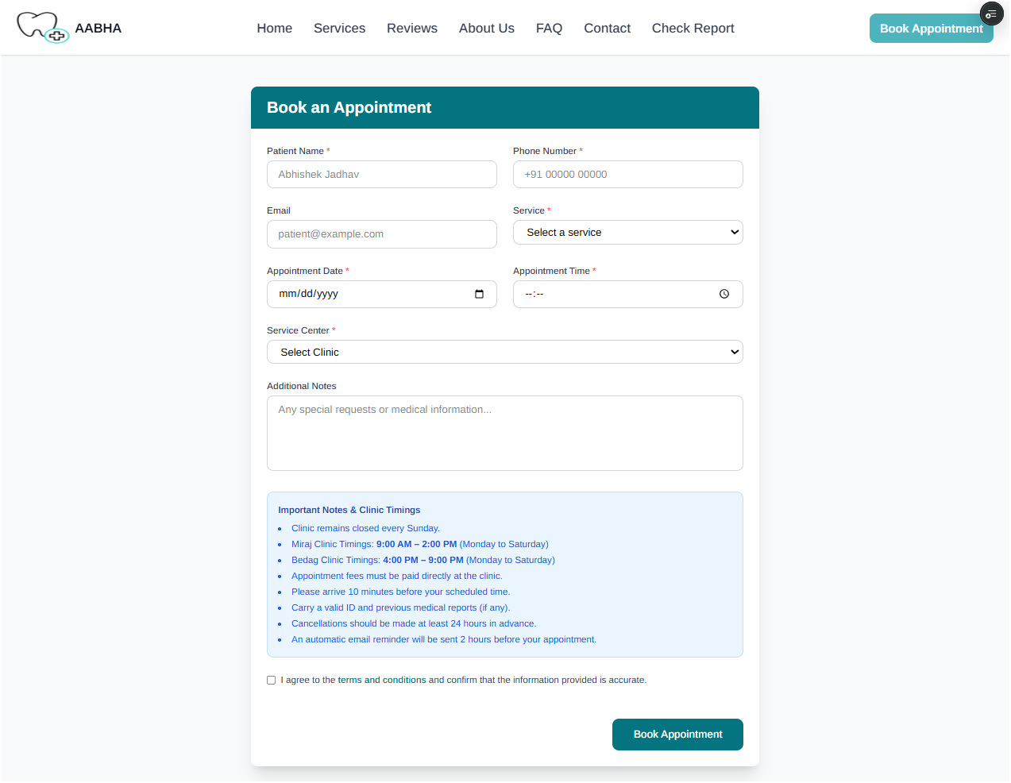

With Input Data –
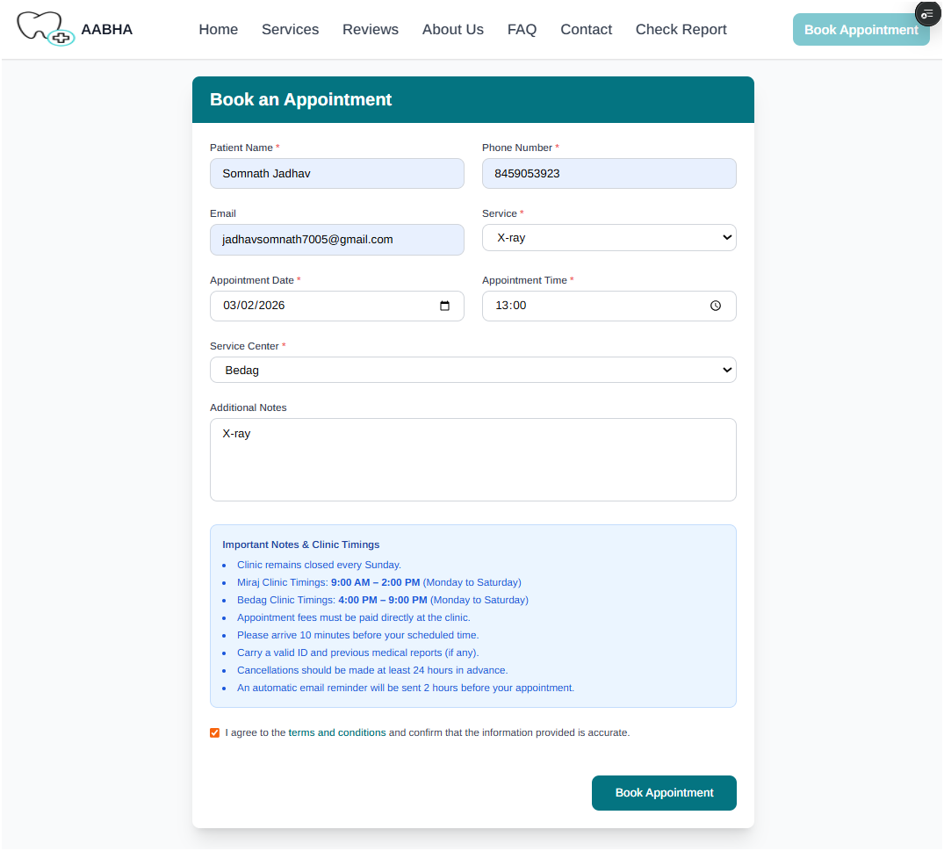

  - Appointment Status/report Checking(without data) –
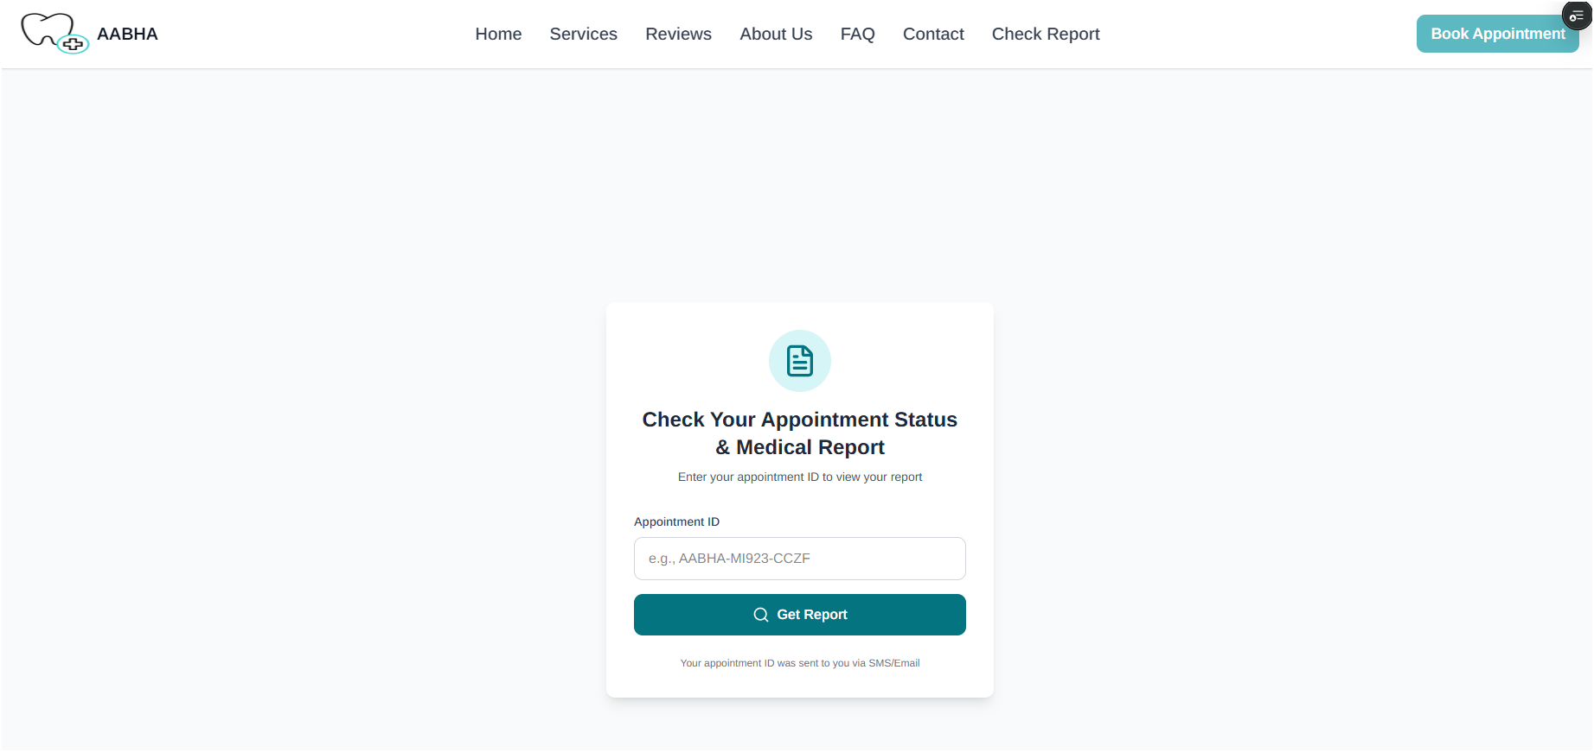
With Data:
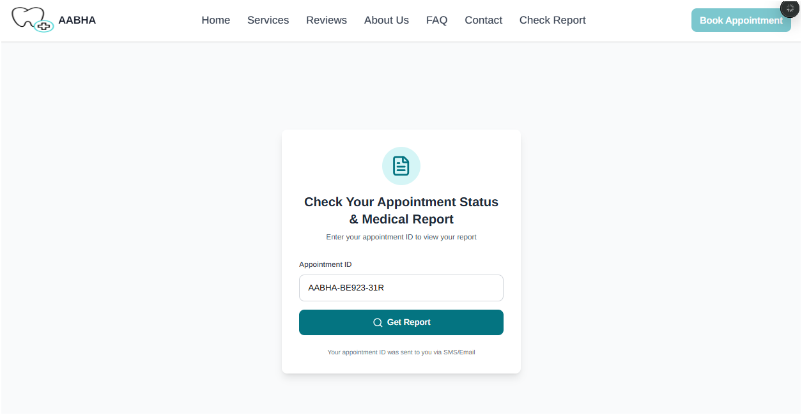

  - Services Section:
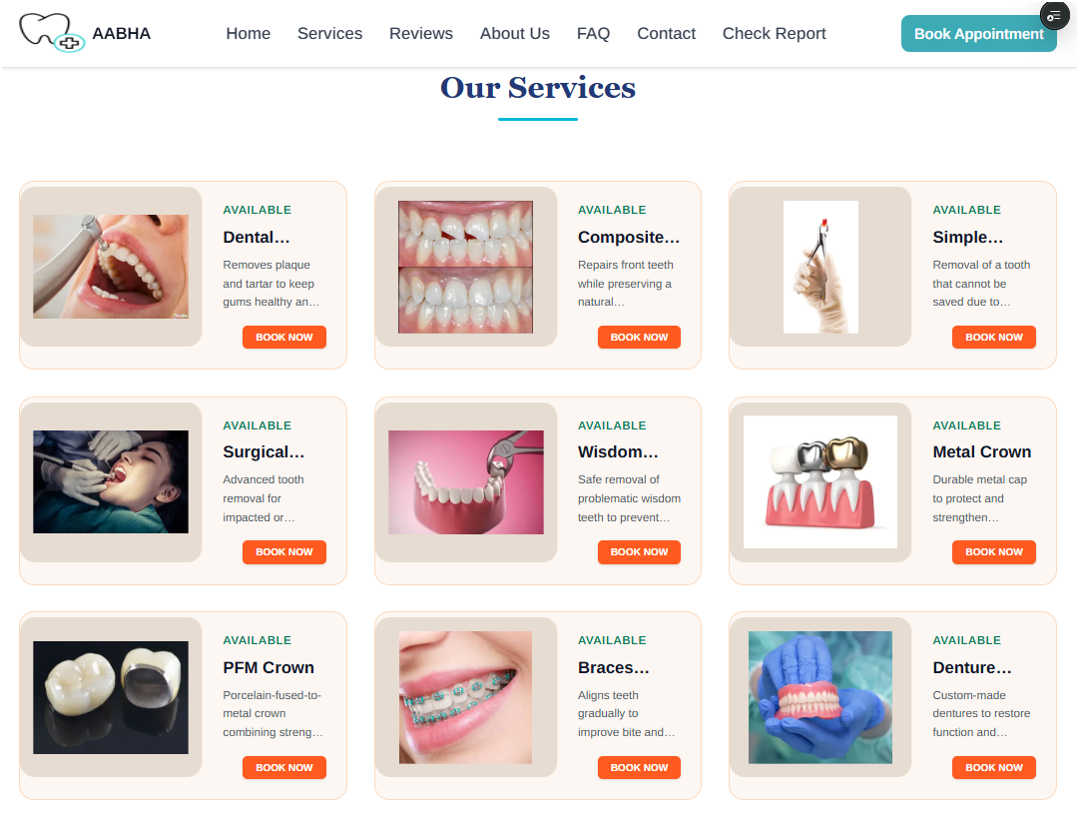
  - Reviews Section:
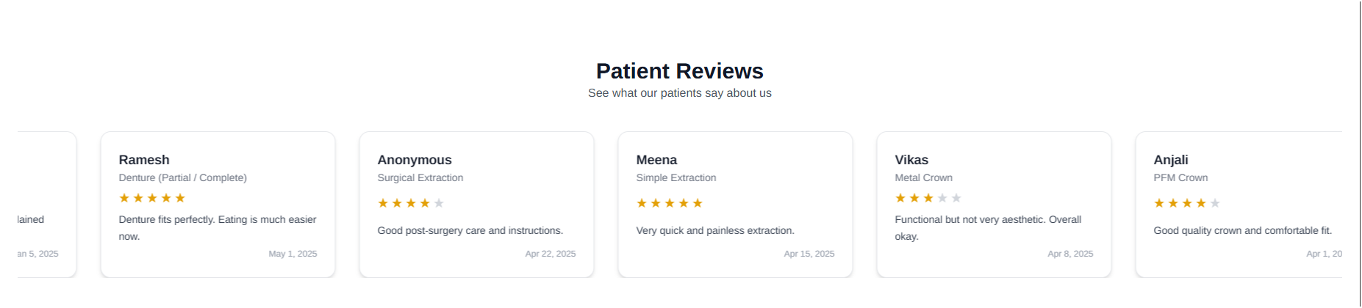
  - About Us Section:
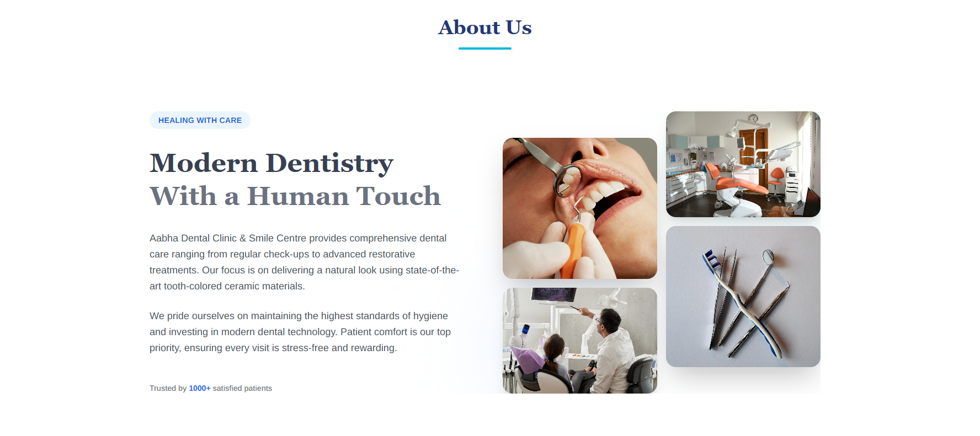
  - Contact Us(without Data):
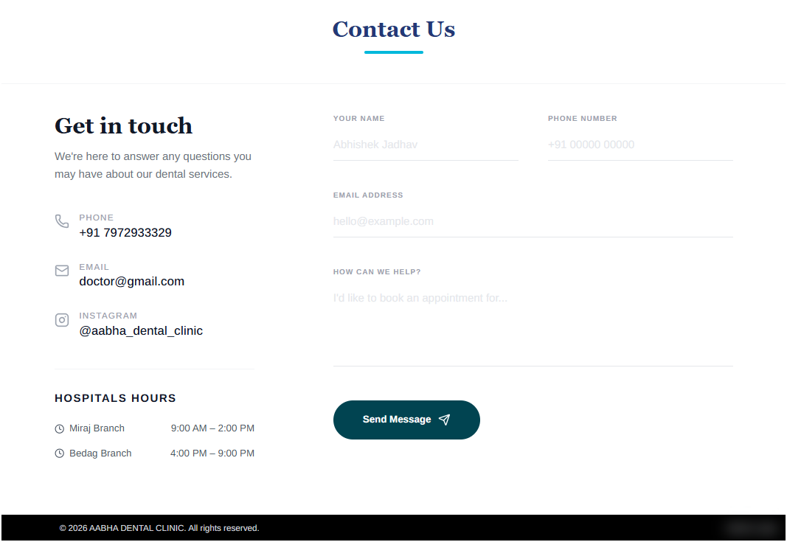
With data:
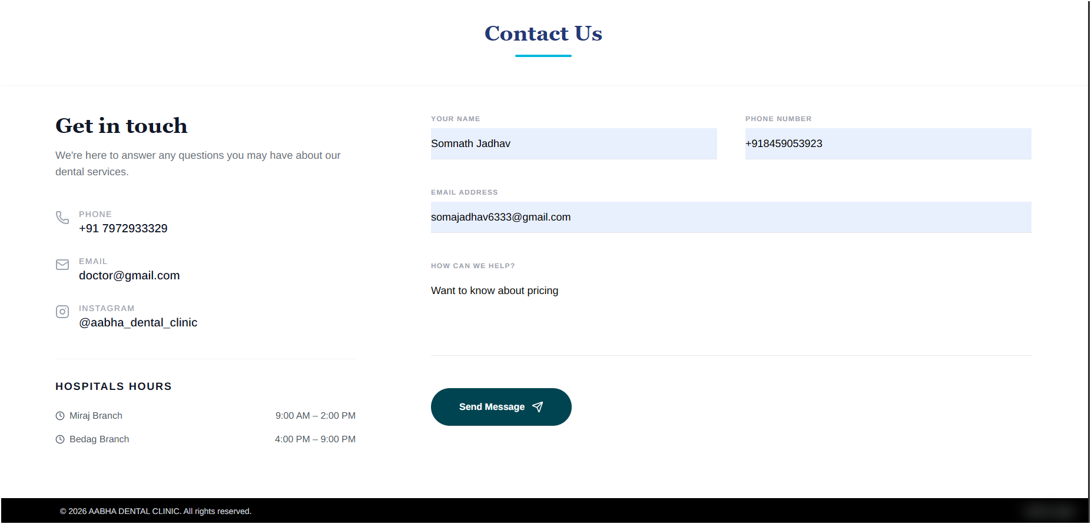

- Admin –
Admin Login Page(without Data)
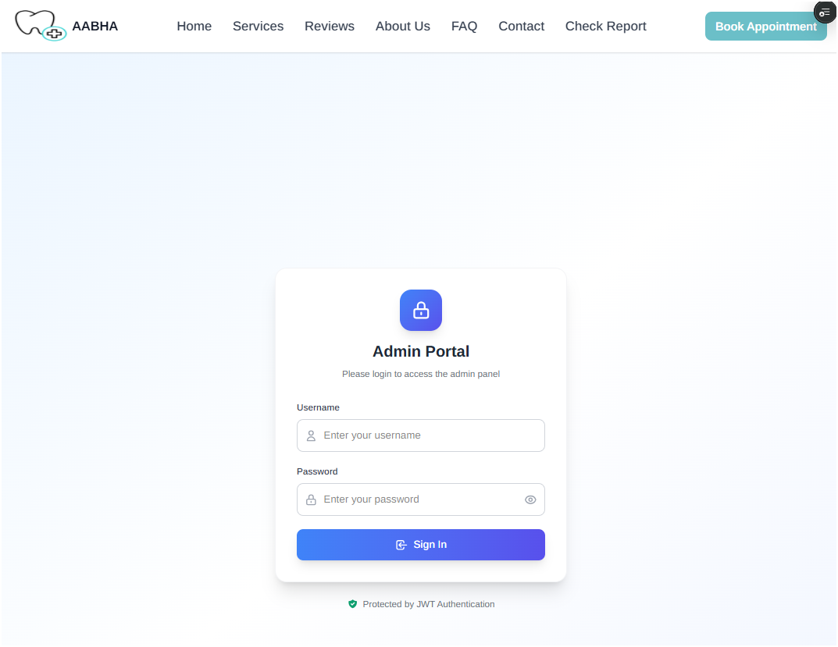
With data -
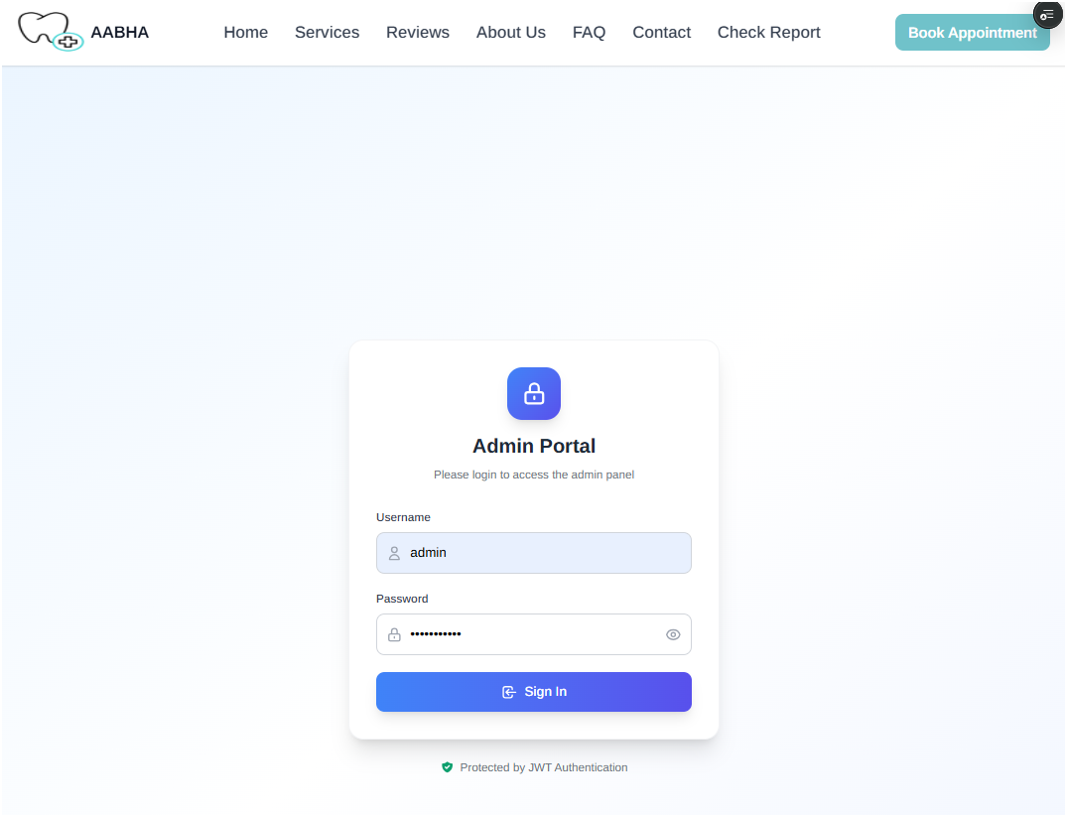

Appointments View: 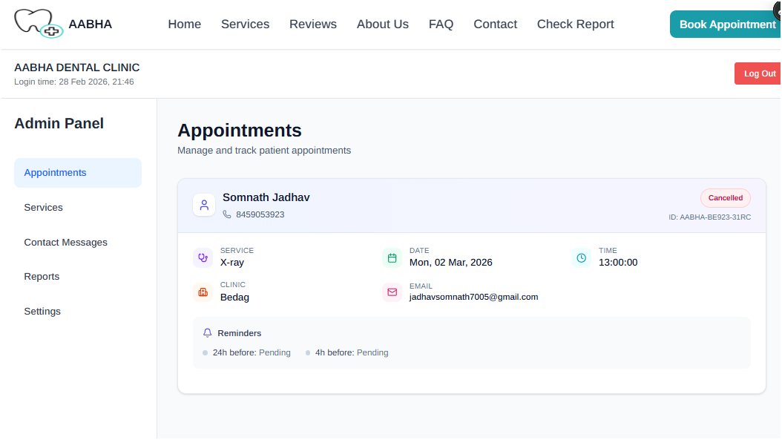
Add/Delete Services (without data) –
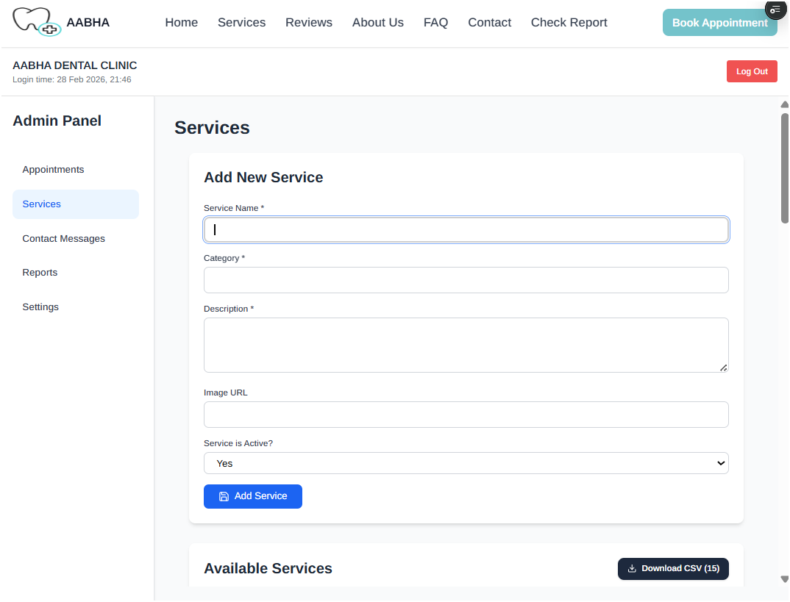

Add/Delete Services (with data) –
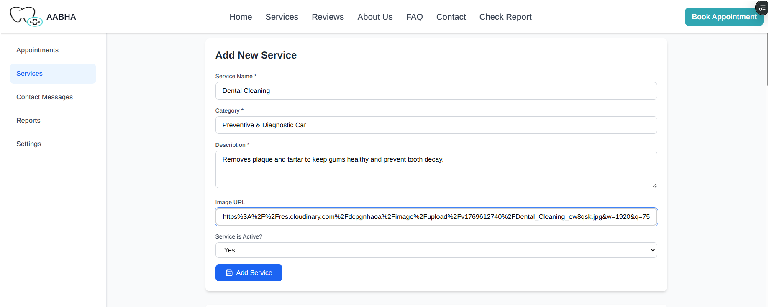

Contact Messages: 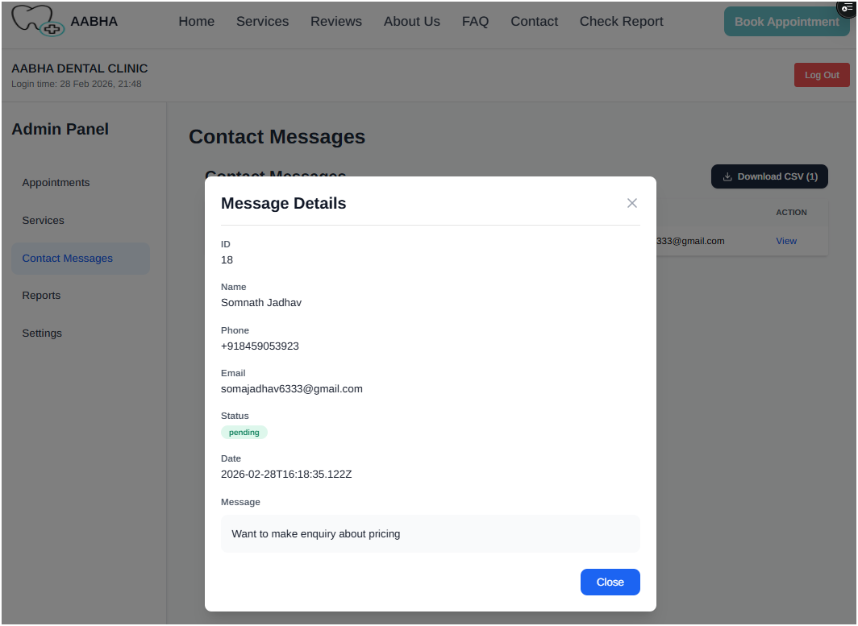

Reports view:
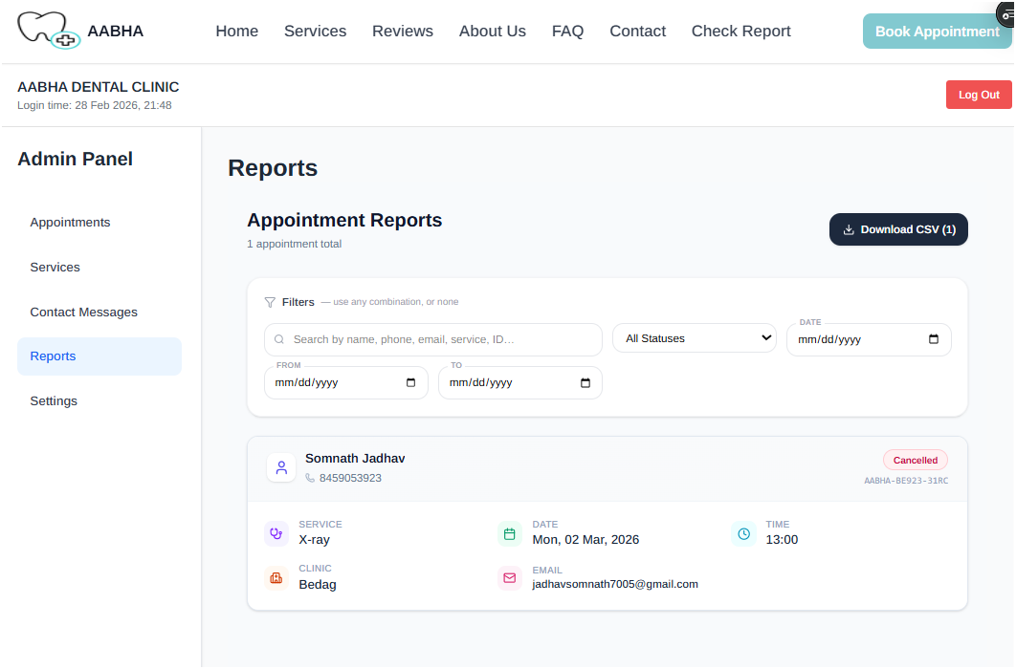

Settings Page (without Data):
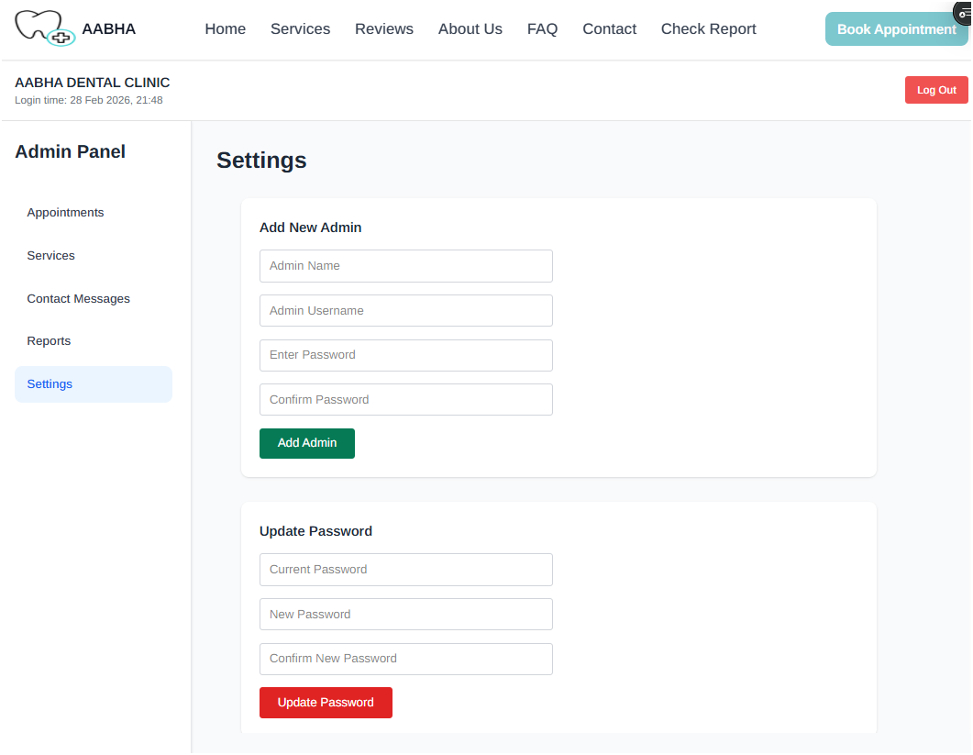

With data:

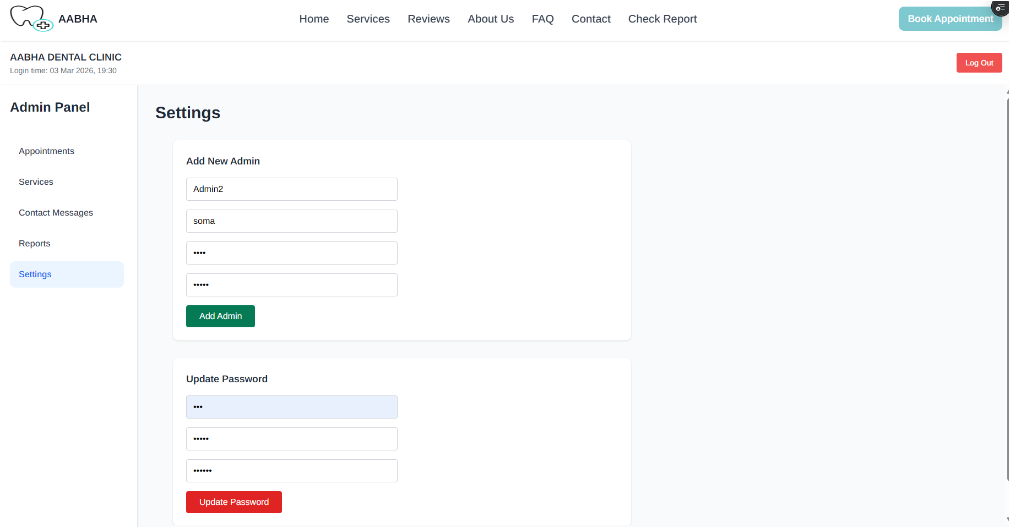

Reports Upload (Without Data):
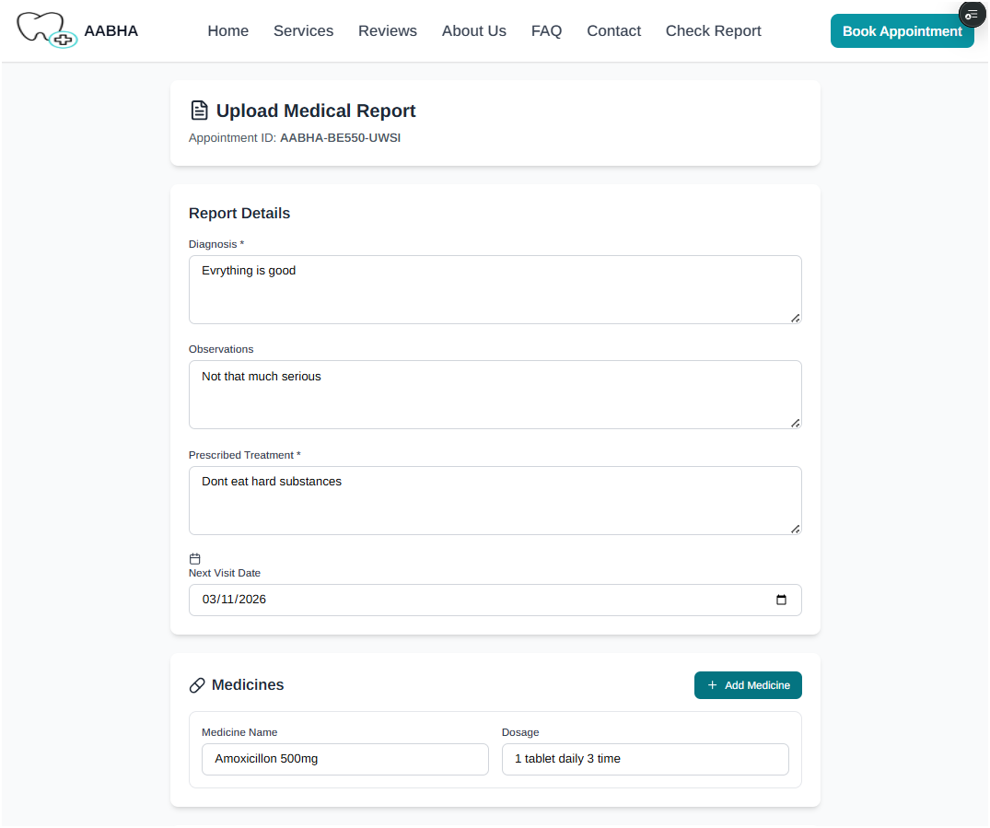
With Data:
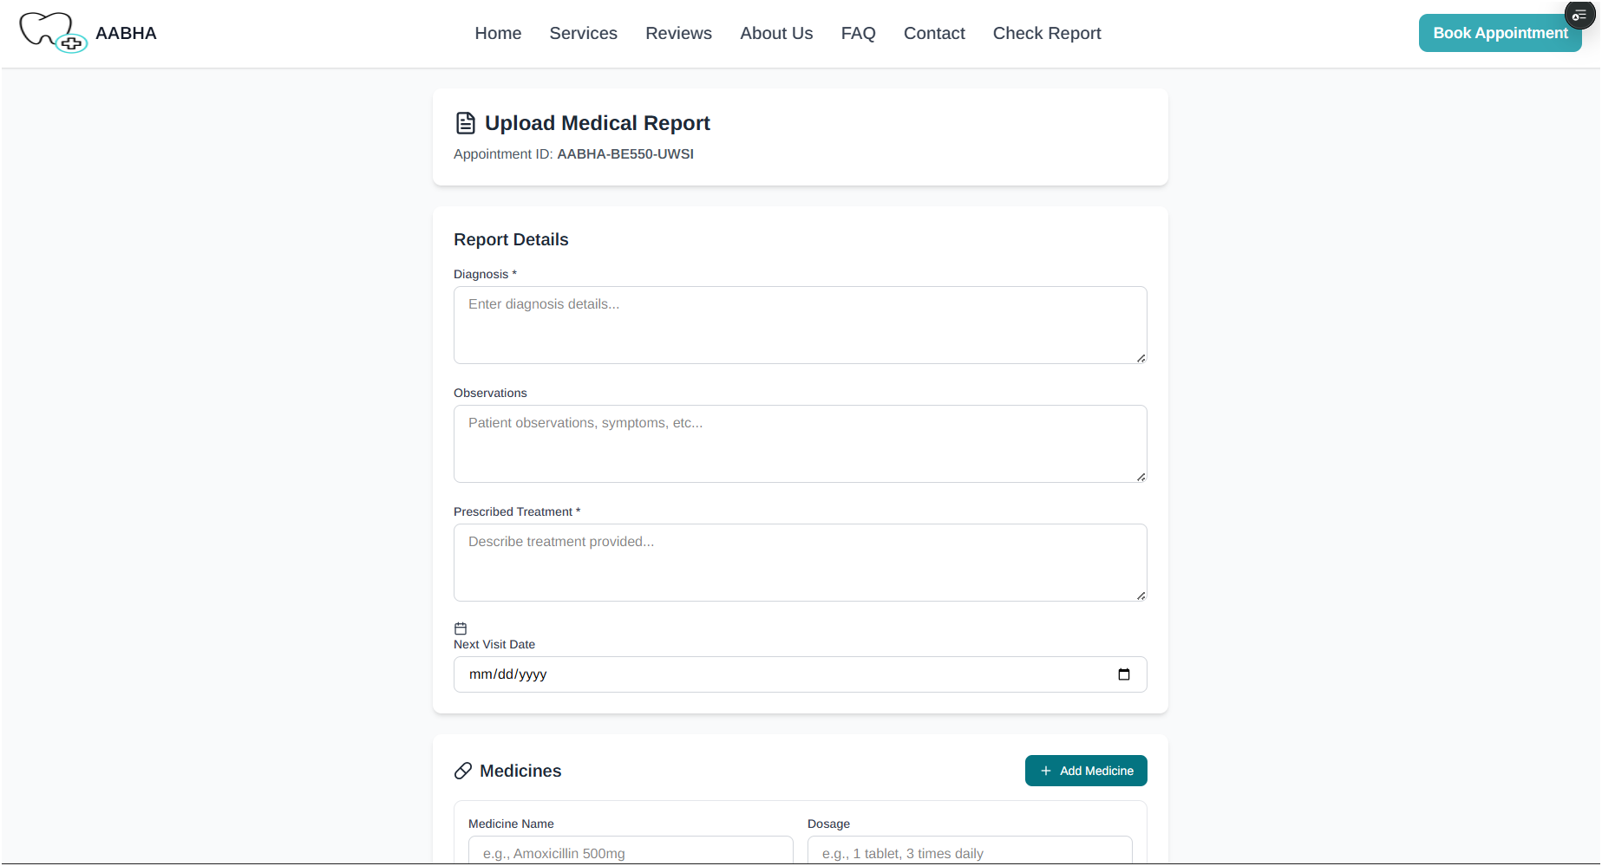

Source Codes:

"use client";
import AppointMentSuccessCard from "@/components/AppointmentSuccessPage";
import {
APPOINTMENT_RESCHEDULED_EMAIL,
BOOKING_CONFIRMATION_EMAIL,
} from "@/model/emailTemplates";
import { useRouter, useSearchParams } from "next/navigation";
import React, { useState, useEffect, Suspense } from "react";
const AppointmentFormContent = () => {
const searchParams = useSearchParams();
const params = useSearchParams();
const router = useRouter();
const query = {
name: params.get("name"),
phone: params.get("phone"),
email: params.get("email"),
date: params.get("date"),
time: params.get("time"),
service: params.get("service"),
at: params.get("at"),
note: params.get("name") ? "Resheduled Your Appointment" : "",
};

const is_resheduled = query.name && query.email && query.phone;
const rawDate = query.date || "";

const appointment_date = rawDate
? new Date(rawDate).toISOString().split("T")[0]
: "";
const [categories, setCategories] = useState([]);
const [showSuccess, setShowSuccess] = useState(false);
const [appointmentData, setAppointmentData] = useState(null);
const [isLoading, setLoding] = useState(false);
const [formData, setFormData] = useState({
patient_name: query.name || "",
phone: query.phone || "",
email: query.email || "",
service: query.service || "",
appointment_date: appointment_date || "",
appointment_time: query.time || "",
notes: query.note || "",
clinic: query.at || "",
});
useEffect(() => {
const fetchCategories = async () => {
const res = await fetch("/api/dental-services", { cache: "no-store" });
const data = await res.json();
setCategories(data.services);
};

fetchCategories();
}, []);
useEffect(() => {
const serviceFromUrl = searchParams.get("service");
if (serviceFromUrl) {
setFormData((prev) => ({
...prev,
service: decodeURIComponent(serviceFromUrl),
}));
}
}, [searchParams]);
const handleChange = (e) => {
const { name, value } = e.target;
setFormData((prev) => ({ ...prev, [name]: value }));
};
const sendConfirmationEmail = async (appointment) => {
if (!appointment?.email) {
console.warn("No email found for appointment → skipping email");
return;
}
try {
const response = await fetch("/api/send-reminder", {
method: "POST",
headers: { "Content-Type": "application/json" },
body: JSON.stringify({
to: appointment.email,
subject: is_resheduled
? "Your Appointment Has Been Rescheduled – Aabha Dental Clinic"
: "Your Appointment is Confirmed – Aabha Dental Clinic",
text: `Dear ${appointment.patient_name || "Patient"}`,
html: is_resheduled
? APPOINTMENT_RESCHEDULED_EMAIL({
patientName: appointment.name || "Patient",
appointmentId: appointment.appointment_id,
oldDate: query.date,
oldTime: query.time,
oldService: query.service,
newDate: appointment.preferred_date,
newTime: appointment.preferred_time,
newService: appointment.service_name || "General Dental",
clinic: appointment.at || "Aabha Dental Clinic",
})
: BOOKING_CONFIRMATION_EMAIL({
patientName: appointment.name || "Patient",
appointmentId: appointment.appointment_id,
date: appointment.preferred_date,
time: appointment.preferred_time,
service: appointment.service_name || "General Dental",
clinic: appointment.at || "Aabha Dental Clinic",
}),
}),
});

if (!response.ok) {
const errData = await response.json().catch(() => ({}));
throw new Error(errData.message || `HTTP ${response.status}`);
}

console.log("Confirmation email sent successfully");
} catch (err) {
console.error("Failed to send confirmation email:", err);
}
};
const handleSubmit = async (e) => {
e.preventDefault();
setLoding(true);
try {
const result = await fetch("/api/book-appointment", {
method: "POST",
headers: {
"Content-Type": "application/json",
},
body: JSON.stringify(formData),
});
if (result.ok) {
const data = await result.json();

setAppointmentData({
id: data.appointment.appointment_id,
name: formData.patient_name,
clinic: formData.clinic,
date: formData.appointment_date,
});
const appointment = data.appointment;
await sendConfirmationEmail(appointment);
if (is_resheduled) {
router.push("/admin-panel");
} else {
setShowSuccess(true);
}
setFormData({
patient_name: "",
phone: "",
email: "",
service: "",
appointment_date: "",
appointment_time: "",
notes: "",
clinic: "",
});
}
setLoding(false);
} catch (error) {
console.error("Error booking appointment:", error);
setLoding(false);
}
};
const today = new Date().toISOString().split("T")[0];
if (showSuccess && appointmentData) {
return (
<div className="min-h-screen bg-gray-50 py-12 px-4 sm:px-6 lg:px-8 flex items-center justify-center">
<AppointMentSuccessCard
id={appointmentData.id}
name={appointmentData.name}
clinic={appointmentData.clinic}
date={appointmentData.date}
/>
</div>
);
}
return (
<div className="min-h-screen bg-gray-50 py-12 px-4 sm:px-6 lg:px-8">
<div className="max-w-3xl mx-auto">
<div className="bg-white shadow-xl rounded-lg overflow-hidden">
<div className="bg-teal-600 px-6 py-4">
<h2 className="text-2xl font-bold text-white">
Book an Appointment
</h2>
</div>

<form onSubmit={handleSubmit} className="p-6 space-y-6">
<div className="grid grid-cols-1 md:grid-cols-2 gap-6">
<div>
<label
htmlFor="patient_name"
className="block text-sm font-medium text-gray-700 mb-1"
>
Patient Name <span className="text-red-500">*</span>
</label>
<input
type="text"
id="patient_name"
name="patient_name"
value={formData.patient_name}
onChange={handleChange}
required
className="w-full px-4 py-2 border border-gray-300 rounded-lg focus:ring-2 focus:ring-teal-500 focus:border-transparent outline-none transition"
placeholder="Abhishek Jadhav"
/>
</div>
<div>
<label
htmlFor="phone"
className="block text-sm font-medium text-gray-700 mb-1"
>
Phone Number <span className="text-red-500">*</span>
</label>
<input
type="tel"
id="phone"
name="phone"
value={formData.phone}
onChange={handleChange}
required
className="w-full px-4 py-2 border border-gray-300 rounded-lg focus:ring-2 focus:ring-teal-500 focus:border-transparent outline-none transition"
placeholder="+91 00000 00000"
/>
</div>
<div>
<label
htmlFor="email"
className="block text-sm font-medium text-gray-700 mb-1"
>
Email
</label>
<input
type="email"
id="email"
name="email"
required
value={formData.email}
onChange={handleChange}
className="w-full px-4 py-2 border border-gray-300 rounded-lg focus:ring-2 focus:ring-teal-500 focus:border-transparent outline-none transition"
placeholder="patient@example.com"
/>
</div>
<div>
<label
htmlFor="service"
className="block text-sm font-medium text-gray-700 mb-1"
>
Service <span className="text-red-500">*</span>
</label>
<select
id="service"
name="service"
value={formData.service}
onChange={handleChange}
required
className="w-full px-4 py-2 border border-gray-300 rounded-lg cursor-pointer focus:ring-2 focus:ring-teal-500 focus:border-transparent outline-none transition"
>
<option className="cursor-pointer" value="">
Select a service
</option>
{categories.map((service) => (
<option
className="font-semibold cursor-pointer"
key={service.id}
value={service.name}
>
{service.name}
</option>
))}
</select>
</div>
<div>
<label
htmlFor="appointment_date"
className="block text-sm font-medium text-gray-700 mb-1"
>
Appointment Date <span className="text-red-500">*</span>
</label>
<input
type="date"
id="appointment_date"
name="appointment_date"
value={formData.appointment_date}
onChange={handleChange}
required
min={today}
className="w-full px-4 py-2 border border-gray-300 rounded-lg focus:ring-2 focus:ring-teal-500 focus:border-transparent outline-none transition"
/>
</div>
<div>
<label
htmlFor="appointment_time"
className="block text-sm font-medium text-gray-700 mb-1"
>
Appointment Time <span className="text-red-500">*</span>
</label>
<input
type="time"
id="appointment_time"
name="appointment_time"
value={formData.appointment_time}
onChange={handleChange}
required
className="w-full px-4 py-2 border border-gray-300 rounded-lg focus:ring-2 focus:ring-teal-500 focus:border-transparent outline-none transition"
/>
</div>
</div>
<div>
<label
htmlFor="clinic"
className="block text-sm font-medium text-gray-700 mb-1"
>
Service Center <span className="text-red-500">*</span>
</label>
<select
id="clinic"
name="clinic"
value={formData.clinic}
onChange={handleChange}
required
className="w-full px-4 py-2 border border-gray-300 rounded-lg focus:ring-2 focus:ring-teal-500 focus:border-transparent outline-none transition"
>
<option value="">Select Clinic</option>
<option value="Bedag">Bedag</option>
<option value="Miraj">Miraj</option>
</select>
</div>
<div>
<label
htmlFor="notes"
className="block text-sm font-medium text-gray-700 mb-1"
>
Additional Notes
</label>
<textarea
id="notes"
name="notes"
value={formData.notes}
onChange={handleChange}
rows={4}
className="w-full px-4 py-2 border border-gray-300 rounded-lg focus:ring-2 focus:ring-teal-500 focus:border-transparent outline-none transition resize-none"
placeholder="Any special requests or medical information..."
/>
</div>
<div className="mt-4 p-4 bg-blue-50 border border-blue-200 rounded-lg">
<h3 className="text-sm font-semibold text-blue-800 mb-2">
Important Notes & Clinic Timings
</h3>
<ul className="list-disc list-inside space-y-1 text-sm text-blue-700">
<li>Clinic remains closed every Sunday.</li>
<li>
Miraj Clinic Timings: <strong>9:00 AM – 2:00 PM</strong>{" "}
(Monday to Saturday)
</li>
<li>
Bedag Clinic Timings: <strong>4:00 PM – 9:00 PM</strong>{" "}
(Monday to Saturday)
</li>
<li>Appointment fees must be paid directly at the clinic.</li>
<li>Please arrive 10 minutes before your scheduled time.</li>
<li>Carry a valid ID and previous medical reports (if any).</li>
<li>
Cancellations should be made at least 24 hours in advance.
</li>
<li>
An automatic email reminder will be sent 2 hours before your
appointment.
</li>
</ul>
</div>

<div className="flex items-start gap-2">
<input
id="confirmation"
name="confirmation"
type="checkbox"
required
className="mt-1"
/>
<label htmlFor="confirmation" className="text-sm text-gray-700">
I agree to the{" "}
<span className="font-medium text-teal-600">
terms and conditions
</span>{" "}
and confirm that the information provided is accurate.
</label>
</div>
<div className="flex justify-end pt-6">
<button
type="submit"
className="px-8 py-3 bg-teal-600 text-white font-medium rounded-lg hover:bg-teal-700 focus:outline-none focus:ring-2 focus:ring-teal-500 focus:ring-offset-2 transition transform hover:scale-105">
{isLoading ? "Booking Appointment..." : "Book Appointment"}
</button>
</div>
</form>
</div>
</div>
</div>
);
};
const AppointmentForm = () => {
return (
<Suspense
fallback={
<div className="min-h-screen bg-gray-50 flex items-center justify-center">
<div className="text-gray-600">Loading...</div>
</div>
}
>
<AppointmentFormContent />
</Suspense>
);
};

export default AppointmentForm;

  - Output Design:
- Reports:
- Appointments Report:

- Services Report:
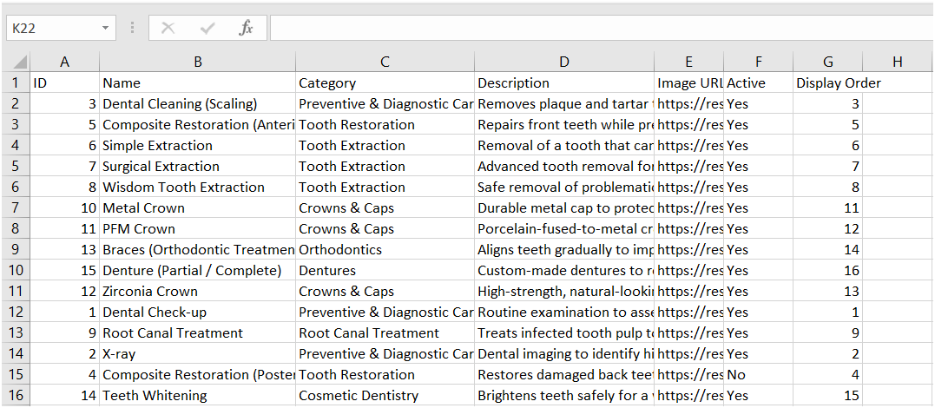

- Contact Messages Report:
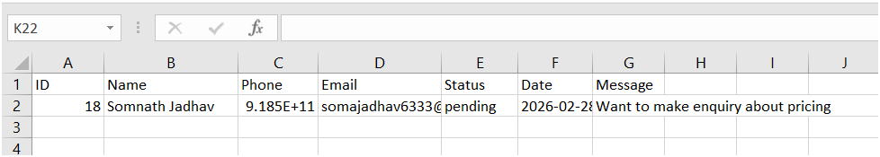

- Reminders:
- Appointment Booking Reminder:
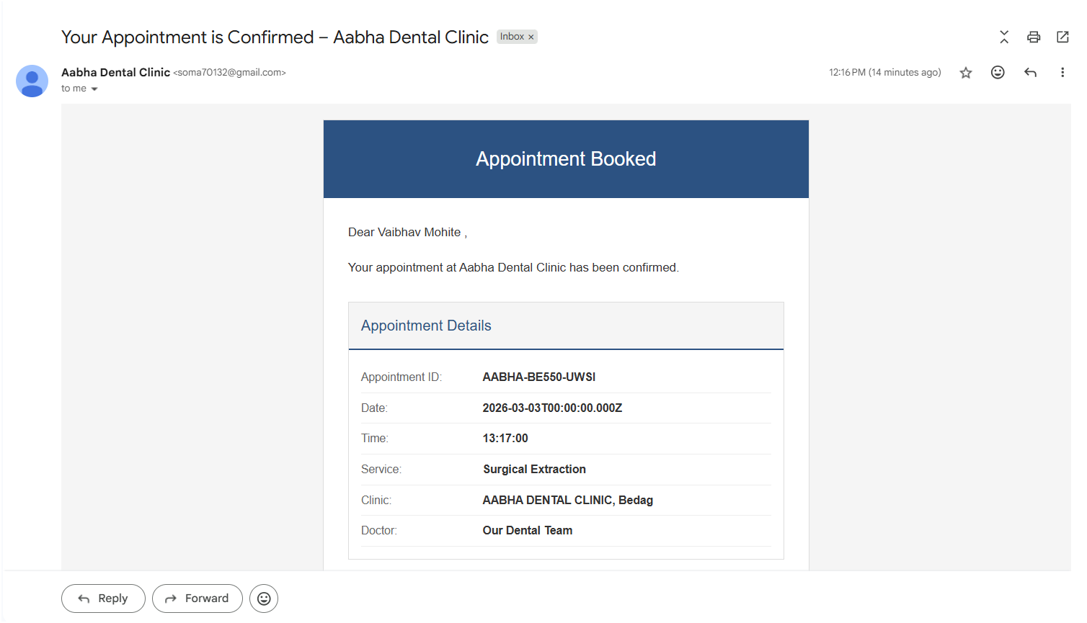
- Appointment Confirmation reminder
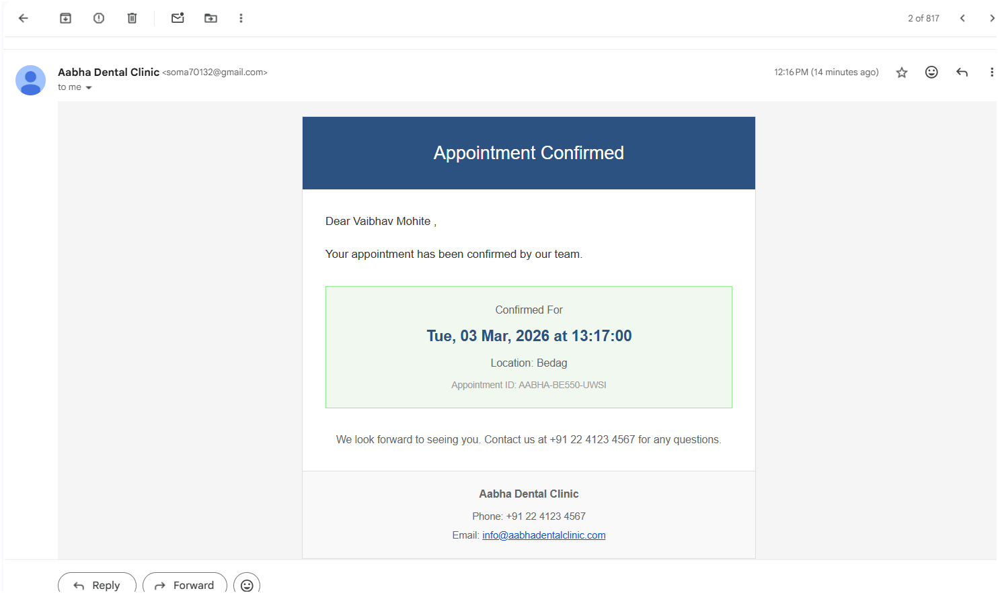

- Appointment Cancellation Reminder:
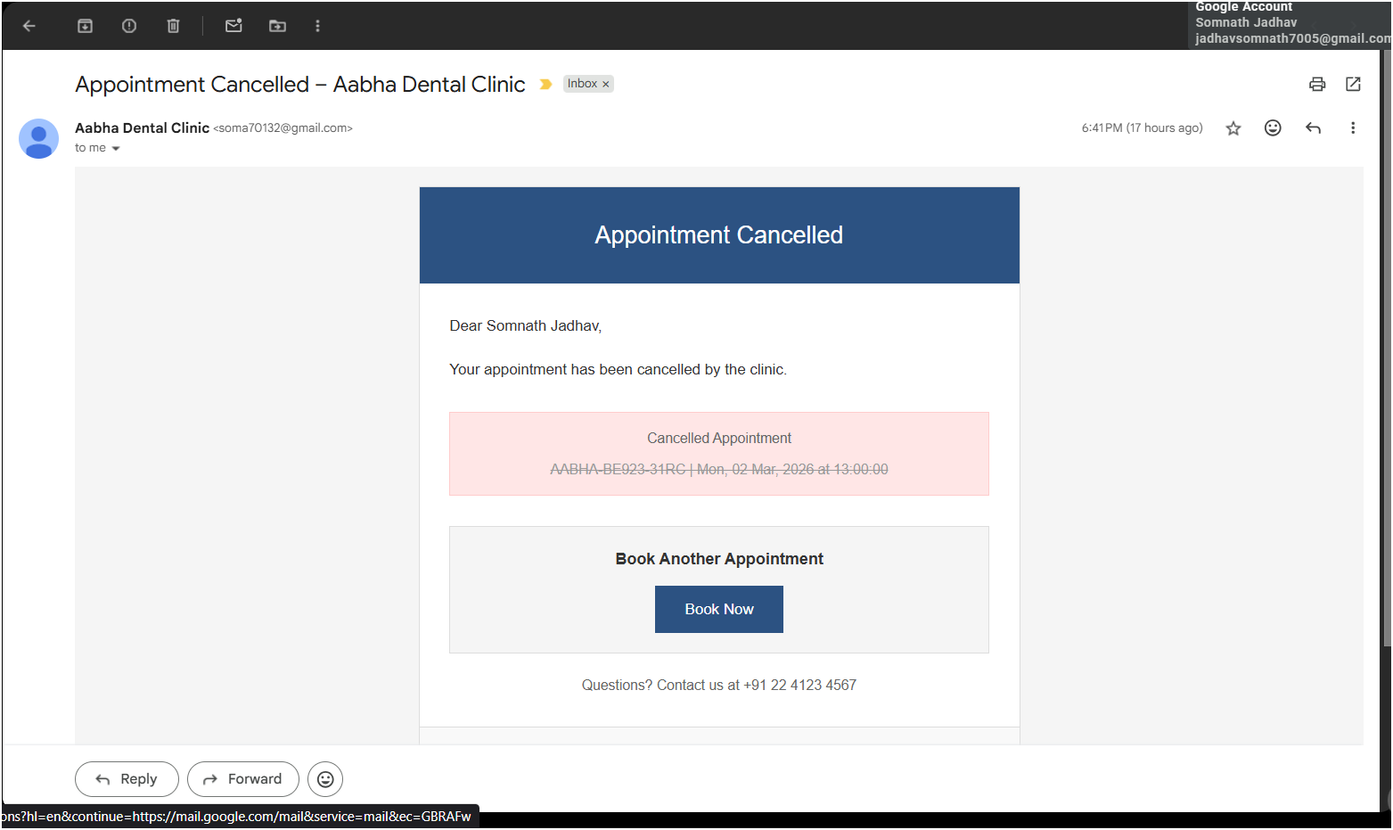
- Appointment Reminder:
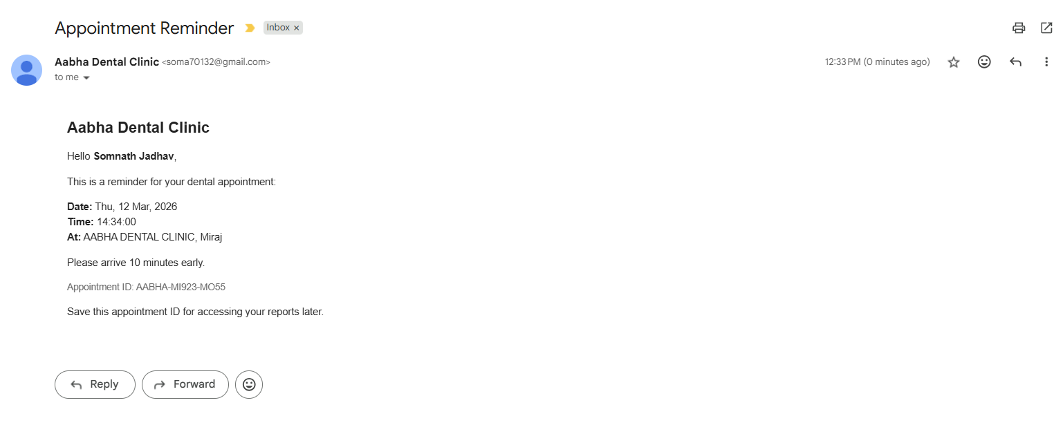

- Appointment Rescheduled Reminder:
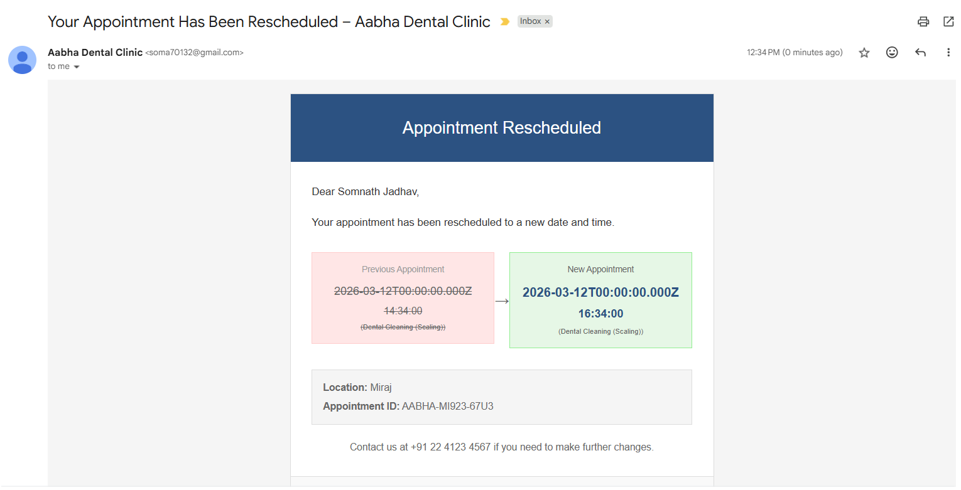
Source Code:
"use client";
import Link from "next/link";
import React, { useState } from "react";

import AppointmentsContent from "./Appointments";
import Services from "./Services";
import SideBar from "./SideBar";
import ContactMessages from "./ContactMsgs";
import Settings from "./Settings";
import AllReportsPage from "./AllReportsPage";

const AdminPageContent = () => {
const [activeTab, setActiveTab] = useState("appointments");

return (
<div className="flex bg-gray-50 min-h-screen">
<SideBar activeTab={activeTab} setActiveTab={setActiveTab} />
<main className="max-h-200 flex-1 overflow-y-auto">
{(() => {
switch (activeTab) {
case "appointments":
return <AppointmentsContent />;

case "services":
return (
<div className="p-8">
<h2 className="text-3xl font-bold text-gray-800">Services</h2>
<Services />
</div>
);

case "messages":
return (
<div className="p-8">
<h2 className="text-3xl font-bold text-gray-800">
Contact Messages
</h2>
<ContactMessages />
</div>
);
case "reports":
return (
<div className="p-8">
<h2 className="text-3xl font-bold text-gray-800">Reports</h2>
<AllReportsPage />
</div>
);

case "settings":
return (
<div className="p-8">
<h2 className="text-3xl font-bold text-gray-800">Settings</h2>
<Settings />
</div>
);

default:
return (
<div className="p-8">
<h2 className="text-3xl font-bold text-gray-800">Welcome</h2>
</div>
);
}
})()}
</main>
</div>
);
};

export default AdminPageContent;
"use client";
import Link from "next/link";
import React, { useState } from "react";

import AppointmentsContent from "./Appointments";
import Services from "./Services";
import SideBar from "./SideBar";
import ContactMessages from "./ContactMsgs";
import Settings from "./Settings";
import AllReportsPage from "./AllReportsPage";

const AdminPageContent = () => {
const [activeTab, setActiveTab] = useState("appointments");

return (
<div className="flex bg-gray-50 min-h-screen">
<SideBar activeTab={activeTab} setActiveTab={setActiveTab} />
<main className="max-h-200 flex-1 overflow-y-auto">
{(() => {
switch (activeTab) {
case "appointments":
return <AppointmentsContent />;

case "services":
return (
<div className="p-8">
<h2 className="text-3xl font-bold text-gray-800">Services</h2>
<Services />
</div>
);

case "messages":
return (
<div className="p-8">
<h2 className="text-3xl font-bold text-gray-800">
Contact Messages
</h2>
<ContactMessages />
</div>
);
case "reports":
return (
<div className="p-8">
<h2 className="text-3xl font-bold text-gray-800">Reports</h2>
<AllReportsPage />
</div>
);

case "settings":
return (
<div className="p-8">
<h2 className="text-3xl font-bold text-gray-800">Settings</h2>
<Settings />
</div>
);

default:
return (
<div className="p-8">
<h2 className="text-3xl font-bold text-gray-800">Welcome</h2>
</div>
);
}
})()}
</main>
</div>
);
};

export default AdminPageContent;

Source Code :
import nodemailer from "nodemailer";
export const transporter = nodemailer.createTransport({
service: "gmail",
auth: {
user: process.env.GMAIL_USER,
pass: process.env.GMAIL_PASS,
},
});
export async function sendEmail({ to, subject, text, html }) {
await transporter.sendMail({
from: `"Aabha Dental Clinic" <${process.env.GMAIL_USER}>`,
to,
subject,
text,
html,
});
}
import { sendEmail } from "@/lib/email";
import { NextResponse } from "next/server";
export async function POST(request) {
try {
const { to, subject, text, html } = await request.json();
await sendEmail({
to,
subject,
text,
html,
});
return NextResponse.json(
{ success: true, message: "Reminder sent successfully" },
{ status: 200 },
);
} catch (error) {
console.error("Email error:", error);
return NextResponse.json(
{ success: false, message: "Failed to send reminder" },
{ status: 500 },
);
}
}

  - User Manual:

1. Introduction
The Dental Clinic Management System is a web-based application designed to manage appointments, patient details, and automated reminders for a dental clinic. This system helps reduce manual work and improves overall efficiency.

2. System Access
The system has two types of users:
- Patient
- Admin

3. Patient User Guide

3.1 Viewing Services
- Open the website.
- Navigate to the Services section.
- View the list of available dental treatments.

3.2 Booking an Appointment
- Go to the Appointment page.
- Fill in the required details:
  - Name
  - Contact number
  - Email
  - Preferred date
  - Preferred time
- Click the Submit button.
- A confirmation message will be displayed after successful booking.

3.3 Receiving Reminder Emails
- The system automatically sends:
  - One reminder 24 hours before appointment

  - One reminder 4 hours before appointment
- No action is required from the patient side.

4. Admin User Guide

4.1 Admin Login
- Go to the Admin Login page.
- Enter username and password.
- Click Login.

4.2 Viewing Appointments
- After login, the dashboard displays all appointments.
- Admin can:
  - View appointment details
  - Check patient information
  - See appointment status

4.3 Filtering Appointments
- Filter by:
  - Date
  - Status (Pending, Confirmed, Completed, Cancelled)
  - Search by patient name

4.4 Updating Appointment Status
- Select an appointment.
- Change status as required.
- Save changes.

4.5 Managing Services
- Add new service
- Edit existing service
- Delete service

4.6 Viewing Contact Messages
- Admin can view messages submitted by patients.

5. Reminder System
- A background scheduler runs automatically every 30 minutes.
- The system checks upcoming appointments.
- Reminder emails are sent automatically.
- Duplicate reminders are prevented.

  - Conclusion:
The Dental Clinic Management System successfully provides a digital solution for managing clinic operations efficiently. The system allows patients to book appointments easily and enables the admin to manage appointments, services, and patient records in a structured manner.
The implementation of automated reminder emails (24 hours and 4 hours before appointments) helps reduce missed appointments and improves communication between patients and the clinic. The use of a secure database ensures proper data storage and retrieval.
Overall, the system reduces manual work, minimizes errors, saves time, and improves the productivity of the clinic. This project has demonstrated how modern web technologies can be applied to solve real-world healthcare management problems.

  - Further Enhancements:
The system can be improved and expanded in the future with the following enhancements:
- Online Payment Integration
Allow patients to pay consultation fees online during appointment booking.
- SMS Reminder Integration
Add SMS notifications along with email reminders.
- Patient Login System
Provide login access for patients to view appointment history and update details.
- Doctor Panel
Create a separate dashboard for doctors to manage their schedules.
- Reports & Analytics
Generate graphical reports for daily, monthly, and yearly appointments.
- Multi-Clinic Support
Expand the system to manage multiple clinic branches.
- Mobile Application
Develop an Android/iOS application for easier access.
- Rescheduling & Cancellation Feature
Allow patients to reschedule or cancel appointments online.

- Bibliography:

Books:
- Pressman, R. S. (2014). Software Engineering: A Practitioner’s Approach. McGraw-Hill Education.
- Sommerville, I. (2016). Software Engineering (10th Edition). Pearson Education.
- Elmasri, R., & Navathe, S. B. (2016). Fundamentals of Database Systems (7th Edition). Pearson.
- Silberschatz, A., Korth, H. F., & Sudarshan, S. (2019). Database System Concepts (7th Edition). McGraw-Hill Education.
- Duckett, J. (2014). Web Design with HTML, CSS, JavaScript and jQuery. Wiley Publications.

Online References:
- Next.js Official Documentation – https://nextjs.org/docs
- Node.js Official Documentation – https://nodejs.org
- PostgreSQL Official Documentation – https://www.postgresql.org/docs
- Nodemailer Documentation – https://nodemailer.com
- MDN Web Docs – https://developer.mozilla.org

