Linux Assignment – Somnath Jadhav

- Create a directory named test_dir using mkdir.
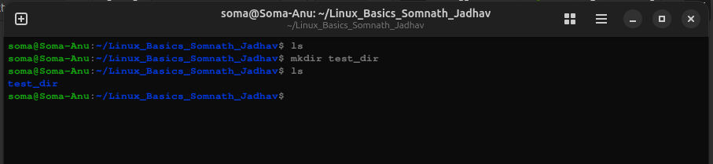
- Inside test_dir, create an empty file called example.txt.
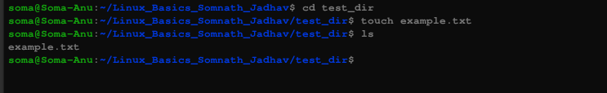
- Rename example.txt to renamed_example.txt using mv.
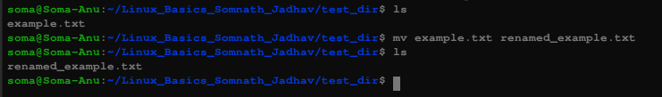
- Use cat to display the contents of /etc/passwd.

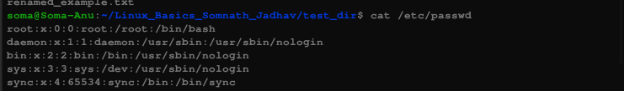

- Display only the first 5 lines of /etc/passwd using head.
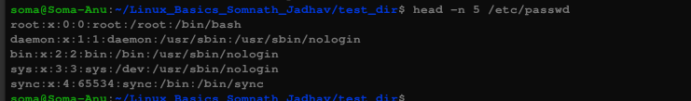
- Display only the last 5 lines of /etc/passwd using tail.

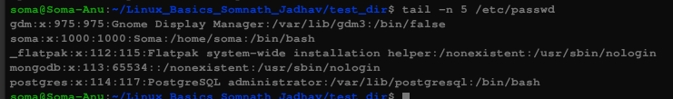
- Use grep to find all lines containing the word “root” in /etc/passwd.
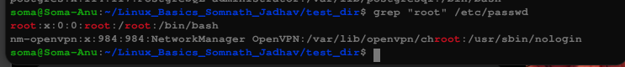
- Compress the test_dir directory into a file named test_dir.zip using zip.
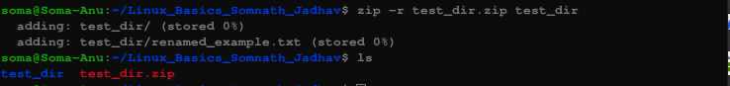

- Unzip test_dir.zip into a new directory named unzipped_dir.
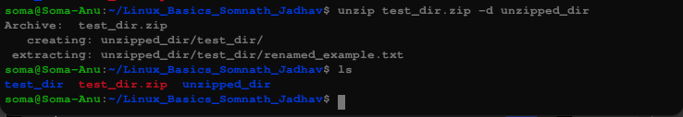

- Use wget to download a file from a URL (e.g., https://example.com/sample.txt).
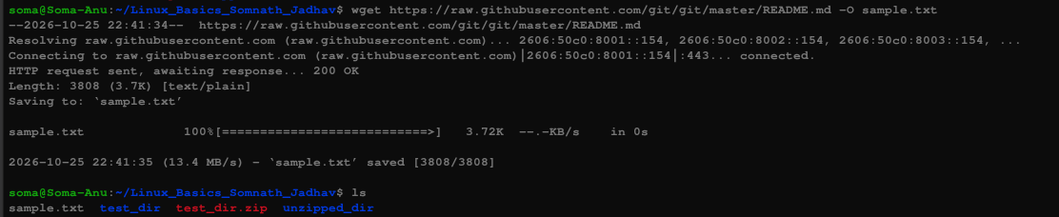
- Create a file named secure.txt and change its permissions to read-only for everyone using chmod.
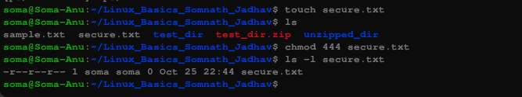

- Use export to set a new environment variable called MY_VAR with the value “Hello, Linux!”.
