|  |  |  |
| --- | --- | --- |
| NAME | TREATMENT(MEDICINE) | DIETARY PLAN |
| **ACNE**  Acne is a skin condition where hair follicles clog with oil and dead skin cells, causing pimples and other blemishes. It's common and can be mild to severe, affecting appearance and mental health. Factors include hormones, genetics, bacteria, excess oil, and certain medications or cosmetics. Treatment aims to reduce oil, speed up skin cell turnover, fight bacteria, and reduce inflammation. | **Benzoyl Peroxide Gel:**   * Apply a thin layer once or twice daily to affected areas. * Begin with a lower concentration (e.g., 2.5% or 5%) and adjust as needed. * Avoid sensitive areas and be cautious with clothing or bedding due to potential bleaching.   **Topical Retinoids (e.g., Tretinoin, Adapalene):**   * Wash face and apply a pea-sized amount to affected areas at bedtime. * Start with a lower concentration and increase as tolerated. * Protect skin from sunlight and use sunscreen during the day.   **Medication for Sensitive Skin:**   * Azelaic Acid Cream or Gel:   + Apply a thin layer to affected areas once or twice daily.   + Start with a lower concentration (e.g., 10% or 15%) to minimize irritation.   + Avoid sunlight exposure and use sunscreen during the day. | Limit extra sugar in your meals. Not more than 2-3 tsp/day  Include omega 3 foods (salmon, tuna, walnuts, flaxseeds) as a part of the daily intake   * more vitamin E rich foods like sunflower seeds, almonds, spinach, avocados. Vitamin E is an antioxidant that protects skin cells. * Make sure to get enough vitamin D from fatty fish, eggs, and fortified milk or juice. Vitamin D helps with skin cell growth and immune function. * Stay hydrated. |

|  |  |  |
| --- | --- | --- |
| NAME | TREATMENT | DIETARY PLAN |
| **Blackheads**  Blackheads, or open comedones, are a form of acne resulting from clogged hair follicles filled with excess oil (sebum) and dead skin cells. Unlike whiteheads, blackheads have open pores, enabling trapped debris to oxidize and darken in colour. | **Salicylic Acid Cleanser or Gel:**   * Wash face with salicylic acid cleanser once or twice daily. * Start with a lower concentration (e.g., 2% or 5%). * Avoid contact with eyes.   **Retinol Serum or Cream:**   * Apply pea-sized amount to clean, dry skin at bedtime. * Start with a lower concentration. * Use sunscreen during the day.   **Clay Masks:**   * Apply thin layer once or twice weekly. * Rinse off after 10-15 minutes. * Moisturize afterward. | Dietary Changes:  - Limit added sugars to 2-3 teaspoons per day.  - Include omega-3 rich foods like salmon, tuna, walnuts, and flaxseeds daily.  Nutrient-Rich Foods:  - Consume vitamin E sources such as sunflower seeds, almonds, spinach, and avocados.  - Ensure adequate vitamin D intake from fatty fish, eggs, and fortified milk or juice.  Hydration:  - Stay hydrated throughout the day.  Remember, consistency with these habits can help manage blackheads effectively. |

DARK SPOTS

Dark spots, also known as hyperpigmentation, can occur due to various factors such as sun exposure, hormonal changes, acne scars, or inflammation.

|  |  |  |
| --- | --- | --- |
| NAME | TREATMENT | DIETARY PLAN |
| DARK SPOTS | HYDROQUONINE-  Dark Spot Removal Cream, For Face, Packaging Size: 20g at Rs 130/piece in  Lucknow | Fruits and vegetables are rich in vitamins, minerals, and antioxidants that promote skin health. Aim to include a variety of colorful fruits and vegetables in your diet, such as berries, citrus fruits, leafy greens, carrots, and bell peppers. |
|  | Vitamin C-  14 best vitamin C serums of 2024, tested by editors | Omega-3 fatty acids have anti-inflammatory properties that can help reduce inflammation in the skin and improve overall skin health. Include sources of omega-3 fatty acids in your diet, such as fatty fish (salmon, mackerel, sardines), flaxseeds, chia seeds, and walnuts. |
|  | Kojic acid - | Green tea contains antioxidants called catechins, which have been shown to have protective effects on the skin and may help improve hyperpigmentation. Enjoying a cup of green tea regularly can be a beneficial addition to your diet. |

DRY SKIN -

|  |  |  |
| --- | --- | --- |
| NAME | TREATMENT | DIETARY PLAN |
| DRY SKIN | Hyaluronic acid- | Focus on consuming foods with high water content to help keep your body hydrated from the inside out. Include plenty of water-rich fruits and vegetables in your diet, such as cucumbers, watermelon, strawberries, oranges, and leafy greens like spinach and lettuce. |
|  | Lotion-  REGALIZ Hydronic Moisturizing Dry Skin Body Lotion, 100 ml | Antioxidants help protect the skin from damage caused by free radicals, which can contribute to dryness and premature aging. Include antioxidant-rich foods in your diet, such as berries (blueberries, strawberries, raspberries), dark leafy greens, tomatoes, carrots, and bell peppers. |
|  | Gel-  Emolene Cream | Uses, Benefits, Price | Apollo Pharmacy | In addition to consuming hydrating foods, remember to drink plenty of water throughout the day to keep your body and skin hydrated. |

EYEBAGS- Eye bags, also known as under-eye bags or periorbital puffiness, are a common cosmetic concern that can make you look tired or older than your age. They often develop due to various factors such as aging, genetics, fluid retention, allergies, lack of sleep, or lifestyle habits like smoking and excessive alcohol consumption.

|  |  |  |
| --- | --- | --- |
| NAME | TREATMENT | DIETARY PLAN |
| EYEBAGS | VITAMIN K CREAM-  Anacis Vitamin K1 Oxiderm OP Cream - Minimizes Scars, Dark Eye Circles,  Bruises, Varicose Veins - 1.01 Oz | Allergies can cause inflammation and swelling around the eyes, leading to the formation of eye bags. Take steps to manage your allergies, such as avoiding triggers, using allergy medications, or using hypoallergenic bedding and cosmetics. |
|  | Hellocell Vitamin K Dr + Petit Cream – Limese India | Lack of sleep can contribute to fluid retention and swelling around the eyes, making eye bags more prominent. Aim for 7-9 hours of quality sleep per night to help reduce puffiness and refresh your appearance. |
|  | VitaMedica Arnica Filler Kit Bundle - Restores, Softens, and Calms Bruised  Skin | Applying cold compresses, such as chilled cucumber slices, cold spoons, or tea bags, can help constrict blood vessels and reduce swelling around the eyes. Apply cold compresses for 10-15 minutes several times a day as needed |

OILY SKIN-

Oily skin is characterized by overactive sebaceous glands that produce excess oil, also known as sebum.

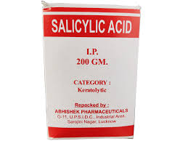 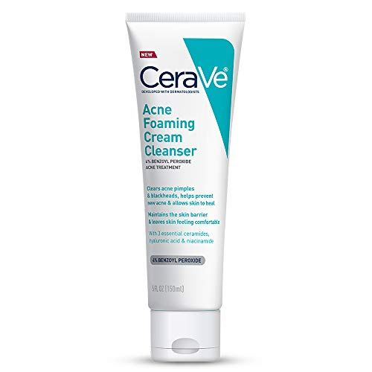

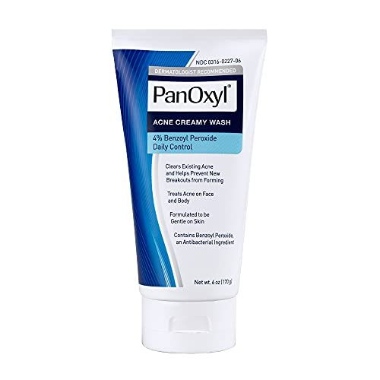 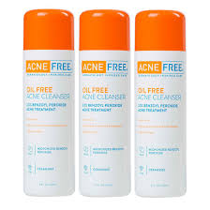

DIETARY PLANS-

* Focus on consuming a balanced diet rich in fruits, vegetables, whole grains, lean proteins, and healthy fats. A well-rounded diet provides essential nutrients that support overall skin health.
* Focus on consuming a balanced diet rich in fruits, vegetables, whole grains, lean proteins, and healthy fats. A well-rounded diet provides essential nutrients that support overall skin health.
* **Moderate Dairy Consumption:** Some individuals find that dairy products, particularly those high in hormones like skim milk, may exacerbate acne and oiliness in certain people. Consider moderating dairy intake or choosing alternatives like almond milk or soy milk.

PORES-

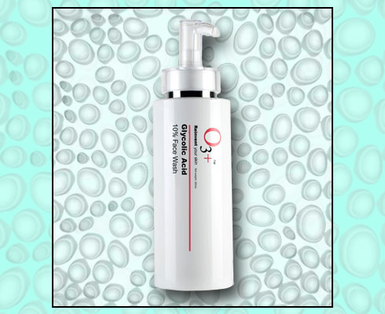 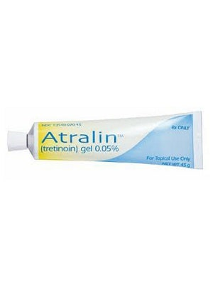

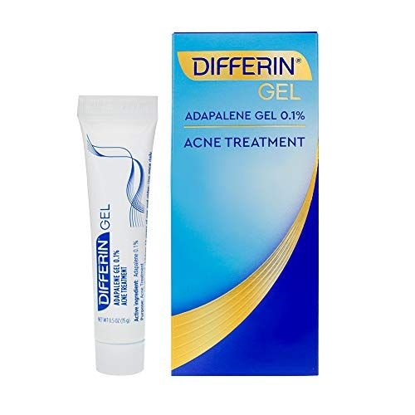 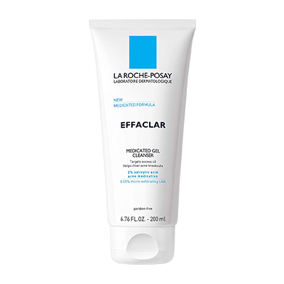

DIETARY PLAN-

Include probiotic-rich foods in your diet to support gut health, as there's evidence suggesting a link between gut health and skin health. Examples of probiotic-rich foods include yogurt, kefir, sauerkraut, kimchi, and kombucha

Limit alcohol and caffeine consumption, as excessive intake can dehydrate the body and potentially affect skin health.

Incorporate lean protein sources into your meals, such as poultry, fish, tofu, legumes, and eggs. Protein is essential for skin repair and regeneration.

Drink plenty of water throughout the day to keep your skin hydrated. Hydration helps maintain skin elasticity and plumpness, which can help reduce the appearance of pores.

REDNESS-

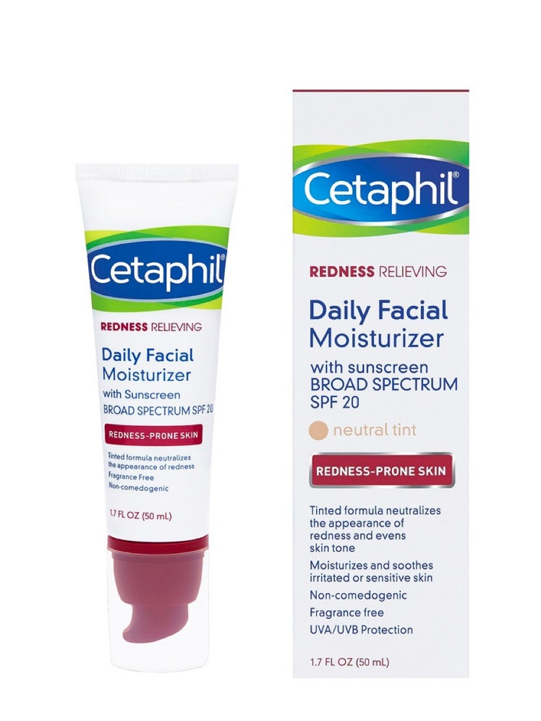 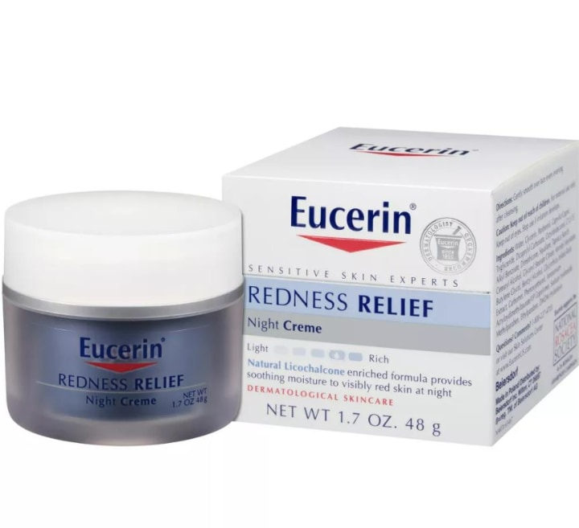

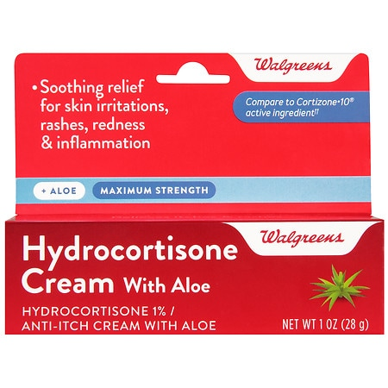

DIETARY PLAN-

Include sources of healthy fats in your diet, such as avocados, nuts, seeds, and olive oil. These fats help maintain skin hydration and may reduce inflammation.

Consume a variety of colorful fruits and vegetables, which are rich in vitamins, minerals, and antioxidants. Aim to include a rainbow of colors in your meals to ensure you're getting a diverse range of nutrients.

Incorporate probiotic-rich foods into your diet to support gut health, as there's a link between gut health and skin conditions like rosacea.