**QNWrite a map reduce program to desing a custom counter to count number of people are affected with 'PULMONARY' disease and 'BRONCHITIS & ASTHMA' in the state 'CA'.**

Driver

Step 1 : Create the ENUM for counters.

Since we are counting 2 types of diognaisis ENUM will become the group and fields will become the counters.

Step2: getting counters and printing it.

In mapper I am using j.getCounter to get all jobs and using c1 and c2 to get the counters for asthma and pulmonary and printing it using sysout

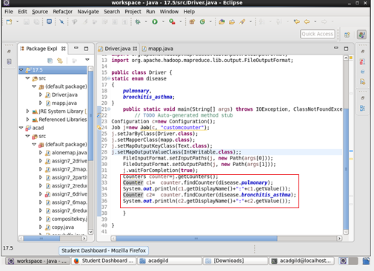

Mapper

Step1:Splitting the value by comma as Delimiter

Step2 :checking for pulmonary as disease and CA as state

Step3:Incrementing the counter

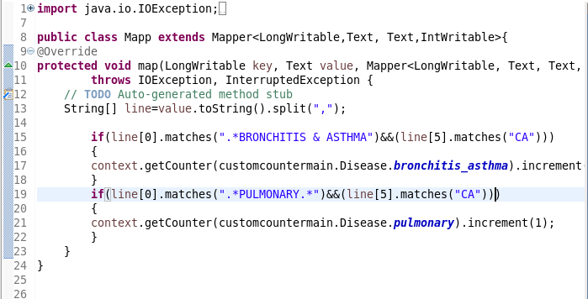

**Running JAR**

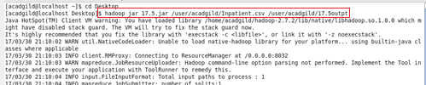

**otpt**

The custom counter and the count is displayed

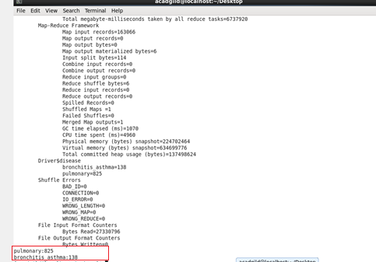

**JOBHISTORY SERVER**

