PIG FILE CONTAINING COMMANDS

QN1.LOAD EMPLOYEEE DATASET ORDER BY RATING DESC AND BY NAMEASC ORDER THEN Limit it by 5 AS we want Employess with hihest rating then generate id and name

QN2.USED FILTER TO FIND ODD ID EMPLOYESS AND THEN ORDERED BY SAL DESC AND THEN LIMIT BY 3 AS WE WANT TOP 3 SALARY OF EMPLOYEES

QN3.AS WE WANT EMPLOYEE WITH MAX EXPENSES I JOIN BOTH RELATION AND THEN GROUP BY EMP_ID,NAME AND THEN FIND THE SUM OF EXPENSES AND THEN ORDER BY DESC LIMIT 1 TO GET MAXIMUM

QN4.JUST DO INNER JOIN AND THEN DISPLAYED OUTPUT

QN5.DID LEFT OUTER JOIN AND THEN USED IS NULL FOR FILTERING EMPTY RECORDS AND GENERATING ID,NAME;

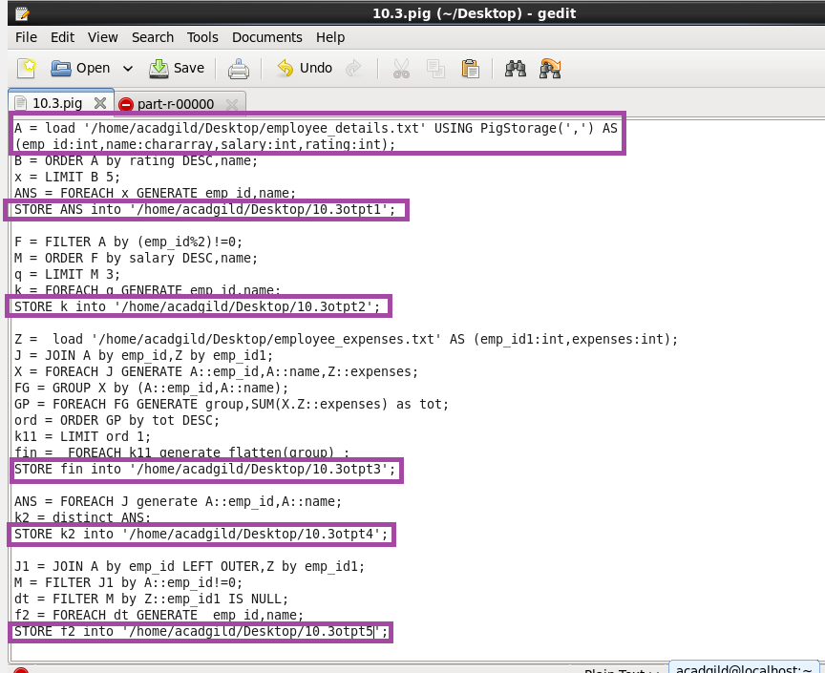

RUNNING PIG SCRIPT

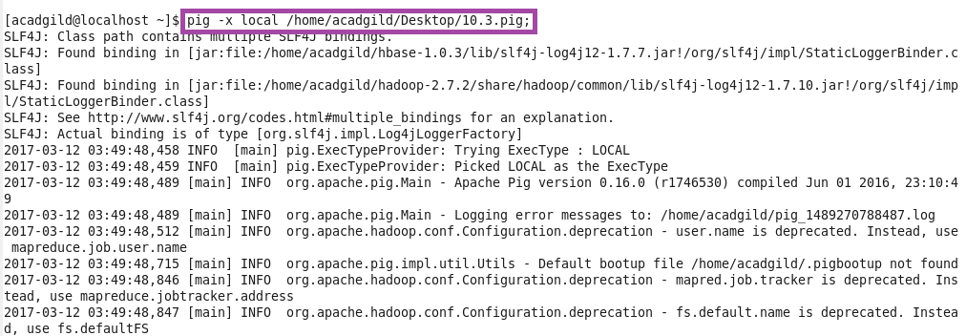

OTPT

