1. **Write a mapreduce program to find the total amount of petrol in volume sold by every distributor.**

**DRIVER CLASS**

**SET 2 JOBS FOR 2 QN**

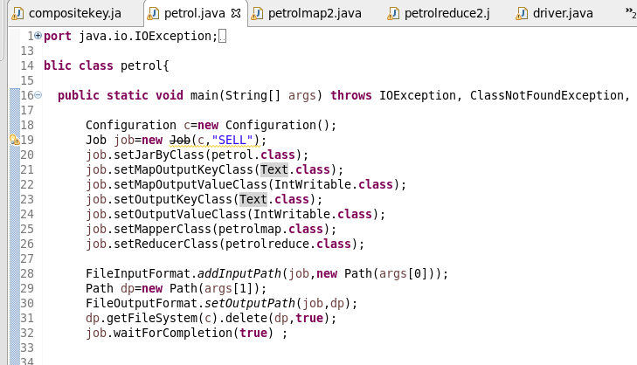

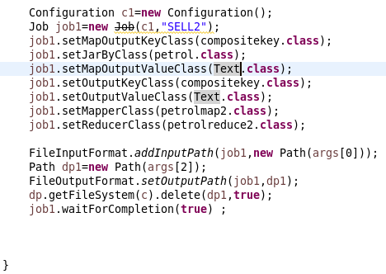

**MAPPER1**

**SPLIITING THE DATASET BY COMMA AND SENDING DISTR NAME AS KEY AND VALUE AS SOLD VOLUME**

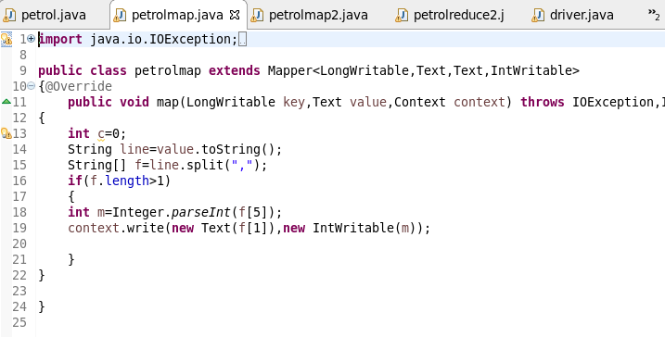

**REDUCER**

**FOUND THE TOTAL AMOUNT BY SUMMING VALUES**

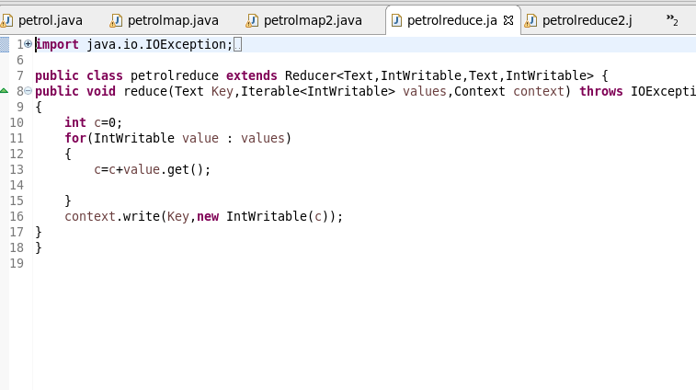

**2. Write a mapreduce program to find which are the top 10 distributors ID's for selling petrol and also display the amount of petrol sold in volume.**

**MAPPER2**

**SINCE WE WANT TOP TOP DISTRIBUTOR ID ,I SEND SENT VOLUME AS KEY AS A COMPOSITE KEY WHICH I OVERRIDE AND SORTED IN DESCENDING ORDER AND SENT DISTRIBUTOR ID AS VALUE**

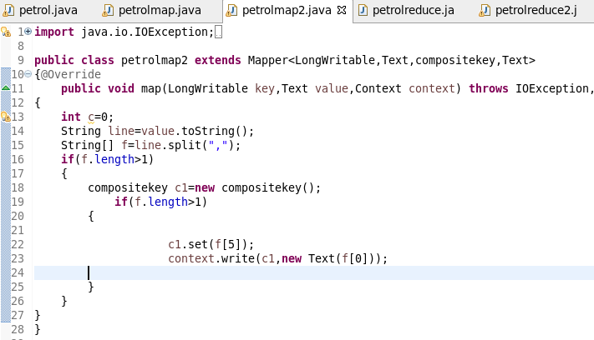

**REDUCER2**

**PRINT THE OUTPUT**

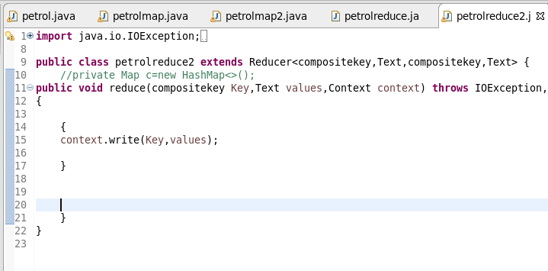

**COMPOSITE KEY**

**STEP1 :OVERRIDE COMPARE TO METHOD AND MULTIPLIED THE OTPT OF COMPARE TO BY -1 SO THE KEY WHICH WILL BE SORTED IN DESCENDING ORDER AND VOLUME SOLD AS VALUE** 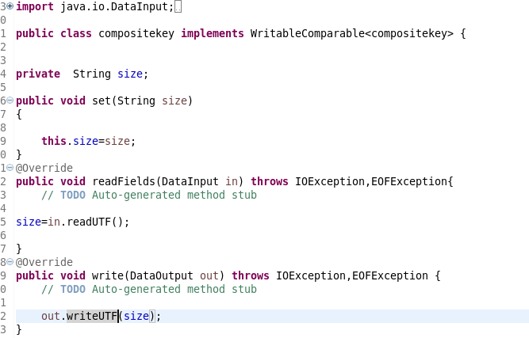

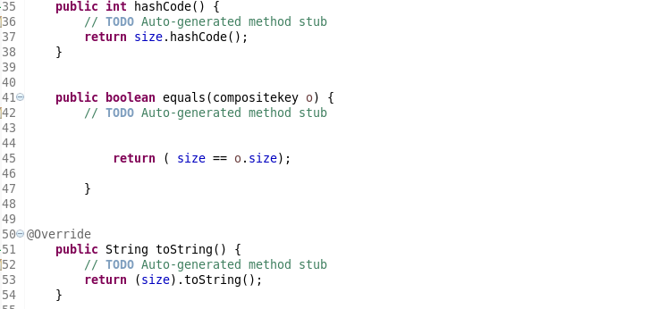  
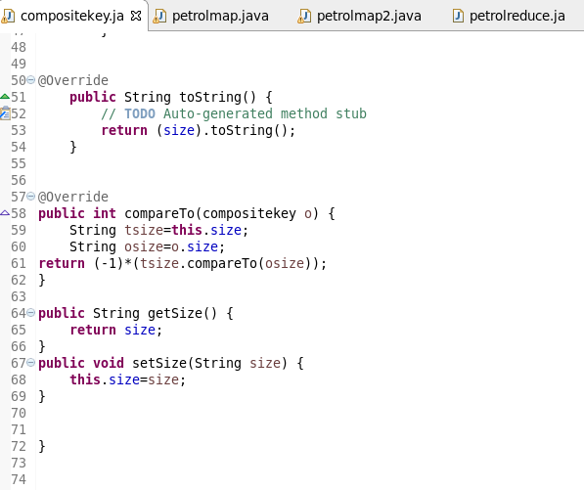

**RUNNING JAR**



**OTPT**

**OTP2 TO GET TOP 10 VALUE I GAVE HEAD –N10 COMMAND**

