1.Write a pig script find the average age of male and female persons died in the titanic tragedy

LOGIC :AS WE WANT THE AVG AGE OF MALE AND FEMALE DIED FILTER THE DATA BY DIED AND THEN GROUP BY SEX AND THEN TAKE AVG OF AGE

2.Write a pig script to find the number of people died and survived in each class

AS WE WANT DEAD AND SURVIVED IN EACH CLASS,I will GROUP BY SURVIVED AND CLASS AND MAKE A COUNT OF PASSENGER ID

PIG COMMANDS

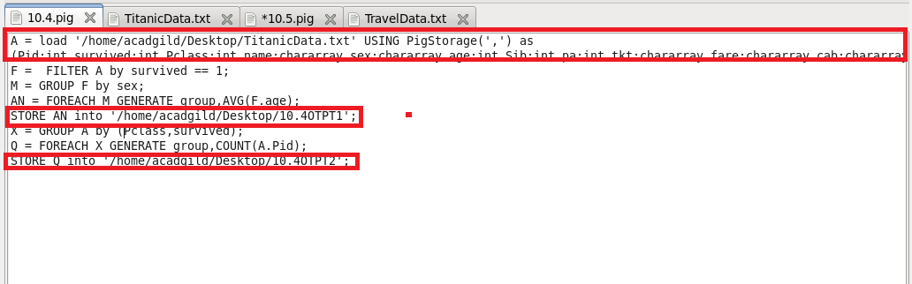

RUNNING PIG SCRIPT

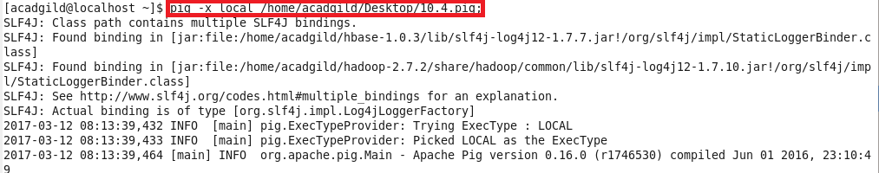



OTPT

