QN1.Write a pig script to find the top 20 destination people travel the most: Based on the given data

LOGIC : load the dataset and then group by destination then since we want the count of people sum the adult,youth,infant,child senior foreach in group and find the sum of it using nested for each then limit by DESC AND LIMIT BY 20

QN2. Write a pig script to find the top 20 locations from where people travel the most

LOGIC : load the dataset and then group by FROM LOCATION and then since we want the count of people sum the adult,youth,infant,child senior foreach group and find the sum of it usig nested for each then limit by DESC AND LIMIT BY 20

PIG COMMANDS

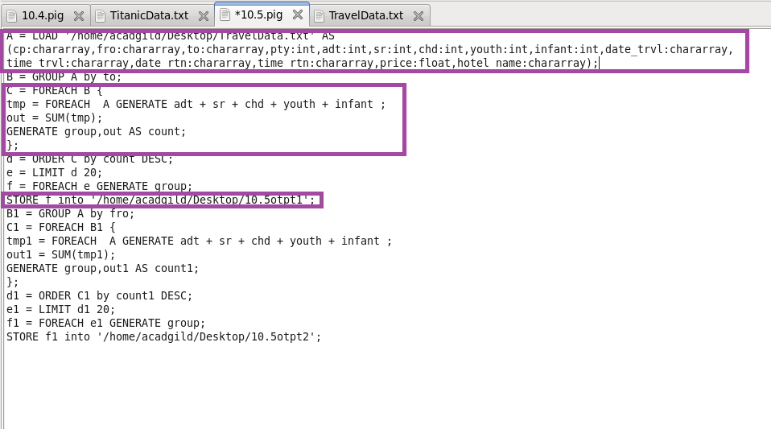

RUNNING PIG SCRIPT

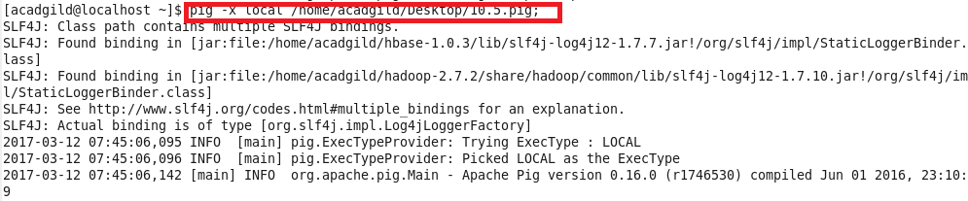

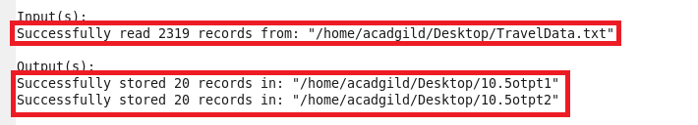

OTPT

