1.Write a pig script to find the minimum temperature observed in a given weather station in a particular year.

SINCE THE YEAR IS A SINGLE YEAR(1800) GROUP BY STATION AND THEN FIND MINIMUM TEMPERATURE BY MIN FUNCTION

2. Write a pig script to find the maximum temperature observed in a given weather station in a particular year.

SINCE THE YEAR IS A SINGLE YEAR(1800) GROUP BY STATION AND THEN FIND MAXIMUM TEMPERATURE BY MAX FUNCTION

3. Write a pig script to find the number of readings given by each weather station according to the DATASET  
SINCE THE YEAR IS A SINGLE YEAR(1800) GROUP BY STATION AND CHECK FOR NOT NULL FOR TEMP COLUMN AND THEN MAKE A COUNT OF READINGS

PIG COMMANDS

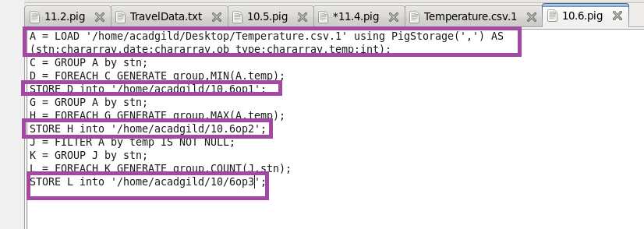B

RUNNING PIG SCRIPT

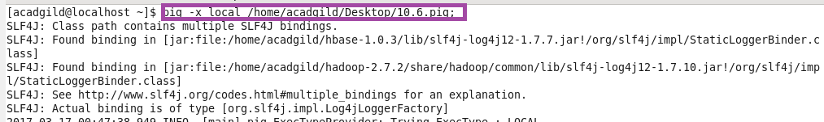

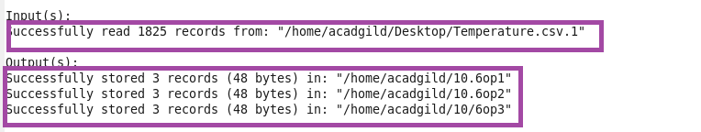

OPT

