**DRIVER**

**IN DRIVER,SET MAPPER CLASS,PARTIIONER CLASS GROUP COMPARATOR CLASS AND COMPOSITE KEY CLASS AS MAP OUTPUT CLASS**

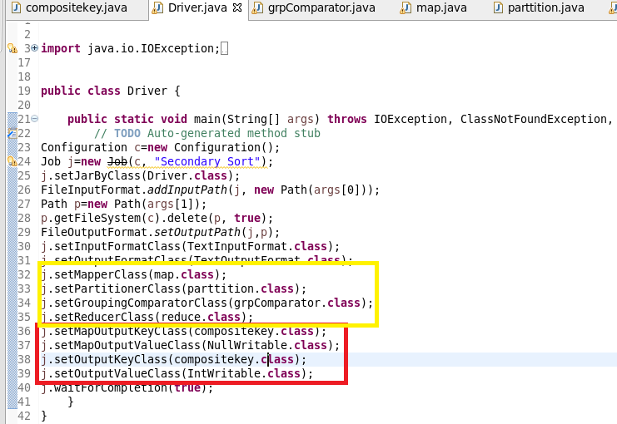

**MAPPER**

**In mapper class split the data by comma and then send compasitekey as key(which consists of combination of year and temperature) and value as null writable**

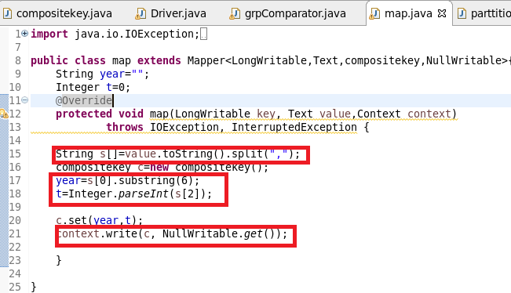

**Composite key class**

**Step1:Override compare method**

**Check if year are same if it is same sort the temperature by descending**

**Step2:Override Tostring :to display the way the composite key should be displayed**

**Step3:read fields and write fields is for serialization and deserialization**

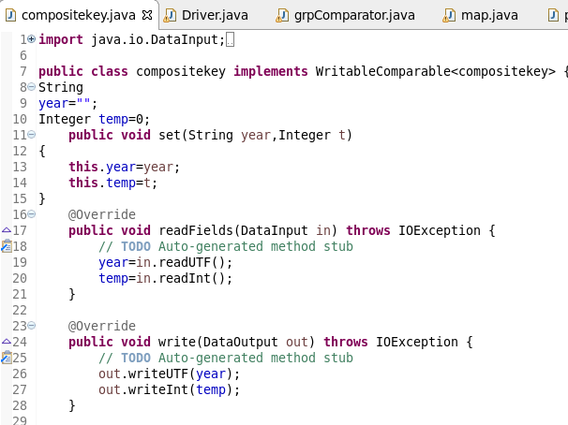

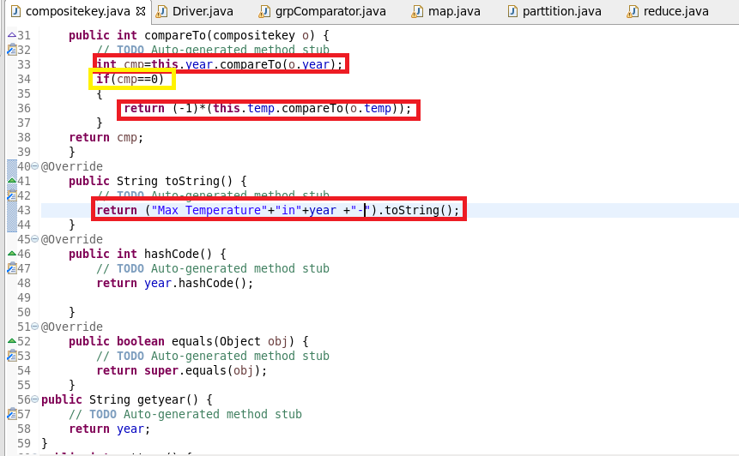

**Custom Partitioner class**

**In partitioner class send the key,value pair from mapper to reducer depending upon hashcode of year**

**Say all 1990 year data should go to same reducer**

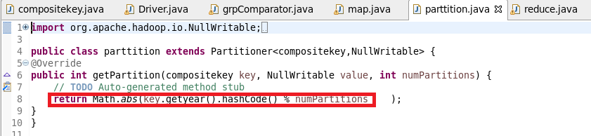

**Group comparator class**

**In group comparator class we must say the reducer to group the key based on year**

**Say if there are 2 keys(1990-12,1990-23).If we did not override these two keys will be considered as unique so we override compare method and compare by year and the kay will be grouped as follows**

**1990(1990-23,1990-12)**

**1991(1991-12,1991-15) and so on**

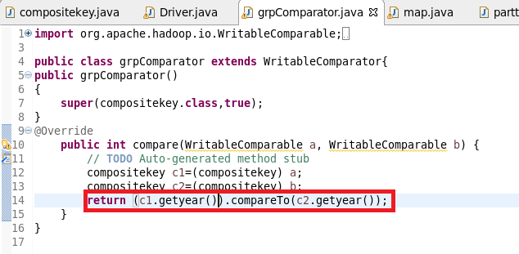

**Reducer**

**In reducer since we want maximum 2 temperature ,I have used linked hashmap of size(2) since we want max 2 temp and Iterate the value and get only top 2 max values as linkedhashmap preserves order and eliminates duplicacy as shown**

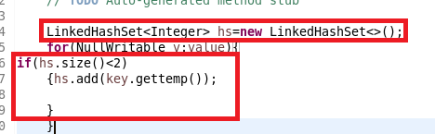

**Then by using Iterator of hashset written these key and values**

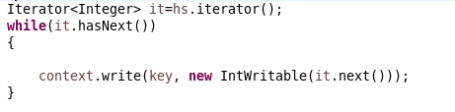

**Complete reducer**

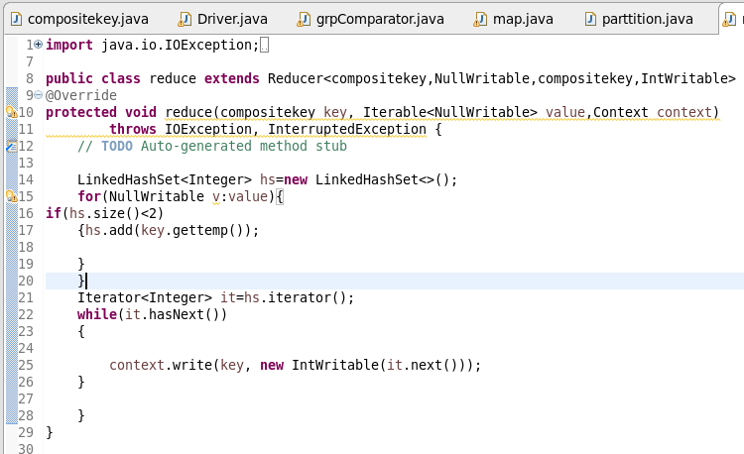

**Running jar**

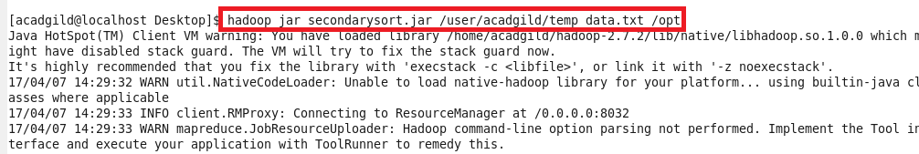

**OUTPUT**

