DRIVER

job: FOR finding the user Rating

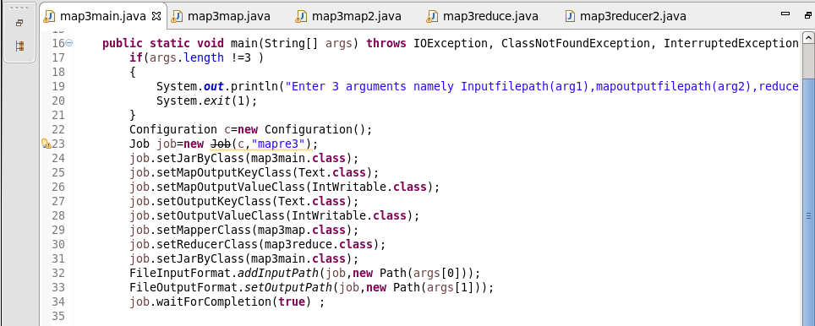

job1: FOR finding the Movie Rating

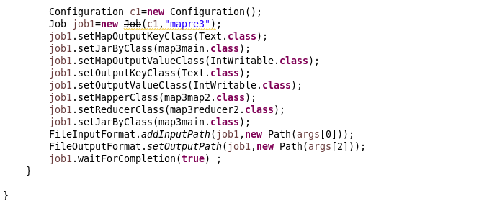

MAPPER CLASS

Logic : Used to split Input by [\\s+](file:///\\s+) for splitti ng by multiple spaces and send the user Id and a count of 1 for each Rating given by a user for a movie as Key and value

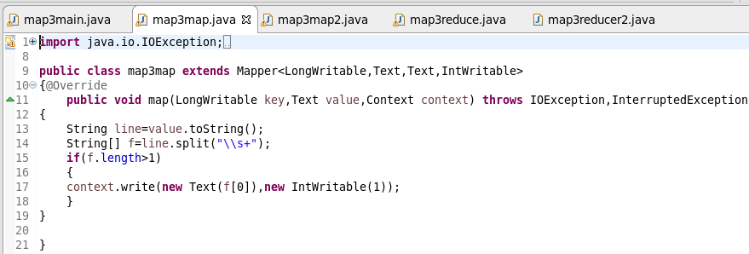

Reducer

Count the no of rating given by each user by iterating through values and adding

MAPPER CLASS

Logic : Used to split Input by [\\s+](file:///\\s+) for splitting by multiple spaces and send the Movie Id and a count of 1 for each Rating given by the users for each movie as Key and value

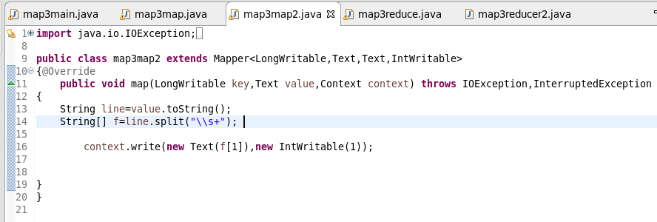

Reducer

Count the no of rating given for each Movie by iterating through values and adding

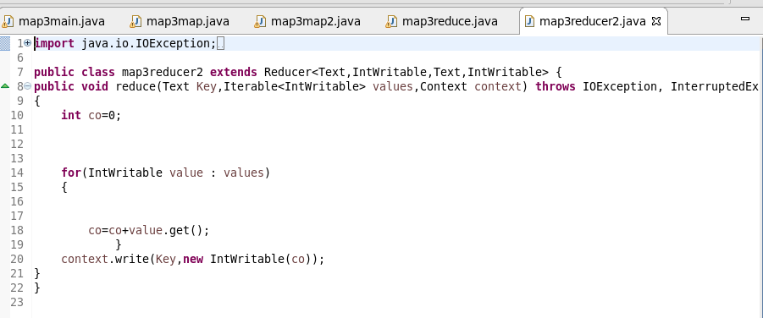

RUNNING JAR



OTPT1

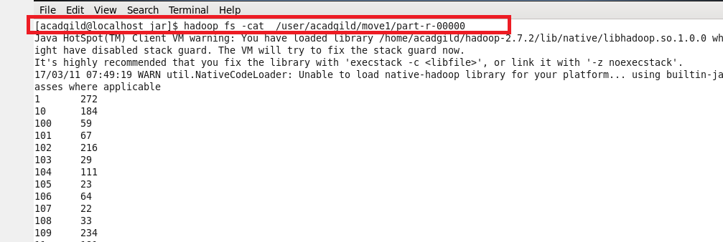

OTPT2

