DRIVER

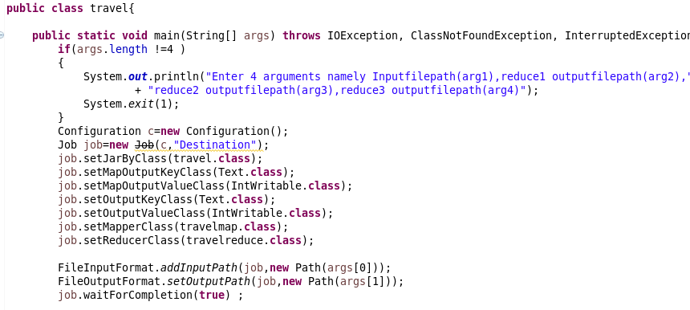

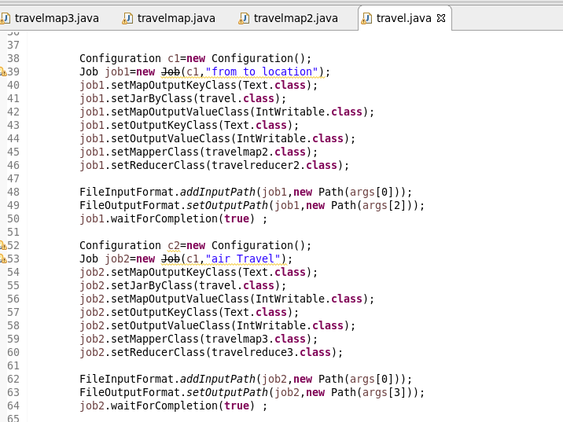

MAPPER FOR QN 1

Logic: Checking the Destination as “MIA” and “MCO” and sending it as AS KEY and adding the adult,senior,children,youth and infants(for loop) and sending it as value

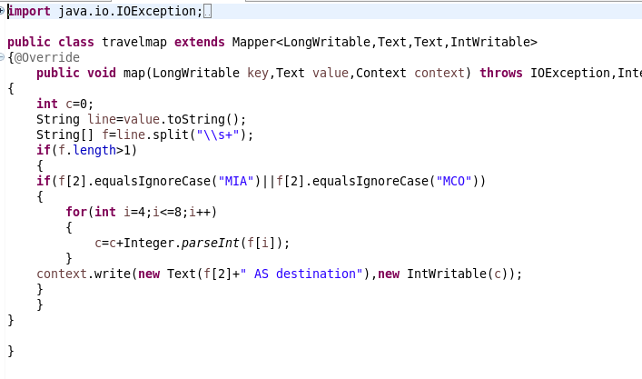

REDUCER FOR QN1

Count the total number of passengers

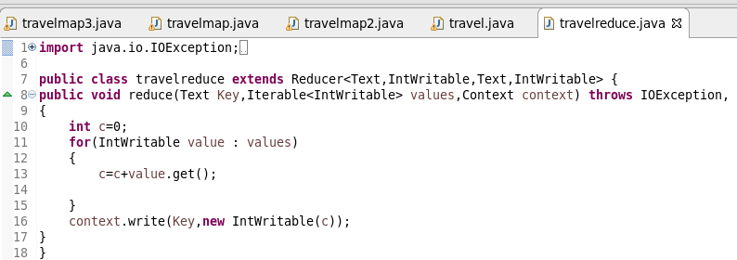

MAPPER FOR QN 2

Logic: Checking the FROM LOCATION as “MIA” and “HOU” and sending it as AS KEY and adding the adult,senior,children,youth and infants(for loop) and sending it as value

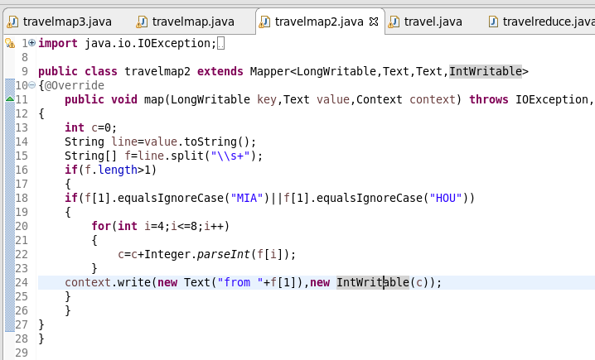

REDUCER FOR QN 2

Count the total number of passengers

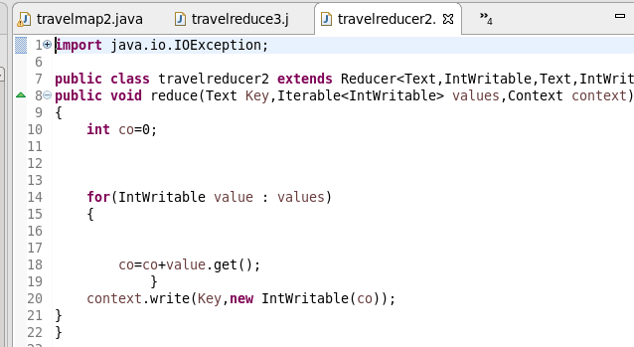

MAPPER FOR QN 3

Logic: Check whether the DESTINATION AS LAS and LAX (1nd  IF CONDITION) then checking for mode as AIR IN (2nd  IF CONDITION) AND THEN SENDING AS KEY AND THEN SENDING TOTAL PASSENGERS AS VALUE

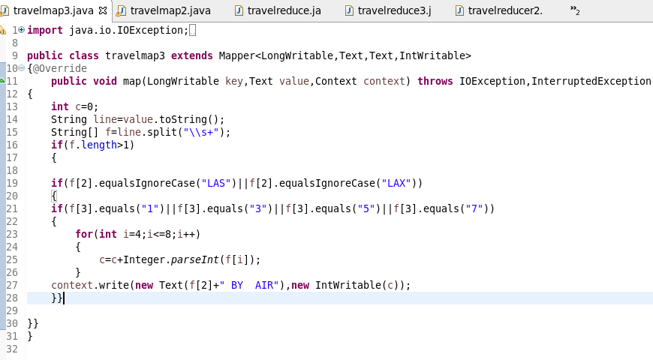

REDUCER FOR QN 3

Count the total number of passengers

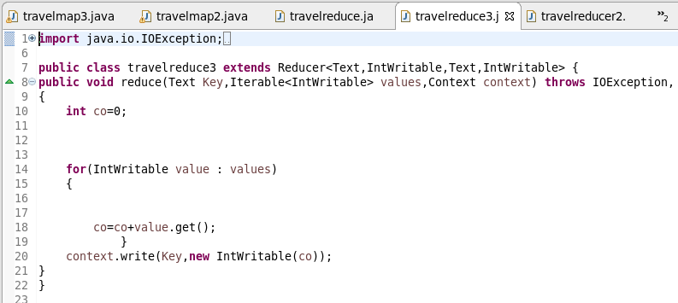

OTPT

