Driver for reading sequence file

Set Input format as SequenceInputfileformat.class to read sequence file

Set Output Format as TextInputformat to write sequence file as Text file

As we want to just read sequence file and write we need Map only job

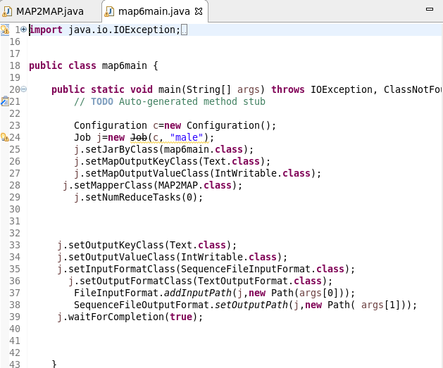

MAPPER CLASS

Used to read input from sequence file

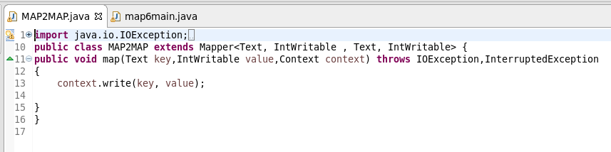

Running jar

INPUT:6.5 assmt sequence file is taken as Input

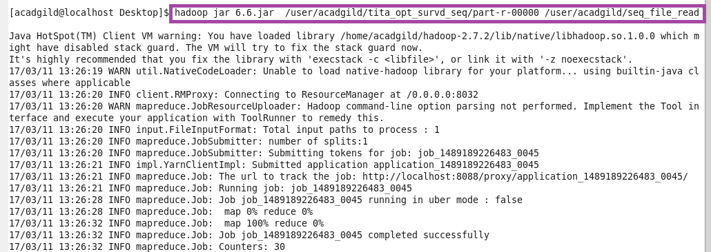

OTPT

