USE CASE OF DOCKER:
Docker is simply an easy way to package software and run at a single step

Test Code:

Sample run before Docker:
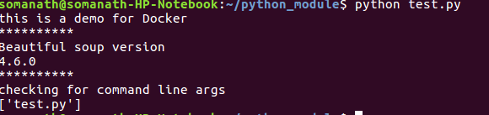

Docker File:
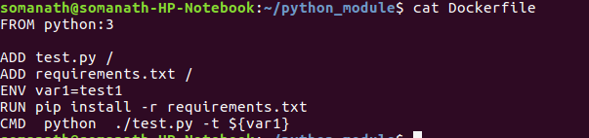

Steps in Building image from Docker:

1.Use docker build to build locally
2.Docker run to complete the Build
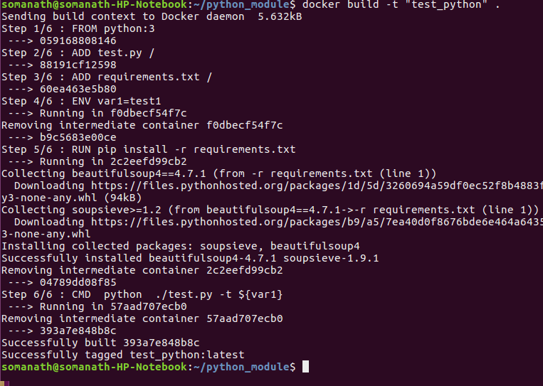

Sample Run through Docker:

Using Cache:
Docker uses cache to install existing packages
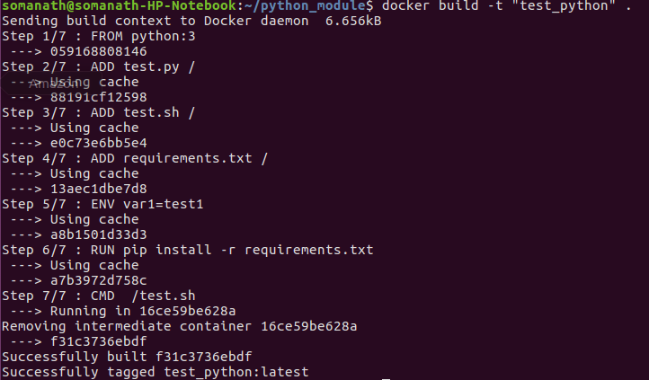

Output through docker

