**USA CRIME ANALYSIS**

**USING MAP REDUCE**

**DRIVER CLASS**

SET 4 JOBS FOR THE 4 TASKS

USED 4 MAPPER CLASSES FOR EACH TASK AND A COMMON REDUCER AND SET THE SAME REDUCER AS THE REDUCER LOGIC IS SAME

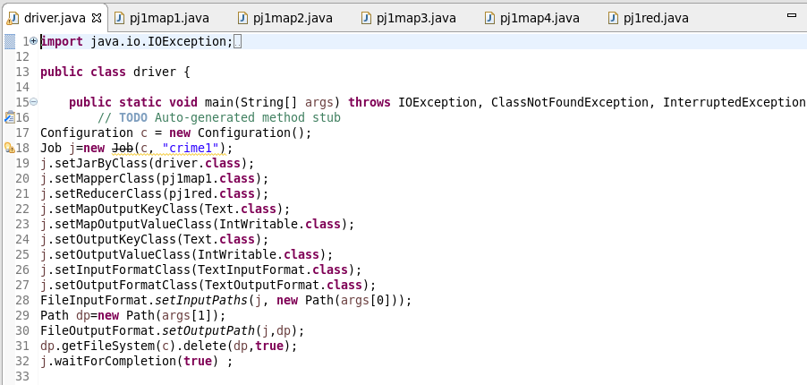

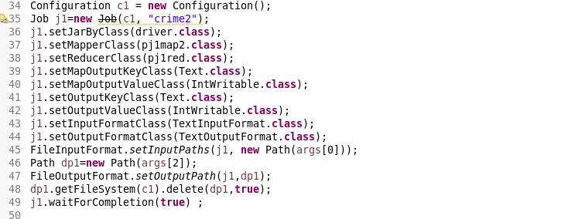

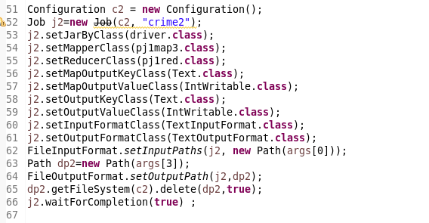

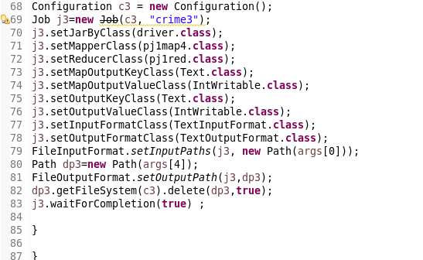

**QN1 1. Write a mapreduce and pig program to calculate the number of cases investigated under each FBI code**

**MAPPER CLASS**

**LOGIC : SENDING THE FBI CODE AS KEY AND A COUNT OF 1 FOR EACH COMPLAINT**

**AS VALUE**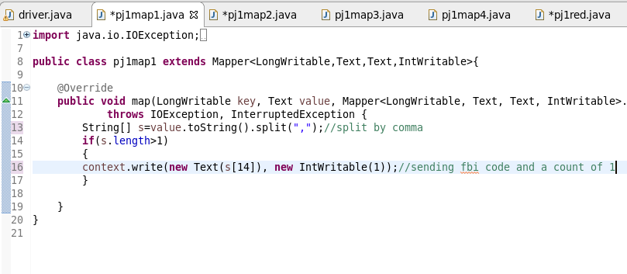

**REDUCER**

**COUNT THE NUMBER OF COMPLAINTS FOR EACH CODE**

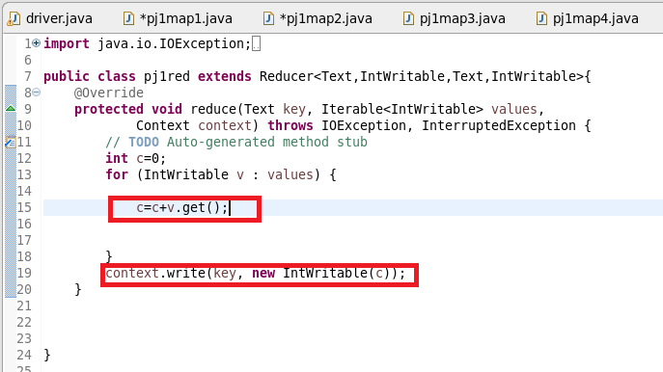

**QN2: Write a mapreduce and pig program to calculate the number of cases investigated under FBI code 32.**

**MAPPER**

**LOGIC: FILTER BY FBI CODE = 32 AND SEND IT AS A KEY AND A COUNT OF 1 FOR EACH COMPLAINT**

**AS VALUE**

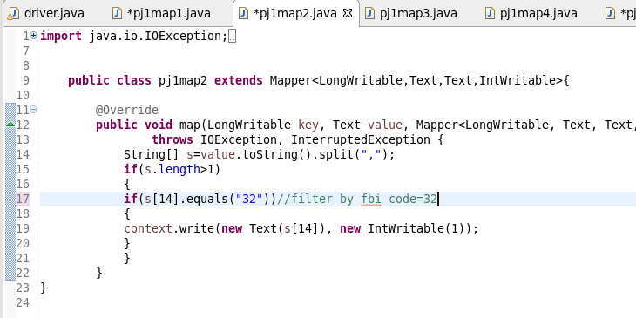

**REDUCER**

**COUNT THE NUMBER OF COMPLAINTS FOR CODE=32**



**QN3. Write a mapreduce and pig program to calculate the number of arrests in theft district wise.**

**MAPPER**

**LOGIC: STEP1:FILTER BY PRIMARY_TYPE AS THEFT**

**SENT DISTRICT AS KEY AND A COUNT OF 1 AS VALUE**

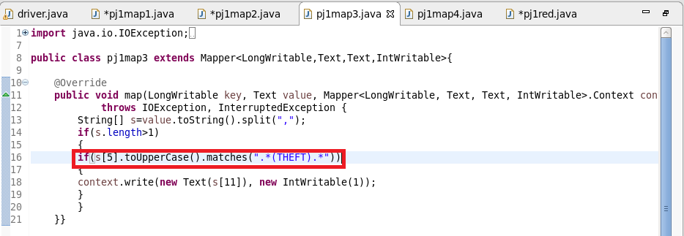

**REDUCER**

**COUNT THE NUMBER OF COMPLAINTS FOR CODE=32**



**QN4Write a mapreduce and pig program to calculate the number of arrests done between October 2014 and October 2015.**

**MAPPER**

**LOGIC :USED DATE FUNCTION AND THEN CHECKED WHETHER ARREST IS TRUE AND SENT TOTAL AS KEY AND A COUNT OF 1 AS VALUE**

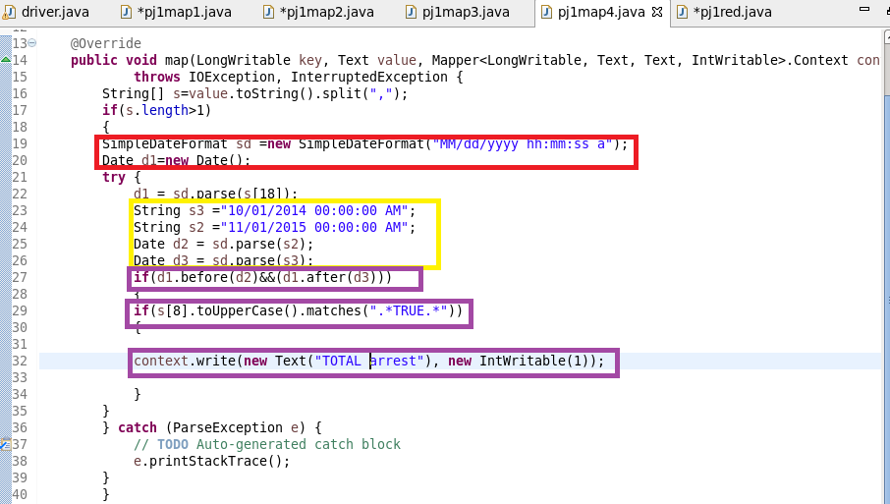

**REDUCER**

**COUNT THE NUMBER OF ARRESTS**

**RUNNING JAR**



**Otpt**

**QN1(PART1)**

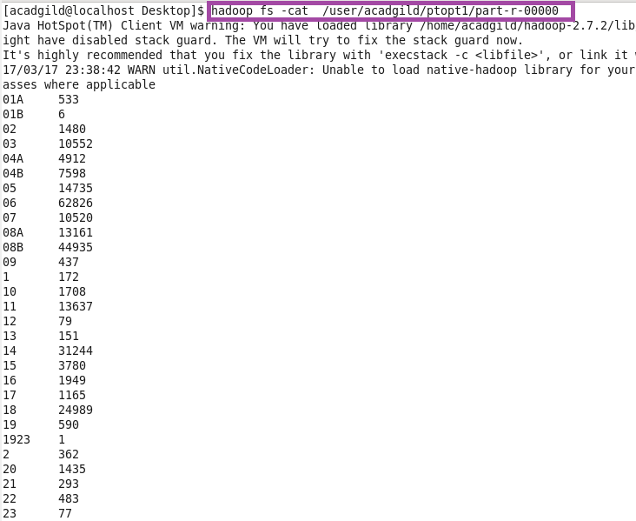

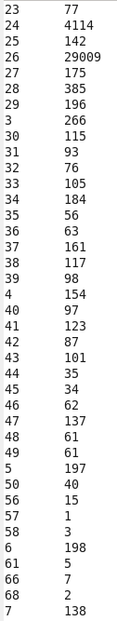

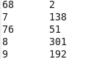

**Otpt2**

**QN2(OPT)**

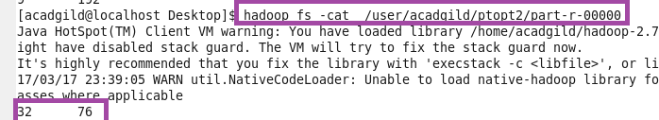

**QN3(Otpt)**

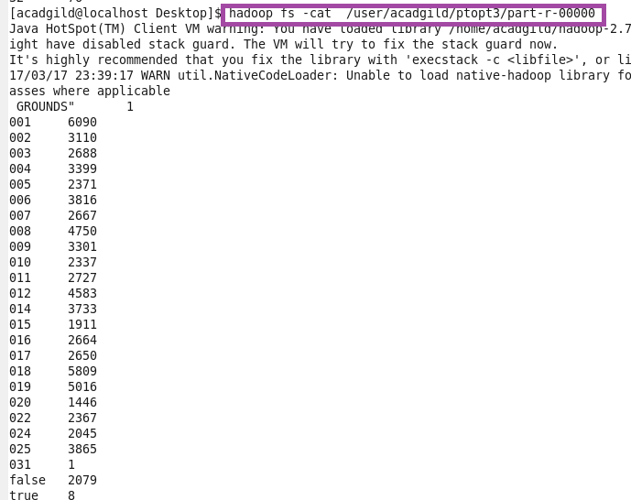

**Otpt4(QN4)**

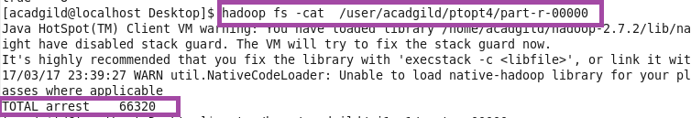

**USING PIG SCRIPT**

**LOGIC**

**QN1: Write a mapreduce and pig program to calculate the number of cases investigated under each FBI code**

**LOGIC:GROUP BY FBI CODE AND MADE A COUNT**

**QN2: Write a mapreduce and pig program to calculate the number of cases investigated under FBI code 32.**

**LOGIC :FILTER BY FBI CODE =32 AND GROUP BY FBI CODE AND MADE A COUNT**

**QN3: 3. Write a mapreduce and pig program to calculate the number of arrests in theft district wise**

**LOGIC: GROUP BY DISTRICT AND THEN FILTER BY ARREST=TRUE AND MADE A COUNT**

**QN4. 4. Write a mapreduce and pig program to calculate the number of arrests done between October 2014 and October 2015.**

**USED TODATE FUNCTION TO CONVERT INTO DATE AND THEN USED DAYS BETWEEN TO FILTER BY DATE AND MADE A COUNT**

**PIG COMMANDS**

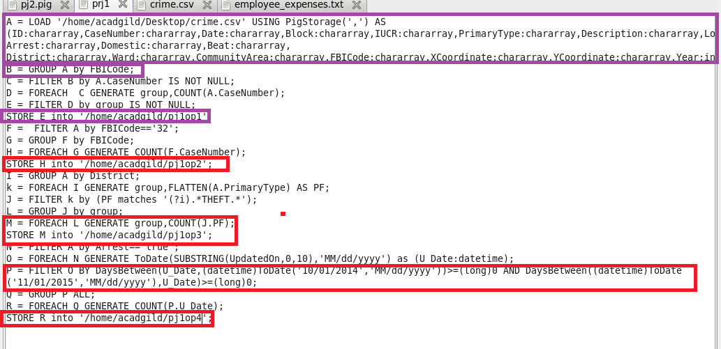

**RUNNING PIG SCRIPT**

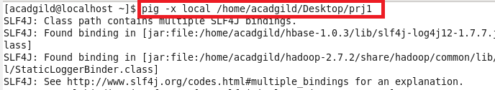

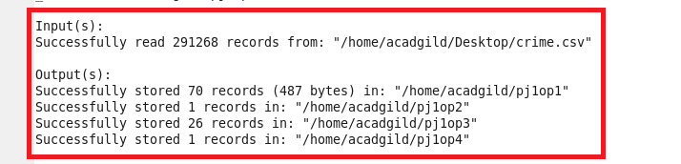

**PIG OTPT1**

**PART1**

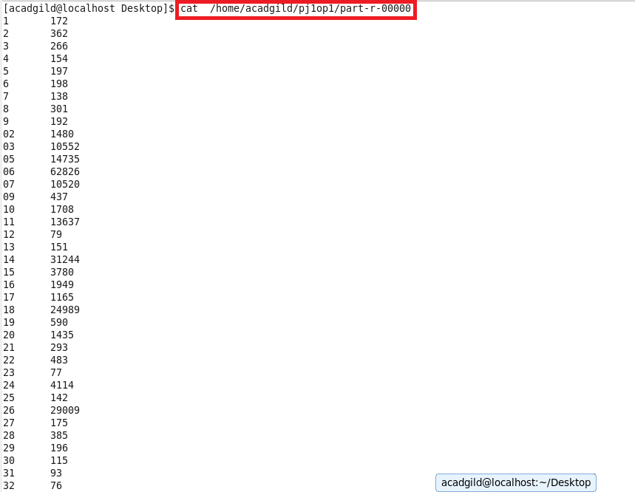

**PART1(CONTND)**

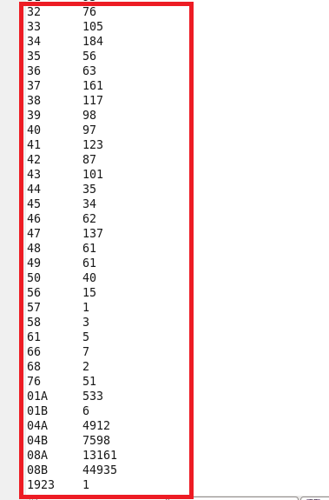

**QN2(PJ1OP2)**

**QN3(PJ1OP3)**

**QN4(PJ1OP4)**

