USA CRIME ANALYSIS
USING MAP REDUCE
DATA DESCRIPTION:
This dataset contains attributes related to crimes taking place in various areas like type of
crime, FBI code related to that criminal case, arrest frequency, location of
crime etc.
The various fields in the data in the followining order
ID,Case Number,Date,Block,IUCR,Primary Type,Description,Location
Description,Arrest,Domestic,Beat,District,Ward,Community
Area,FBICode,X Coordinate,Y
Coordinate,Year,Updated On,Latitude,Longitude,Location

DRIVER CLASS
Line1 to Line 14: Impoerting the necessary jar file
Line 17:Declaring the Configuration object for the job
Line18:Declaring the Job for the first task
Line 19:Setting jar by class
Line 20: Setting Mapper class
Line 21:Setting reducer class
Line 22 to Line 26:Setting mapOutput Key value pairs and Setting reducer Output key value pairs

Line 28:Setting the input path from which the data will be processed
Line 30:Setting the Output path and job wait for completion as true
Since there are 4 jobs the same steps is repeated for the other 3 jobs
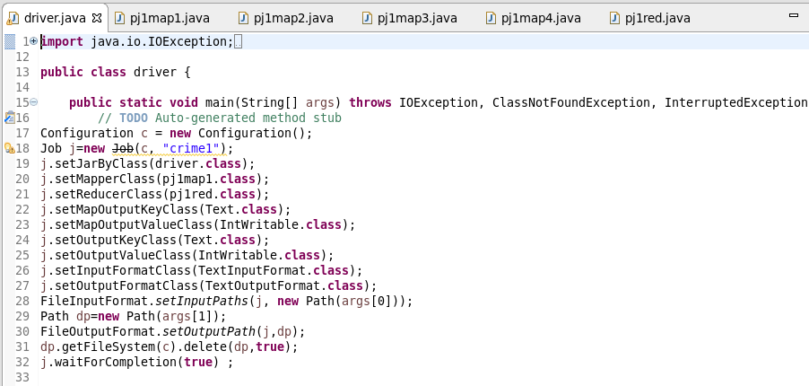

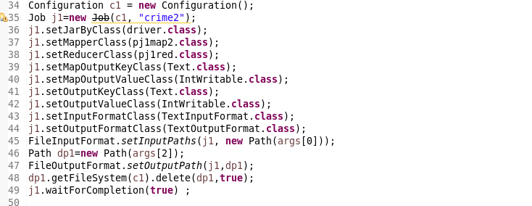
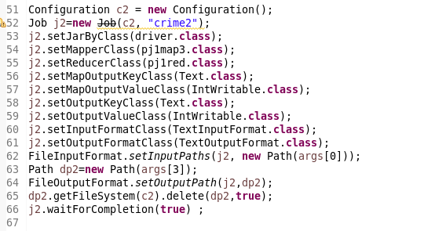
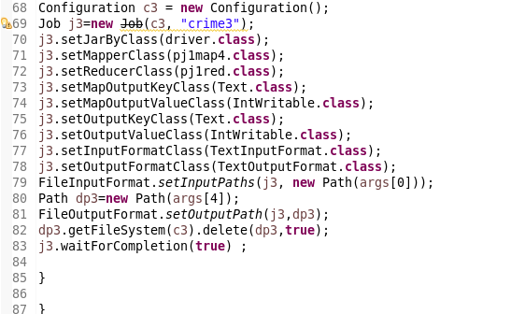
QN1 1. Write a mapreduce and pig program to calculate the number of cases investigated under each FBI code
MAPPER CLASS
LOGIC : SENDING THE FBI CODE AS KEY AND A COUNT OF 1 FOR EACH COMPLAINT
AS VALUE
Description:
Line 1 to line 10:Importing the necessary jars for map reduce
Line 11:Overriding the map method of mapper class to do our computation
Line 13:Splitting the input data by comma
Line 14 :ensure proper splitting by setting s.length>1 to avoid array index exception
Line 16:SENDING THE FBI CODE AS KEY AND A COUNT OF 1 FOR EACH COMPLAINT in context

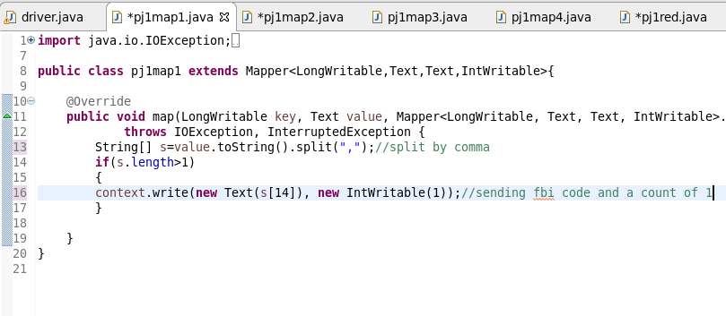
REDUCER
COUNT THE NUMBER OF COMPLAINTS FOR EACH CODE
Description:
Line 1 to 9:Importing the necessary jars for map reduce
Line 9:Overriding the reduce method to do our computation
Line 12:Declaring a variable of Int datatype ’c’ to sum up the complaints
Line 13:Iterating the values for each key
Line 15:Adding the complaints
Line 19:code is written as key and tolal count as value

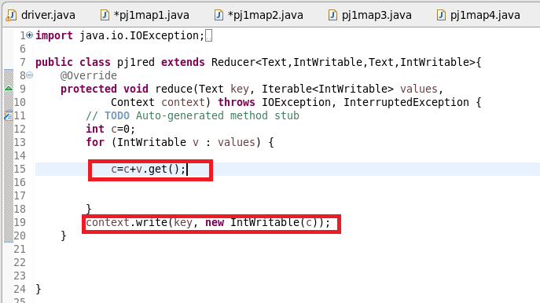
QN2: Write a mapreduce and pig program to calculate the number of cases investigated under FBI code 32.
MAPPER
LOGIC: FILTER BY FBI CODE = 32 AND SEND IT AS A KEY AND A COUNT OF 1 FOR EACH COMPLAINT
AS VALUE
Description:
Line 1 to line 10:Importing the necessary jars for map reduce
Line 11:Overriding the map method of mapper class to do our computation
Line 14:Splitting the input data by comma
Line 15:ensure proper splitting by setting s.length>1 to avoid array index exception
Line 17:checking the FBI Code equal to 32 by if condition
Line 19:SENDING THE FBI CODE AS KEY AND A COUNT OF 1 FOR EACH COMPLAINT in context

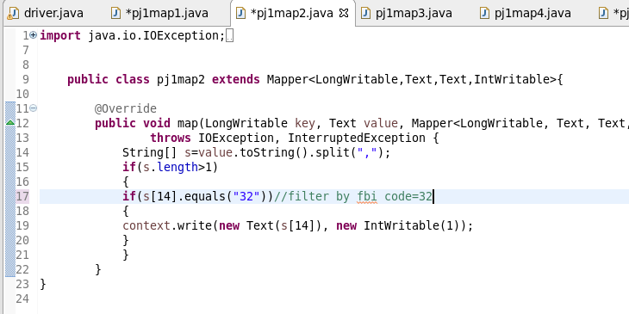
REDUCER
COUNT THE NUMBER OF COMPLAINTS FOR CODE=32
Description:
Line 1 to 9:Importing the necessary jars for map reduce
Line 9:Overriding the reduce method to do our computation
Line 12:Declaring a variable of Int datatype ’c’ to sum up the complaints for code 32
Line 13:Iterating the values for key
Line 15:Adding the complaints
Line 19:code is written as key and tolal count as value

QN3. Write a mapreduce and pig program to calculate the number of arrests in theft district wise.
MAPPER
LOGIC: STEP1:FILTER BY PRIMARY_TYPE AS THEFT
SENT DISTRICT AS KEY AND A COUNT OF 1 AS VALUE
Description:
Line 1 to line 10:Importing the necessary jars for map reduce
Line 11:Overriding the map method of mapper class to do our computation
Line 13:Splitting the input data by comma
Line 14 :ensure proper splitting by setting s.length>1 to avoid array index exception
Line 16:FILTER BY PRIMARY_TYPE AS THEFT
Line 18:SENDING THE district AS KEY AND A COUNT OF 1 FOR EACH COMPLAINT in context
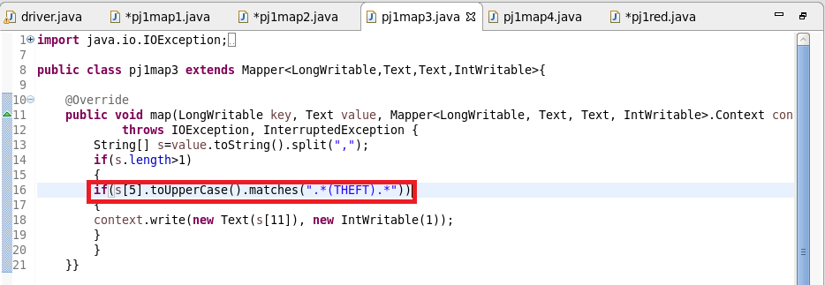
REDUCER
COUNT THE NUMBER OF COMPLAINTS FOR CODE=32
Description:
Line 1 to 9:Importing the necessary jars for map reduce
Line 9:Overriding the reduce method to do our computation
Line 12:Declaring a variable of Int datatype ’c’ to sum up the complaints for each district
Line 13:Iterating the values for key
Line 15:Adding the complaints
Line 19:District is written as key and tolal count as value

QN4Write a mapreduce and pig program to calculate the number of arrests done between October 2014 and October 2015.
MAPPER
LOGIC :USED DATE FUNCTION AND THEN CHECKED WHETHER ARREST IS TRUE AND SENT TOTAL AS KEY AND A COUNT OF 1 AS VALUE
Description:

Line 1 to line 10:Importing the necessary jars for map reduce
Line 14:Overriding the map method of mapper class to do our computation
Line 16:Splitting the input data by comma
Line 17 :ensure proper splitting by setting s.length>1 to avoid array index exception
Line 19:Creating a new Instance of simple date format with the given date format
Line 22:Since arrest date is update on cloumn 19,converting the string to date
Line 23:Declaring a string with date as october 1 2014
Line 24:Declaring a string with date as october 1 2015
Line 25 and 26:Parsing it into date format
Line 27:checking the arrest within the two dates
Line 29:checking for arrest is true
Line 32: Sending arrest as key and a count of 1 as value
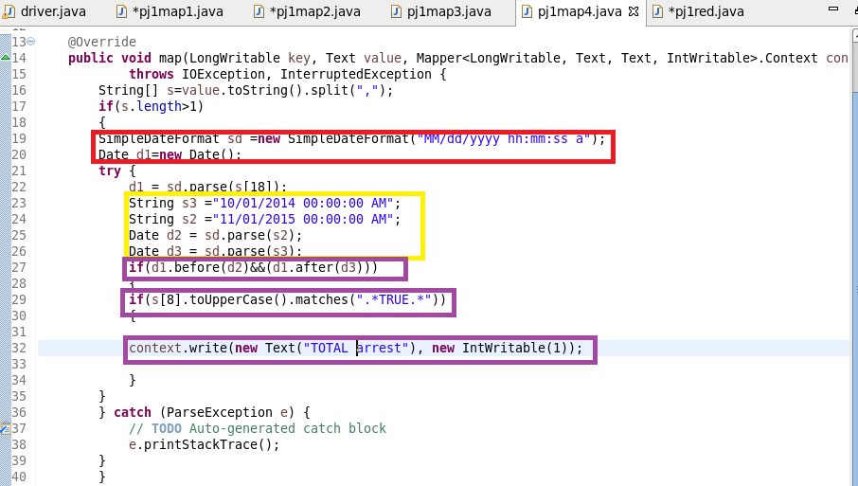
REDUCER
COUNT THE NUMBER OF ARRESTS
DESCRIPTION:
Line 1 to 9:Importing the necessary jars for map reduce
Line 9:Overriding the reduce method to do our computation
Line 12:Declaring a variable of Int datatype ’c’ to sum up the complaints for each district
Line 13:Iterating the values for key Total arrest
Line 15:Adding the arrest
Line 19:Total Arrest is written as key and tolal count as value
RUNNING JAR
Otpt
QN1(PART1)

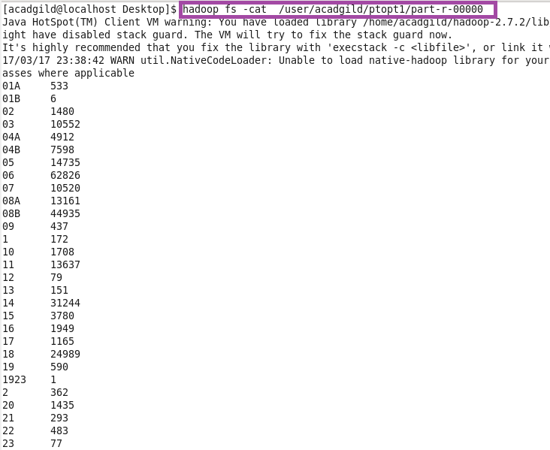

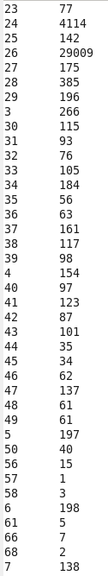

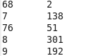
Otpt2

QN2(OPT)

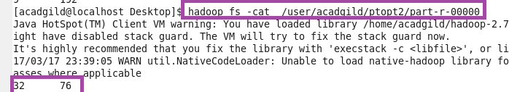
QN3(Otpt)

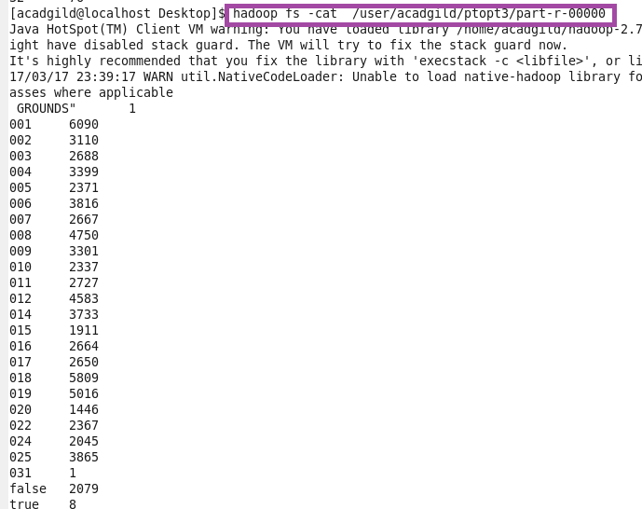
Otpt4(QN4)
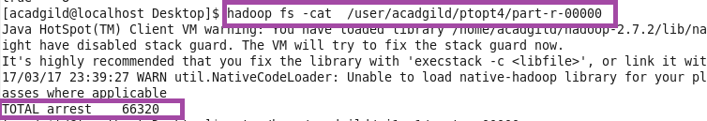

USING PIG SCRIPT
LOGIC
QN1: Write a mapreduce and pig program to calculate the number of cases investigated under each FBI code
LOGIC:GROUP BY FBI CODE AND MADE A COUNT
Description:
Step1: Loading the Data using PigStorage(‘,’) as the Input data is Delimited by comma
Step2:Groupping by FbI Code
Step3: Filtering the null values
Step4:Counting the cases under each FBI code
Step 5:Storing the result
QN2: Write a mapreduce and pig program to calculate the number of cases investigated under FBI code 32.
LOGIC :FILTER BY FBI CODE =32 AND GROUP BY FBI CODE AND MADE A COUNT
Description:
Step1: Loading the Data using PigStorage(‘,’) as the Input data is Delimited by comma
Step2: Filtering by FBI Code equal to 32
Step3:Group by FBI Code
Step4:Counting the cases under 32 FBI code
Step5:Storing the Result

QN3: 3. Write a mapreduce and pig program to calculate the number of arrests in theft district wise
LOGIC: GROUP BY DISTRICT AND THEN FILTER BY ARREST=TRUE AND MADE A COUNT
Description:
Step1: Loading the Data using PigStorage(‘,’) as the Input data is Delimited by comma
Step2:flattening the Primary type
Step3: Filtering by Primary type as theft
Step4:Groupping and Counting the cases under arrest where arrest is true
Step5:Storing the Result

QN4. 4. Write a mapreduce and pig program to calculate the number of arrests done between October 2014 and October 2015.
USED TODATE FUNCTION TO CONVERT INTO DATE AND THEN USED DAYS BETWEEN TO FILTER BY DATE AND MADE A COUNT

PIG COMMANDS
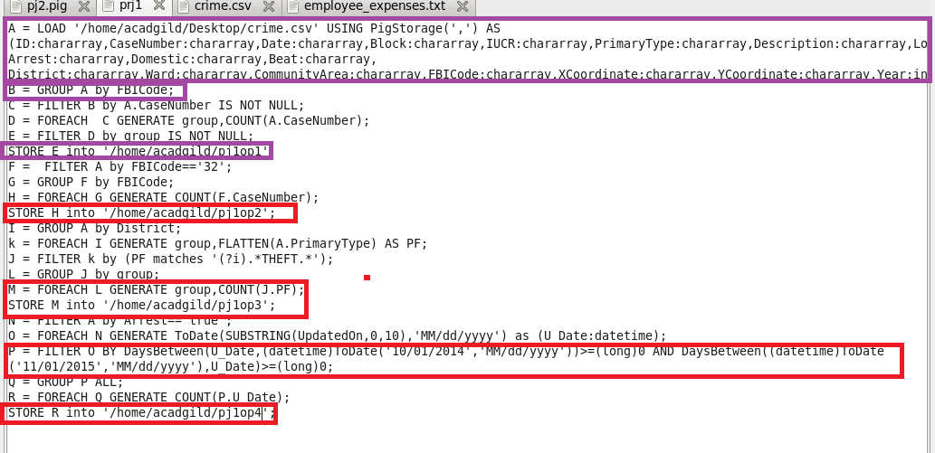

RUNNING PIG SCRIPT
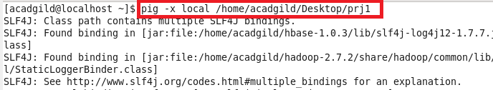
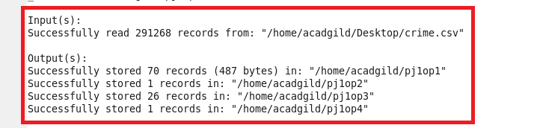
PIG OTPT1
PART1

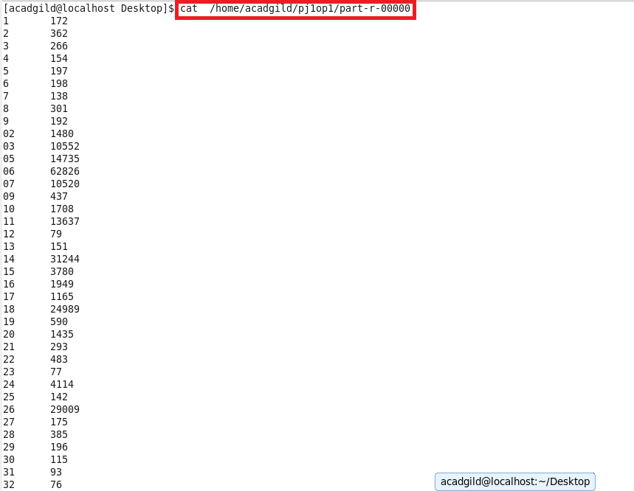

PART1(CONTND)

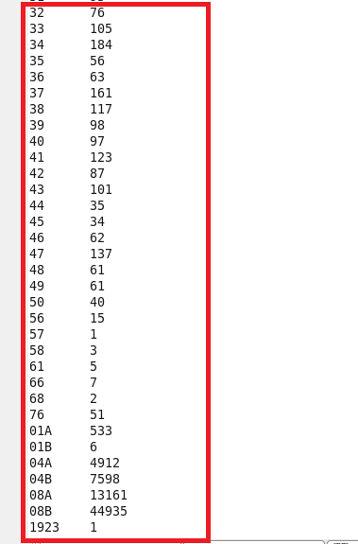

QN2(PJ1OP2)
QN3(PJ1OP3)
QN4(PJ1OP4)

