Consumer complaint Analysis
Data Description:
The dataset consists of consumer complaints details. In the process consumer files the complaints to consumer forum and then consumer forum forwards the complaint to respective company.
It contains the following fields
Date received,Product,Sub-product,Issue,Sub-issue,Consumer complaint narrative,Company public response,Company,State,ZIP code,Submitted via,Date sent to company,Company response to consumer,Timely response?,Consumer disputed?,Complaint ID,
sample data
10/16/2015,Debt collection,"Other (phone, health club, etc.)",Cont'd attempts collect debt not
owed,Debt was discharged in bankruptcy,,,"Convergent Resources, Inc.",OH,438XX,Web,10/16/2015,Closed with explanation,Yes,,1612132
This entire column "Other (phone, health club, etc.)"
Should be product but, if we split this file based on comma then this column will be splitted into 3 columns which will result in wrong outputs.
In order to tackle this we should remove the commas present only inside double quotes

MAP REDUCE TO REMOVE ALL COMMAS WITHIN DOUBLE QUOTES
DRIVER CLASS
Line1 to Line 14: Impoerting the necessary jar file
Line 18:Declaring the Configuration object for the job
Line19:Declaring the Job for the first task
Line 20:Setting jar by class
Line 21 to Line 25:Setting mapOutput Key value pairs and Setting reducer Output key value pairs
Line 26: Setting Mapper class
Line 27:As it is a map only job setting setnum reduce tasks as”0”

Line 29:Setting the input path from which the data will be processed
Line 31:Setting the Output path
Line 33: job wait for completion as true
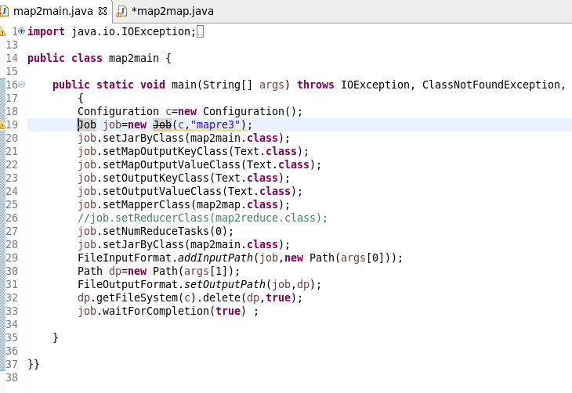

MAPPER CLASS
LOGIC: I WILL SET A BOOLEAN AS FALSE AND IT WILL REVERSES IT STATE WHEN EVER THERE IS A DOUBLE QUOTE
STEP 2: WHENEVER IT ENCOUNTERS A COMMA AND IS WITHIN DOULE QUOTES IT REPLACES THE COMMA AND IT STORE OR ELSE THE CHARACTER IS WRITTEN WITH THE HELF OF If CONDITION AS HIGHLIGHTED
Description:
Line 1 to line 10:Importing the necessary jars for map reduce
Line 12:Overriding the map method of mapper class for our computation
Line 15:Storing the entire value of mapper in the string “line”
Line16:Defining a string line1 where the new records after removing commas within quotes will be concatenated
Line 17:Setting a boolean m as False
Line 18:running a for loop starting from starting index to last index of string line
Line 19 to 23: WHENEVER the char at that index is double quotes(“),the boolean gets reversed
Line 23 to 27:if the char at the index is comma and boolean is true indicating that within double quotes the comma is replaced
Line 28:the character get appended with the new string line1.

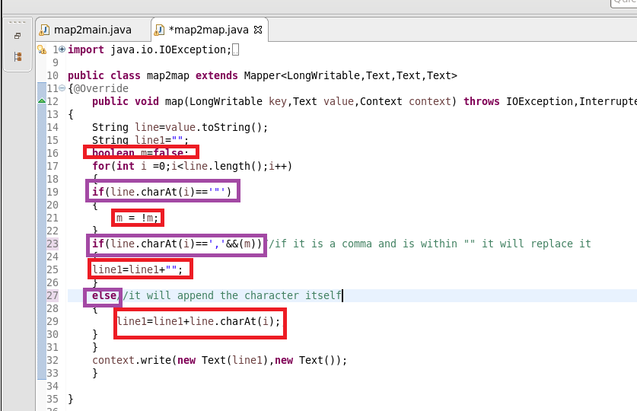
RUNNING JAR
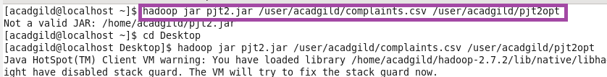
OTPT
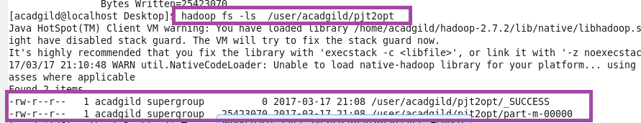
AS FROM THE FIGURE YOU CAN SEE THAT THE COMMA WITHIN DOUBLE QUOTES ARE REPLACED
AS SHOWN IN HIGHLIGHTED
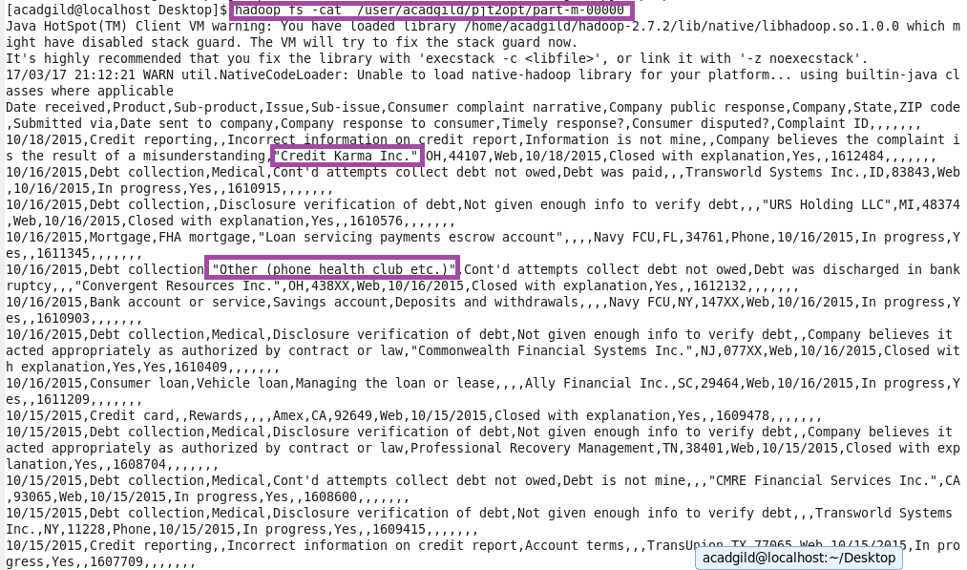
USED GET COMMAND TO COPY TO LOCAL FOR DOING PIG
PIG COMMANDS
- Write a pig script to find no of complaints which got timely response
LOGIC:
Step 1:loading cleared data
Step2: filter complaints where timely response is true
Step 3: group by timely response and make a count of id

- Write a pig script to find no of complaints where consumer forum forwarded the complaint same day they received to respective company
Step1:loading cleared data
Step2:filter where date received =date sent to company
Step 3:making COUNT AFTER GROUPIN BY ALL

- Write a pig script to find list of companies topping in complaint chart (companies with maximum number of complaints)
I AM MAKING A LIST OF TOP 10 COMPANIES
Step1:loading cleared data
Step2:group by company name
Step3:make a count of cid for Each company
Step4: order by desc order of counts and limit by 10
- Write a pig script to find no of complaints filed with product type has "Debt collection" for the year 2015
Step1:filter by product =”DEBT COLLECTION”
Step2:USED SUBSTRING FUNCTION TO GENERATE YEAR as “DAT”
Step3:filter by DAT==2015
STEP4:MADE COUNT

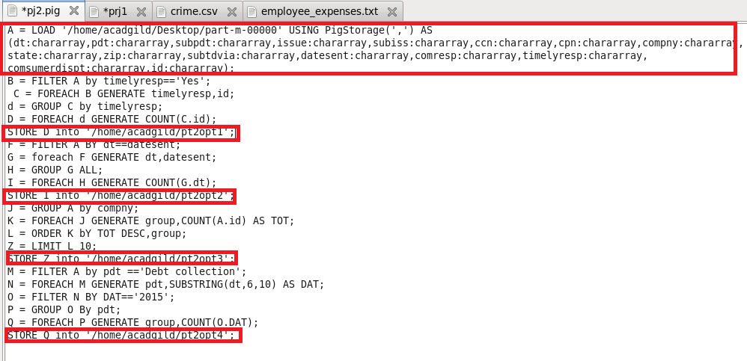
RUNNING PIG SCRIPT
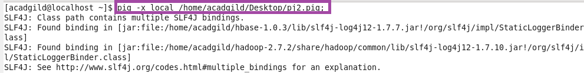
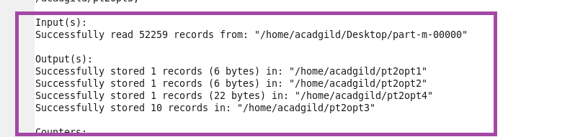
OTPT
