**MAP REDUCE TO REMOVE ALL COMMAS WITHIN DOUBLE QUOTES**

**DRIVER CLASS**

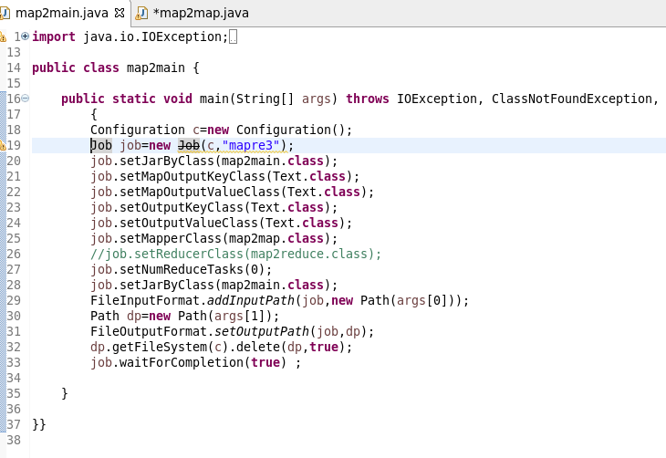

**MAPPER CLASS**

**LOGIC: I WILL SET A BOOLEAN AS FALSE AND IT WILL REVERSES IT STATE WHEN EVER THERE IS A DOUBLE QUOTE**

**STEP 2: WHENEVER IT ENCOUNTERS A COMMA AND IS WITHIN DOULE QUOTES IT REPLACES THE COMMA AND IT STORE OR ELSE THE CHARACTER IS WRITTEN WITH THE HELF OF If CONDITION AS HIGHLIGHTED**

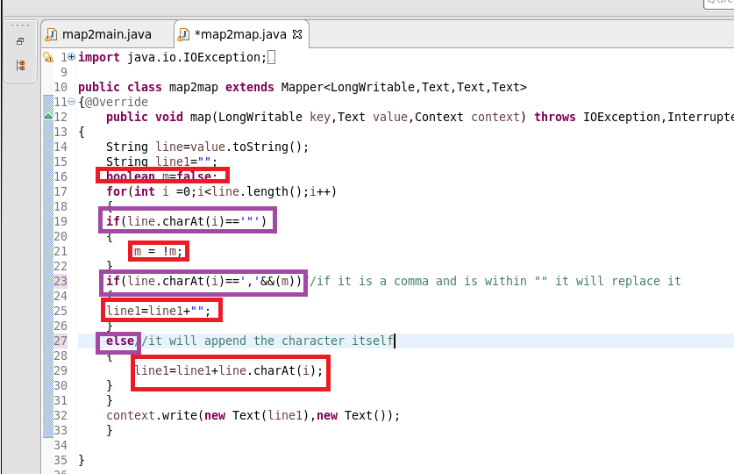

**RUNNING JAR**

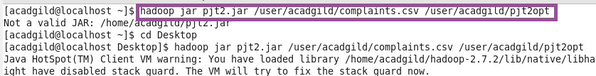

**OTPT**

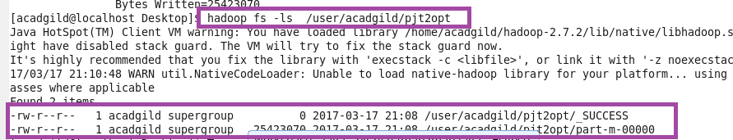

**AS FROM THE FIGURE YOU CAN SEE THAT THE COMMA WITHIN DOUBLE QUOTES ARE REPLACED**

**AS SHOWN IN HIGHLIGHTED**

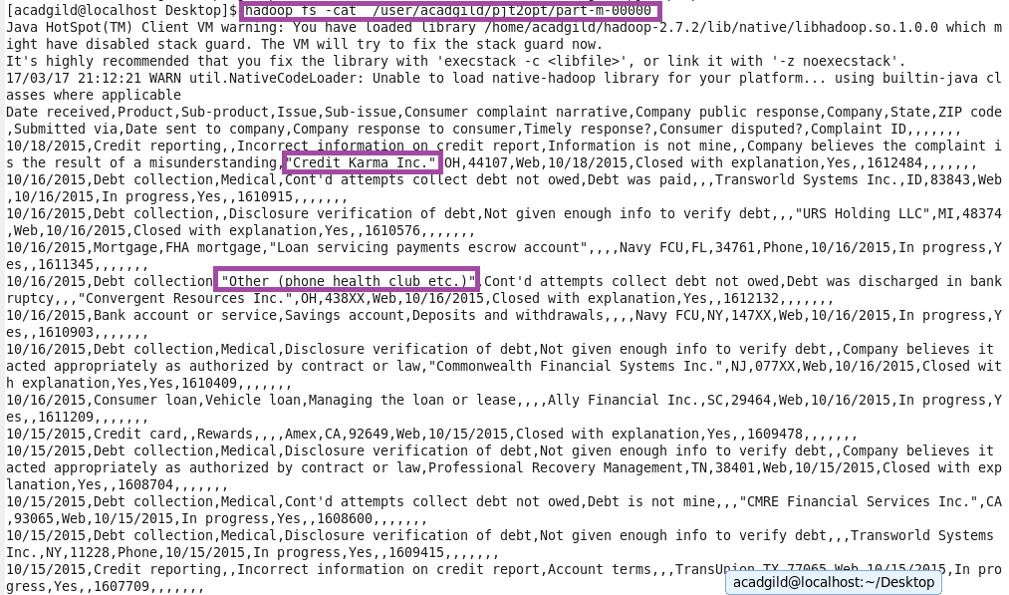

**USED GET COMMAND TO COPY TO LOCAL FOR DOING PIG**



**PIG COMMANDS**

1. **Write a pig script to find no of complaints which got timely response**

**LOGIC:**

**Step 1:loading cleared data**

**Step2: filter complaints where timely response is true**

**Step 3: group by timely response and make a count of id**

1. **Write a pig script to find no of complaints where consumer forum forwarded the complaint same day they received to respective company**

**Step1:loading cleared data**

**Step2:filter where date received =date sent to company**

**Step 3:making COUNT AFTER GROUPIN BY ALL**

1. **Write a pig script to find list of companies topping in complaint chart (companies with maximum number of complaints)**

**I AM MAKING A LIST OF TOP 10 COMPANIES**

**Step1:loading cleared data**

**Step2:group by company name**

**Step3:make a count of cid for Each company**

**Step4: order by desc order of counts and limit by 10**

1. **Write a pig script to find no of complaints filed with product type has "Debt collection" for the year 2015**

**Step1:filter by product =”DEBT COLLECTION”**

**Step2:USED SUBSTRING FUNCTION TO GENERATE YEAR as “DAT”**

**Step3:filter by DAT==2015**

**STEP4:MADE COUNT**

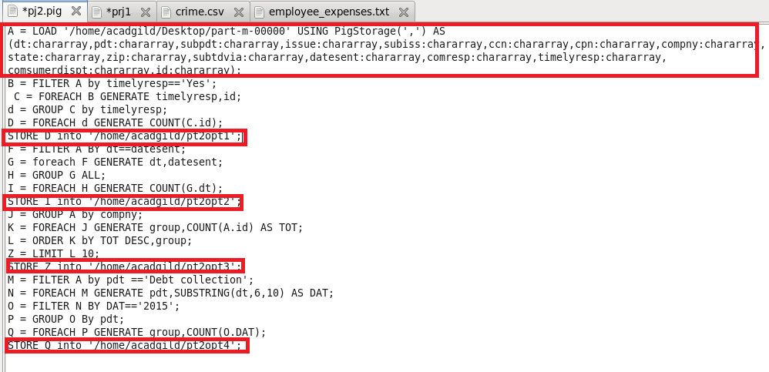

**RUNNING PIG SCRIPT**

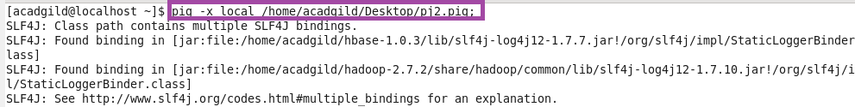

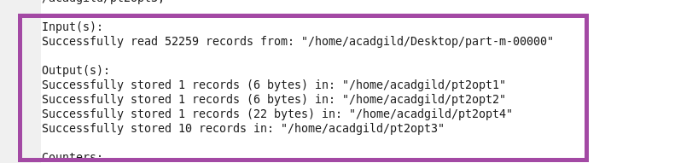

**OTPT**

