**DDL IN HIVE**

DDL MEANS DATA DEFINITION LANGUAGE which provide commands to create modify and remove database objects such as table.

DDL Statement in hive

Following are the DDL statements in hive

**1.CREATE DATABASE/SCHEMA, TABLE, VIEW, FUNCTION, INDEX**

**2.DROP DATABASE/SCHEMA, TABLE, VIEW, INDEX**

**3.TRUNCATE TABLE**

**4.ALTER DATABASE/SCHEMA, TABLE, VIEW**

**5.SHOW DATABASES/SCHEMAS, TABLES, TBLPROPERTIES, VIEWS, PARTITIONS, FUNCTIONS, INDEX[ES], COLUMNS, CREATE TABLE**

**6.DESCRIBE DATABASE/SCHEMA, table_name, view_name**

**Create database**

**It** is used to create a database

**Syntax**

**CREATE (DATABASE|SCHEMA) [IF NOT EXISTS] database_name here if not exists is optional;**

**example**

a database demo is created

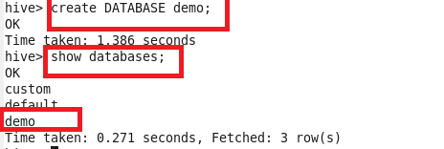

**Create Table**

**Suppose we want to create a demo_table into the above created database “demo”**

**Use “use database ” to go into database AND THE TABLE IS CREATED AS SHOWN BELOW**

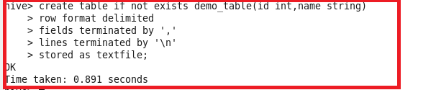

**HERE TABLE NAME IS “ demo_table” where input fields are terminated by “,” and stored as text file.By default it is stored as text file it can also be stored as sequence file ,RC file**

**TRUNCATE TABLE:**

**It is used to delete all the records of a table but schema is not deleted**

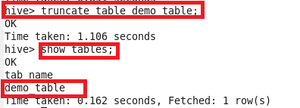

**As we see truncate table only delete the records but the table schema is not deleted**

**Describe table :**

**It is used to describe the table**

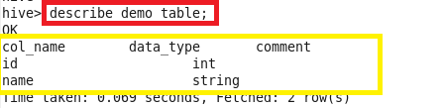

**If we want detailed description we can use formatted word before table name as shown**

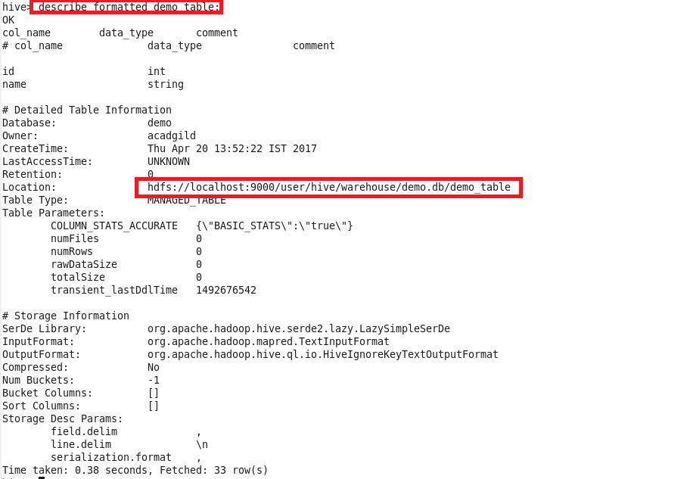

**Alter table :**

**Alter table can be used to rename table as shown**

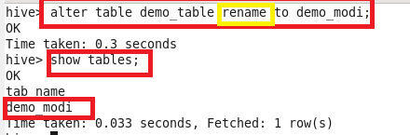

**Alter table can also be used to add column**

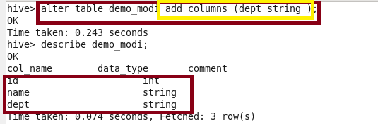

**Drop table**

**It is used to delete table with its full schema**

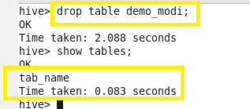

**Drop database**

**It is used to delete the database**

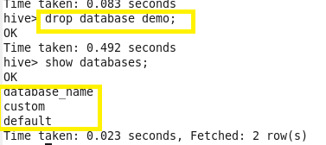

**DML IN HIVE**

**It is a sel of commands used for selecting, inserting, updating data from table**

**In hive the following DML are used**

**Select:**

**It is used to select data from a table**

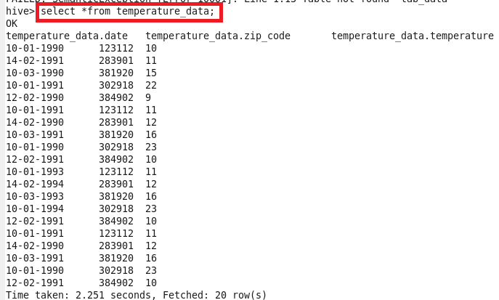

**Load Data:It is used to insert data from a file in Hdfs or local location**

**Here data is loaded from local location as shown**



**HiveQL Manipulations**

**Select where**

**It is used to filer data by using where as shown**

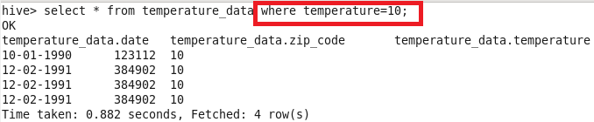

**Select orderby/sort by**

**It is used to order the data by ascending or descending**

**Here the data is sorted based on desc order as shown below**

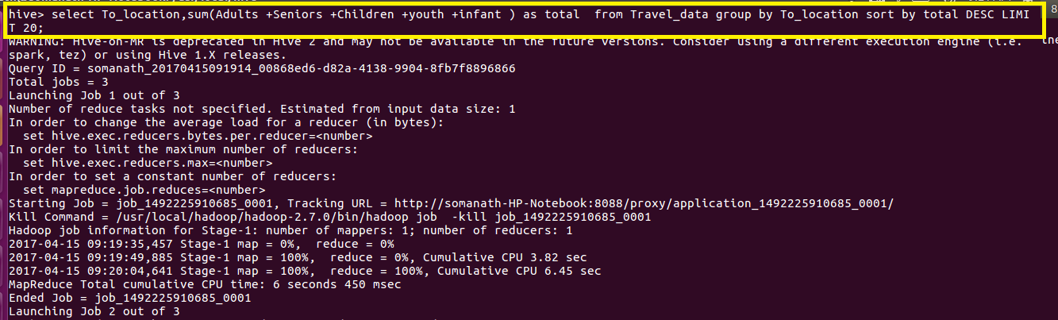

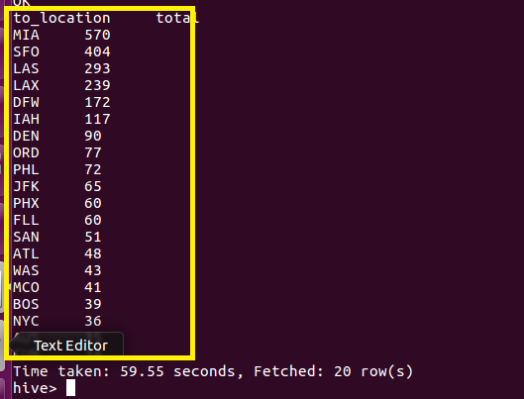

**Select group by :**

**It is used to perform grouping operation on data selected**

**Here grouping is done as per skill and counting is made**

