**Build and Deploy hadoop word count program using SBT**

**Input file**

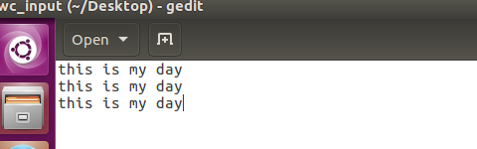

**Step1:CREATED A Project”wordcount_sbt” IN TERMINAL AND In source/main/java folder added mapper.jav,driver.java,reducer and build.sbt in root.**



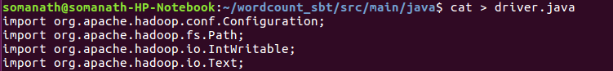

**USE sbt compile command TO build the sbt project**

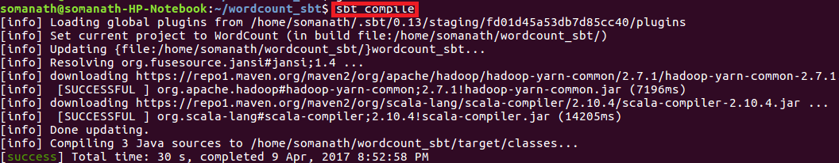

**Step3:Used sbt eclipse to build the project and classpath that are required for eclipse**

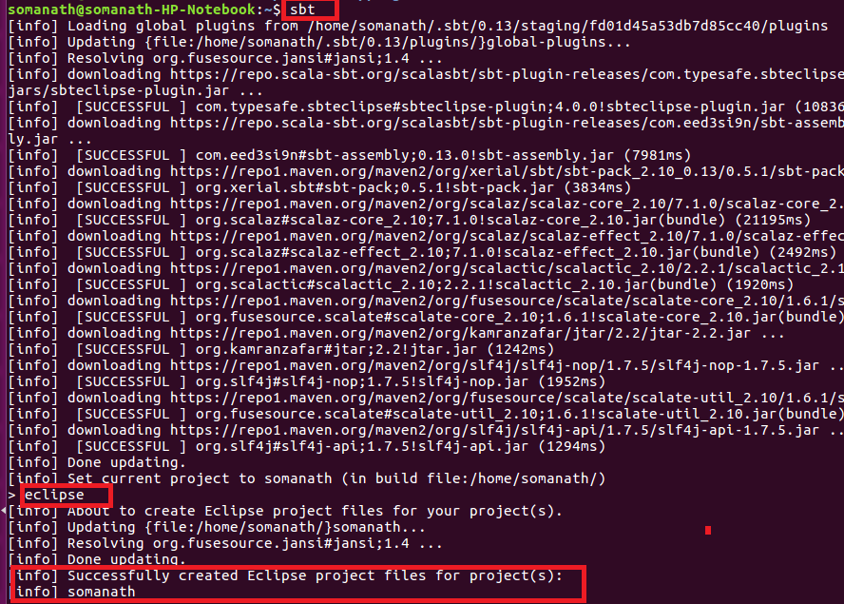

**Step4:Importing project into Eclipse**

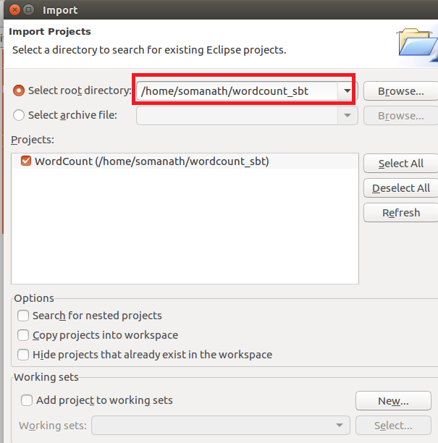

NOW WE CAN SEE IN PROJECT EXPLORER THE WORDCOUNT PROJECT IS CONVERTED TO **Sbt PROJECT** INSIDE ECLIPSE

Driver

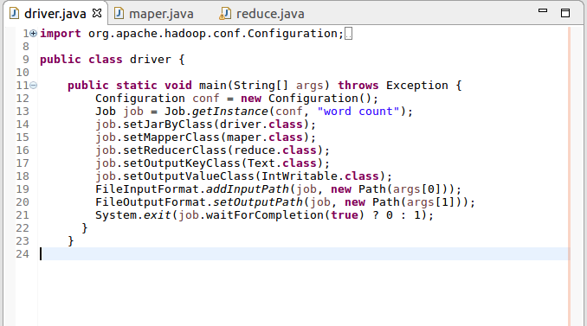

**Mapper:**

In mappersplit the words by space and send word as key and count of 1 as value

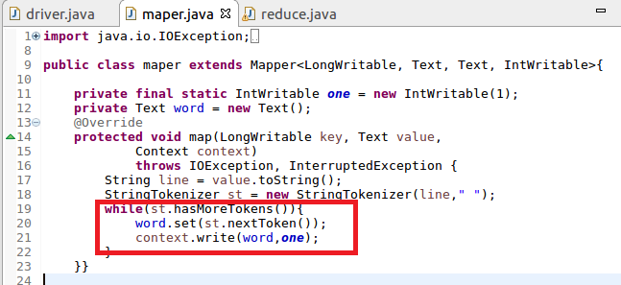

**Reducer**

Count the total occurrence of words

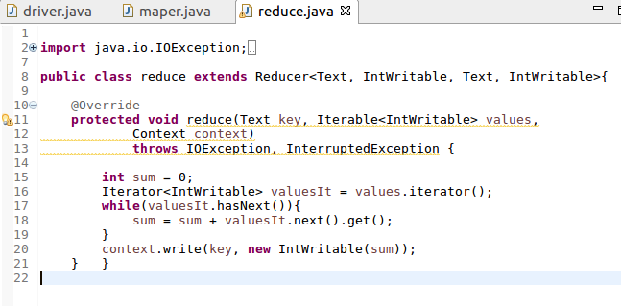

**In root directory added a build.sbt file and added the following dependencies**

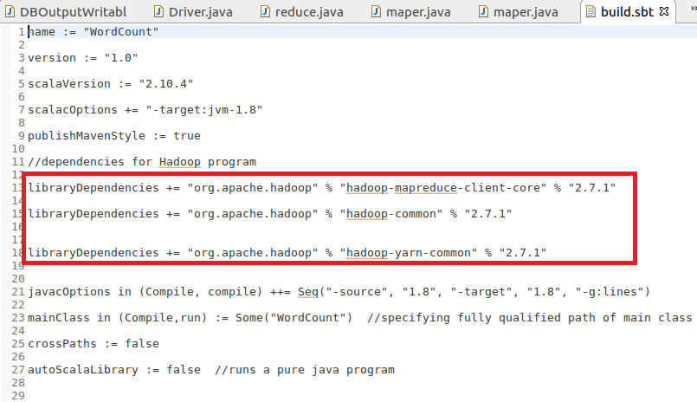

Step4:  used **sbt package to**  for building the JAR file**.**After successfully packaging the class files as a JAR, you can see the jar file in the **target directory**.

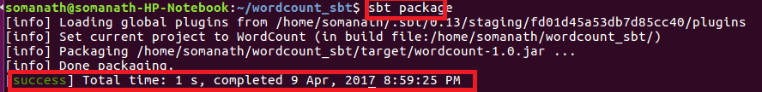

**Step5:Running jar file create d by sbt**

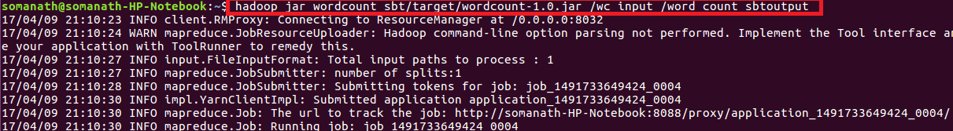

Output

