**Build and Deploy hadoop word count program using Gradle**

**Input file**

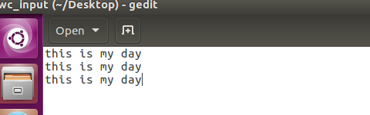

**Step1:CREATED A Project”wordcount” IN TERMINAL AND In source/main/java folder added mapper.jav,driver.java,reducer . Java as shown**

**In root directory added a build.gradle file and added the following dependencies(image shown below of gradle build)**

**USE GRADLE BUILD TO build the Gradle project**

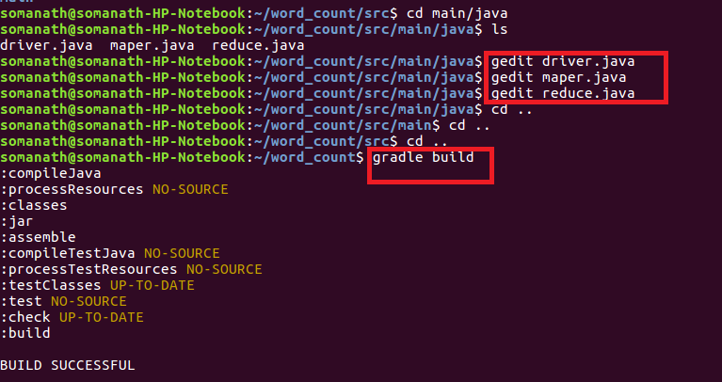

**Step3:Used Gradle eclipse to build the project and classpath that are required for eclipse**

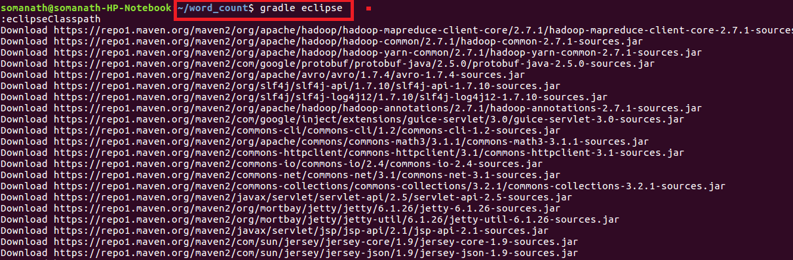

**Build Success: build successful will be displayed and word count jar file will be created in libs**

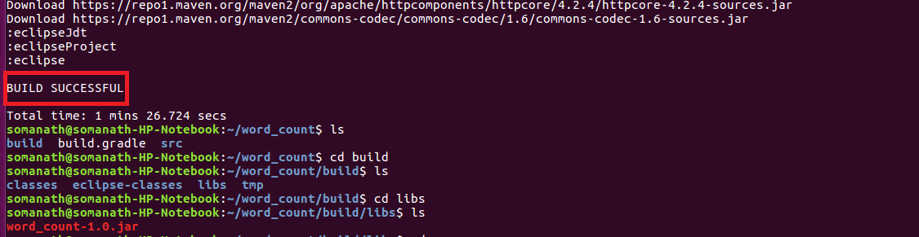**Step4:Importing project into Eclipse**

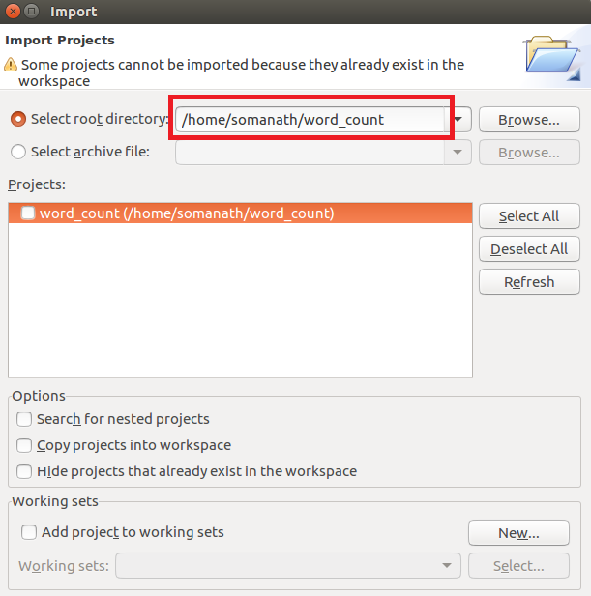

NOW WE CAN SEE IN PROJECT EXPLORER THE WORDCOUNT PROJECT IS CONVERTED TO GRADLE PROJECT INSIDE ECLIPSE

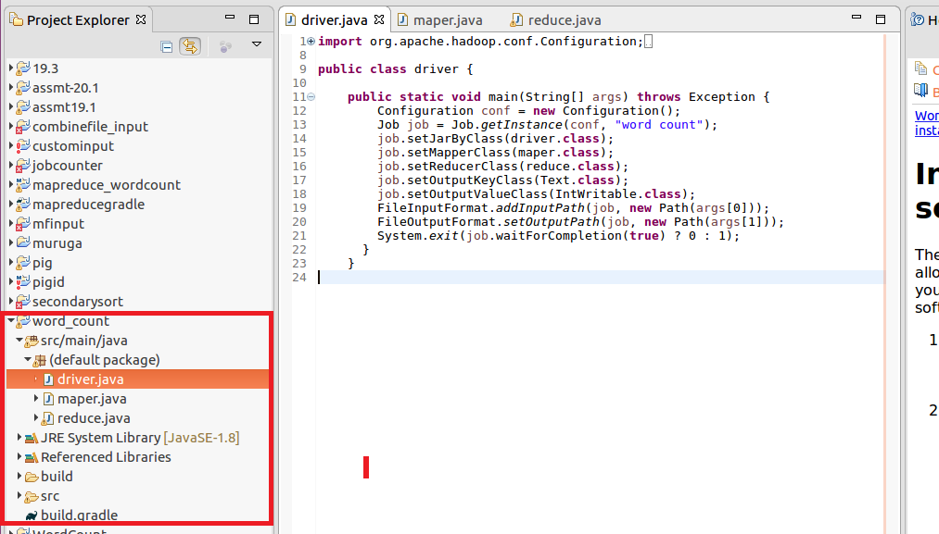

**Mapper:**

In mappersplit the words by space and send word as key and count of 1 as value

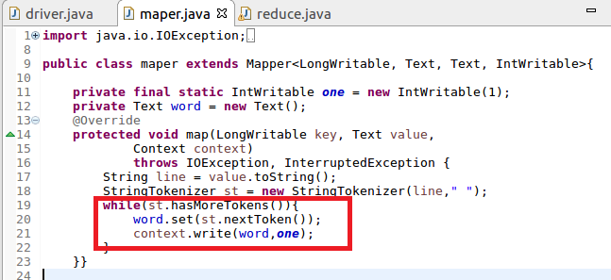

**Reducer**

Count the total occurrence of words

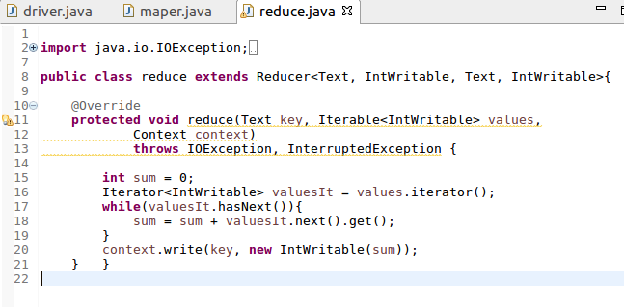

**Build.gradle**

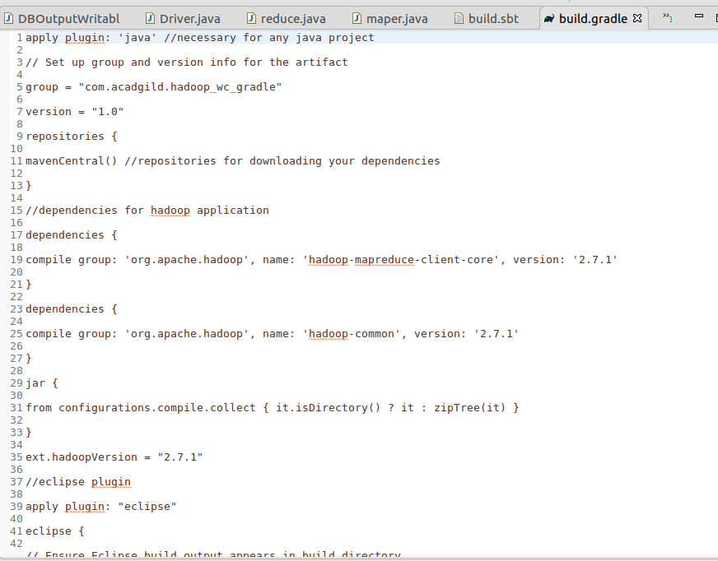

**Step5:Running jar file create d by gradle**

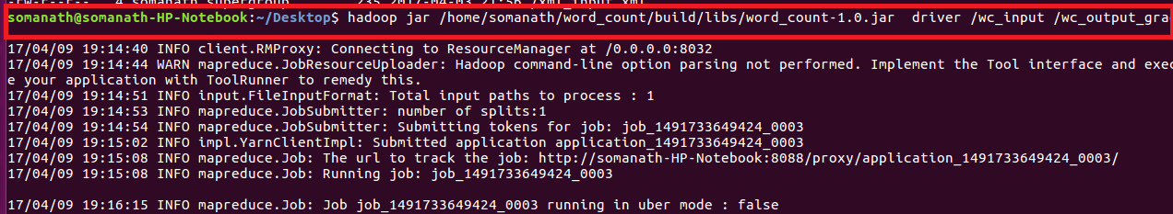

Output

