Write a program that accepts the job_id as argument and returns a custom counter and a system counter (total records input to the map tasks) associated with that job.

**Job for which system counter** (**total records input to the map tasks**) **and custom counter are to be found**

**Form History server User Interface**

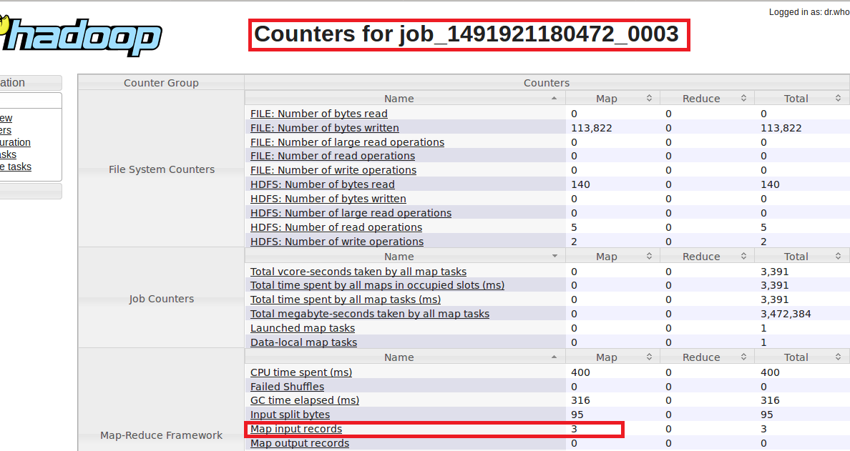

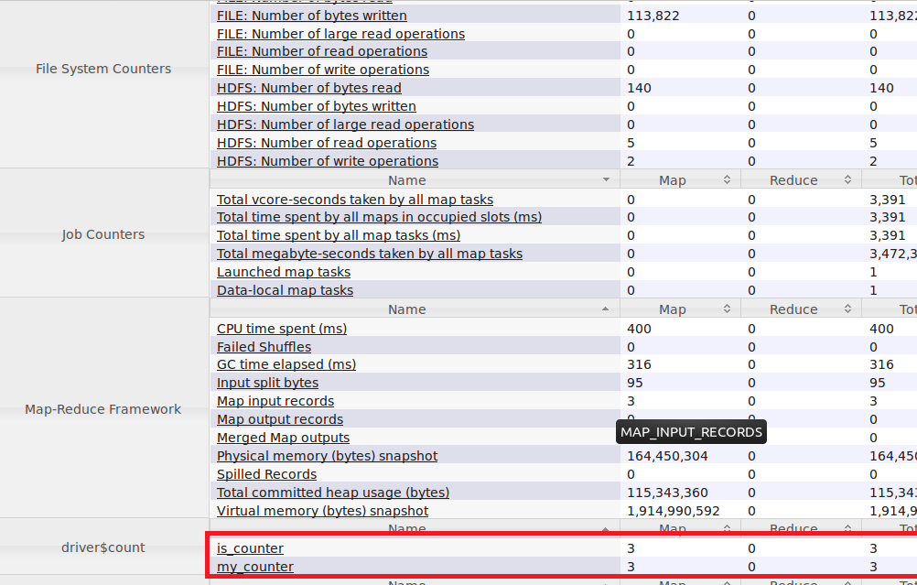

**From Terminal**

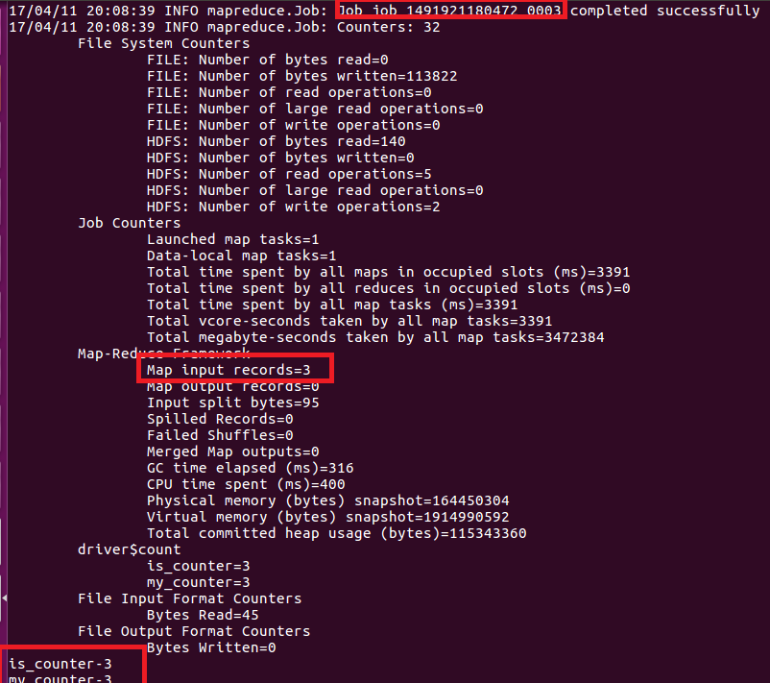

**We can see from the output that for the jobid 1491921180472_0003 there is 3 system counter for map_input records and 2 custom counter namely is_counter and my_counter**

**Objective:**

**The code below is used to display the custom counter and system counter for the job id 1491921180472_0003**

**Code Logic:**

**Step1: we will retrieve a running job object with the job client for the given Jobid which is given as args[0] and we will check whether the Job id is complete or correct by using two if condition**

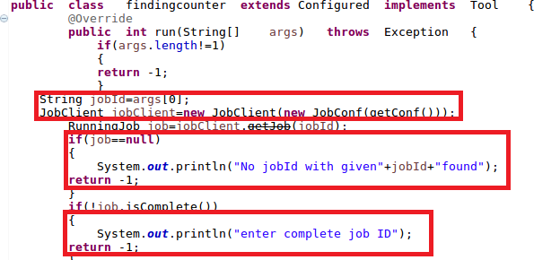

**Step2:After checking the Job has completed we will use RunningJob ‘s object( job)’s get counter() method to get the custom counter and system counter**

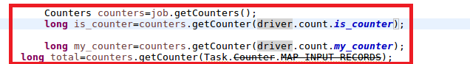

**Step3: Printing the counters**

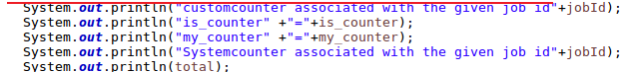

**Full code:**

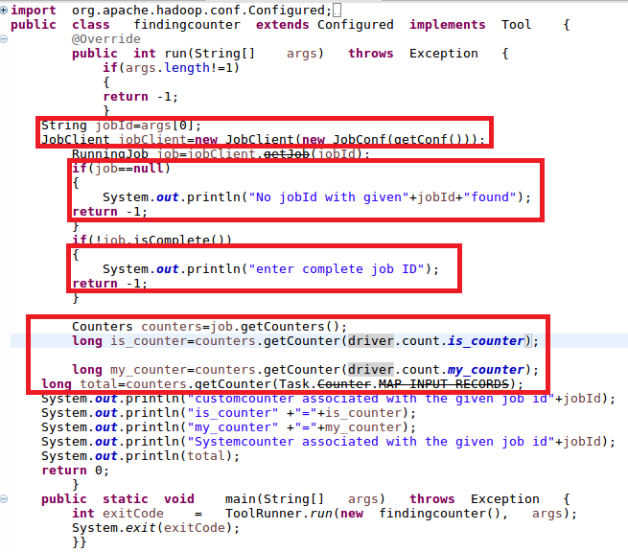

**Output**

