DRIVER CLASS

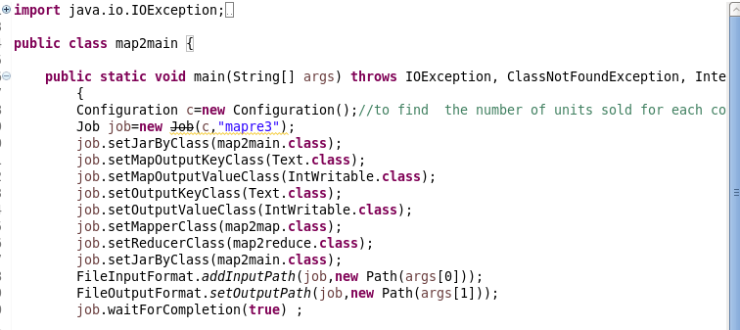

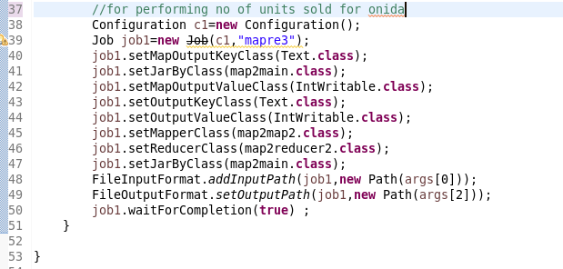

LOGIC FOR NO OF UNITS SOLD FOR EACH COMPANY

MAPPER : I will remove NA containing records and then send the company name as key and for each key I will sent 1 as value.So that a count could be made in reducer

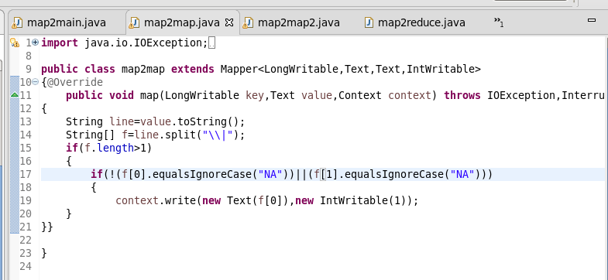

REDUCER:COUNT the no of units for each company by iterating

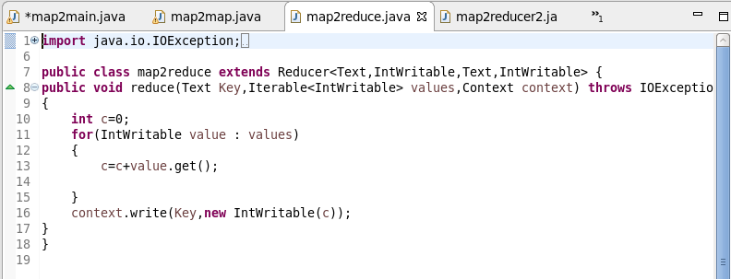

LOGIC FOR NO OF UNITS SOLD FOR ONIDA COMPANY

MAPPER : I will remove NA containing records and filter only those having “ONIDA”then send the company name as key and for each key I will sent 1 as value.So that a count could be made in reducer

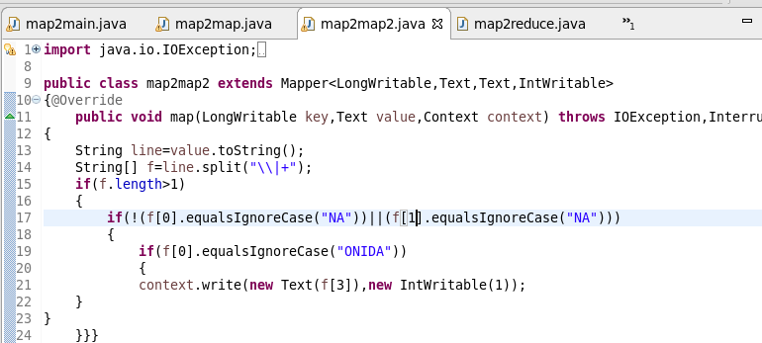

REDUCER:COUNT the no of units for ONIDA company by iterating

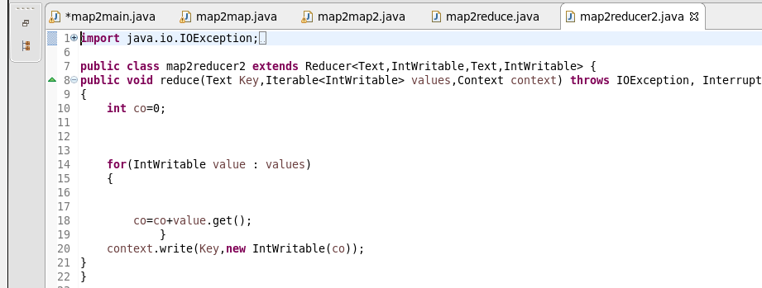  
RUNNING JAR

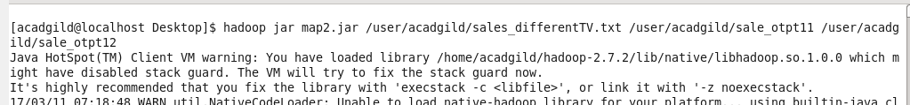

OTPT 1

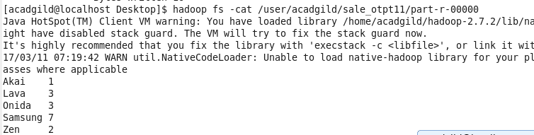

OTPT2

