UDF
LOGIC USED UDF TO FILTER THE TWEETS BY DONALD TRUMP AS SHOWN AND MADE A COUNT
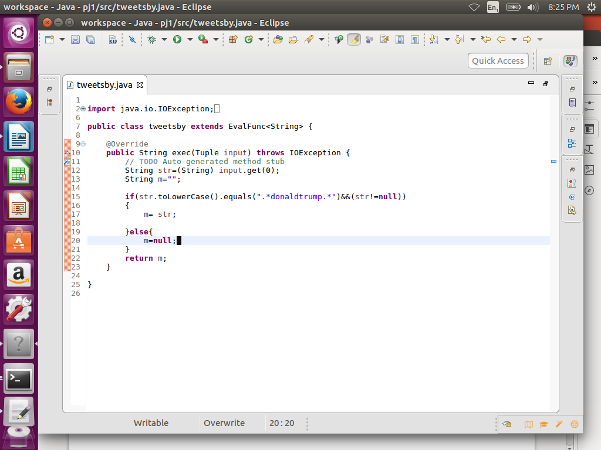
PIG COMMANDS
LOGIC:load the data and then used tweetby function of udf (Step d) to filter tweets by trump
STEP1:REGISTER UDF
Step2:load a using schema as shown
Step3:foreach A generating tweetsby(handle) which will perform filtration accoding to udf
Step :group by Donald trump and made a count
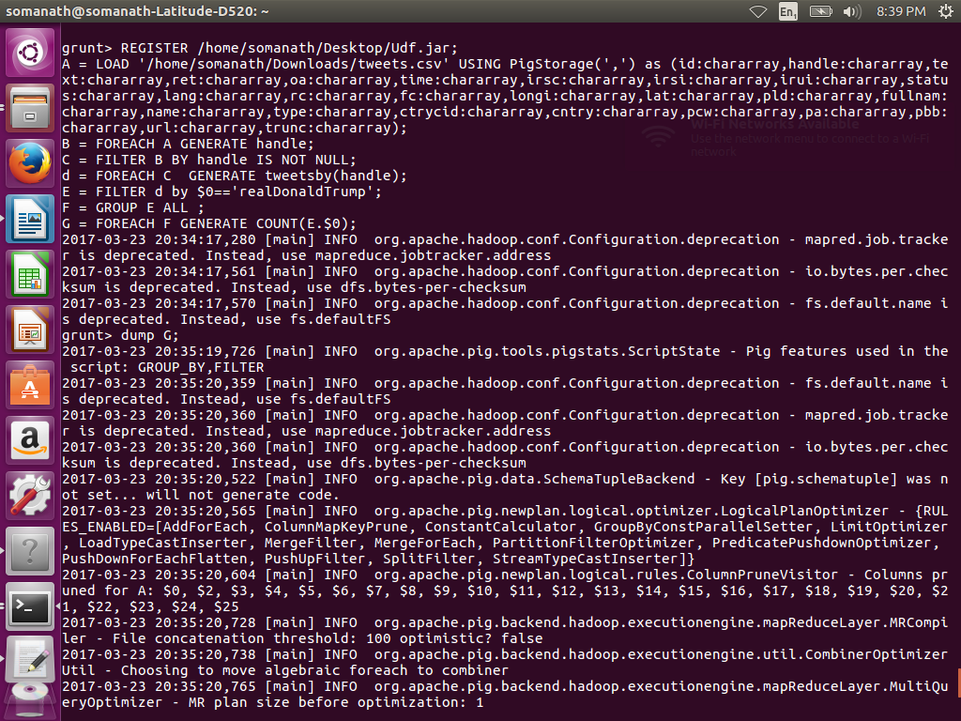
UDF CODE

OUTPUT
3218
