**Qn1.Run a map only job on the word count program using static configurations**

**IT can be done statically by using set num reduce tasks**

DRIVER

IN Driver class as It is a map only job set num reduce tasks to zero

Then set output file format as Sequence Output File format.

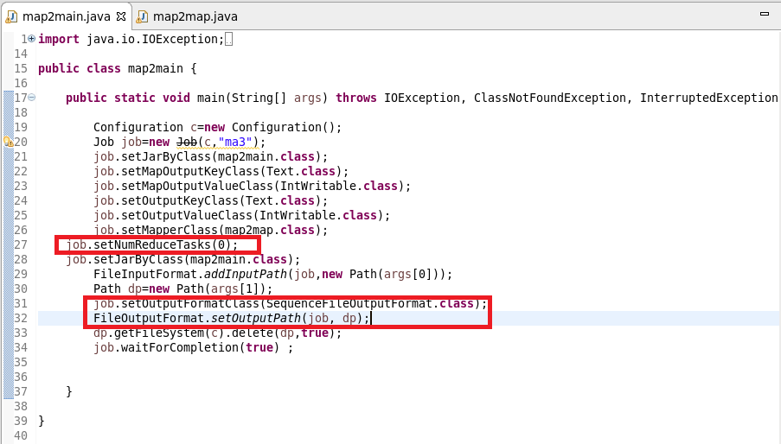

MAPPER CLASS

In mapper class I used a hashmap and updated it in such a way that if the word repeats I will increase the count by 1 and put it in hash map or else give a value of 1

Cleanup Method :I will override the clean method and write the final key and value instead of writing in mapper as mapper will be invoked for each line

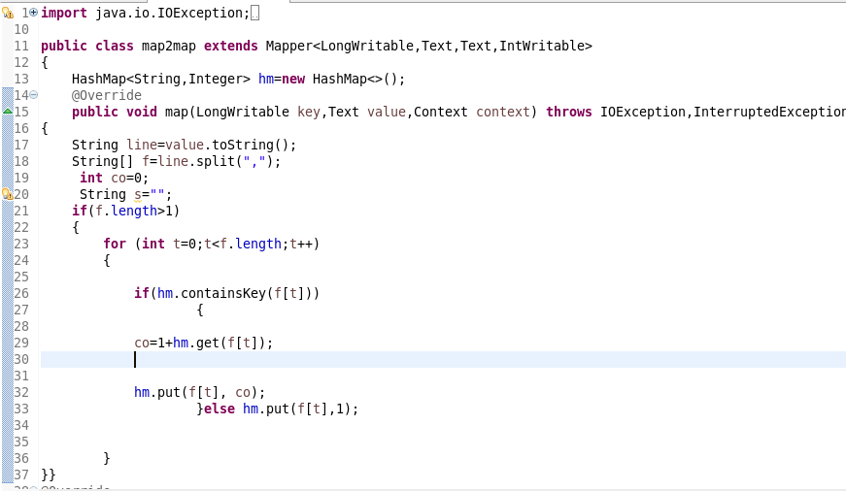

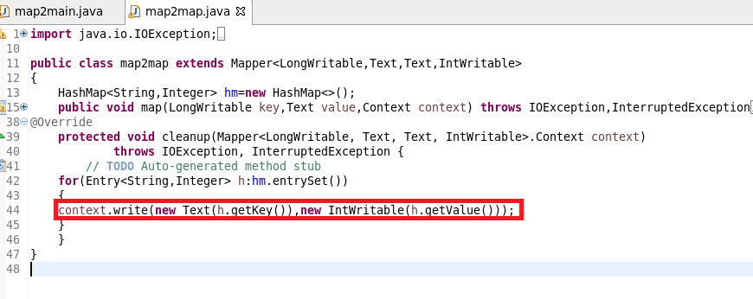

RUNNING JAR

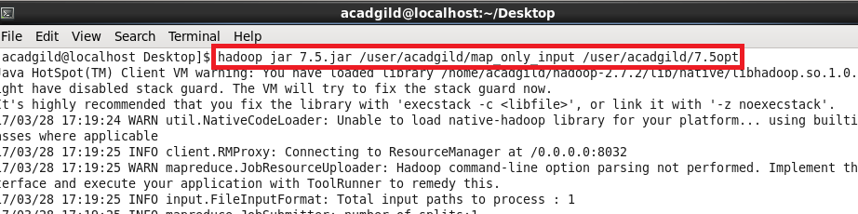

**OUTPUT**

**USED text COMMAND TO OPEN SEQUENCE FILE**

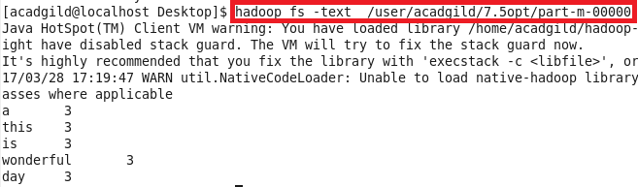

**QN2.Run the mapreduce word count program and set the number of reducers to 2 using static configurations**

**Driver**

**Here We can use SetNumReduceTasks(2)**

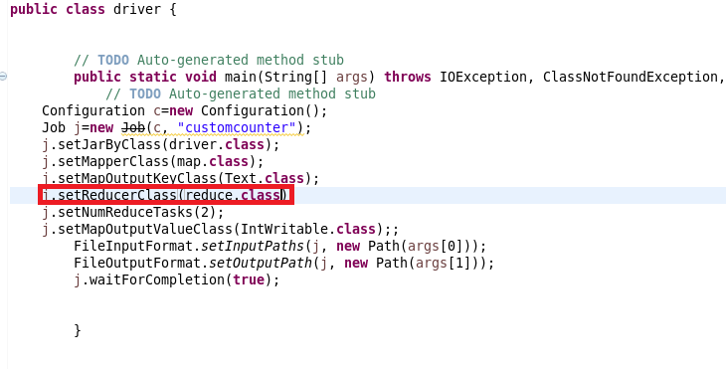

**Mapper**

send the words as key and for each key I will sent 1 as value.So that a count could be made in reducer

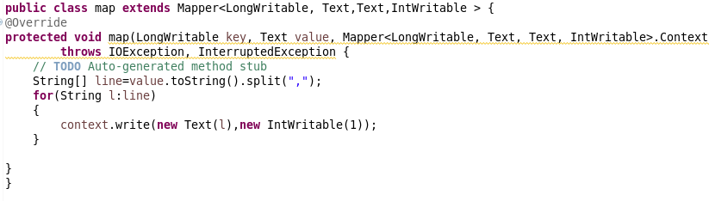**Reducer**

Made a count of Words

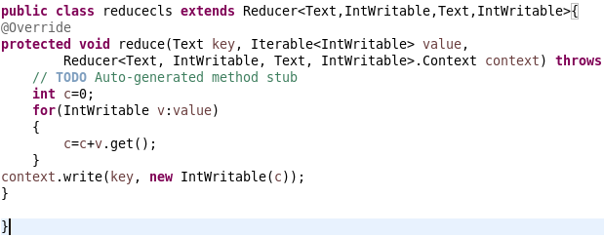

**Running Jar**

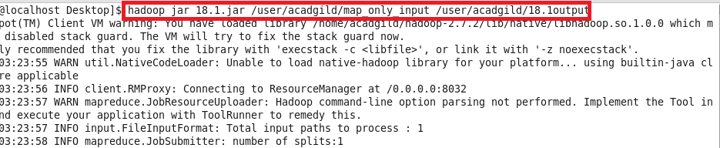

**Output**

