**Create a database named 'custom'. Create a table named temperature_data inside custom having below fields: 1. date (mm-ddyyyy) format 2. zip code 3. Temperature**

**Step1:Database creation**

**Custom data base created**

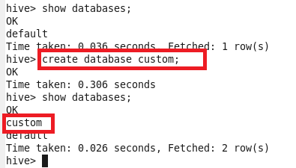

**Creating table**

**Here External Table is created with the name temperature_data with date ,zip_code,temperature as fields with if not exist option which fetches the data from /hive/dataset in hdfs and the data is stored as Textfile and as the input data is delimited by comma row format delimiter is “,”**

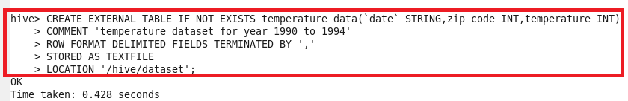

**Output:**

**We can see that the temperature_data table is created in custom directory**

