**Calculate the number of employees corresponding to each skill from the table 'employee' which is loaded in the Demo.**

**Step1:Creating table and Loading Data**

**A table employee is created with name,skill,id,company_name as fields .Since inputs are delimited by comma fields terminated by ‘,’ is given**

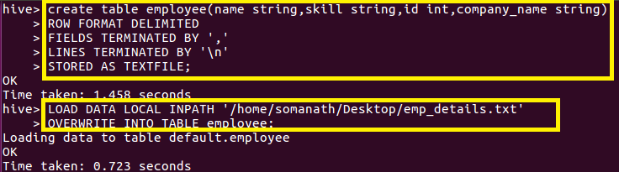

**Since we want to calculate the number of employees under each skill, we will group by skill and make a count as shown and give it a alias name employee_count**

