DRIVER

Set the Output as Sequence file using SequenceFileOutputFormat.class

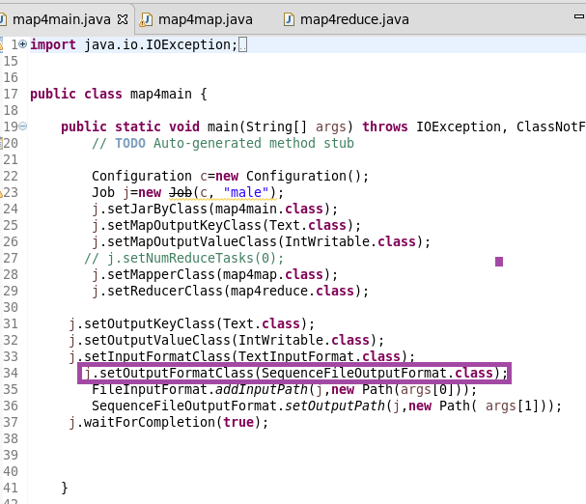

MAPPER

Filtering the Survived and sending the sex as key and a count of one as value

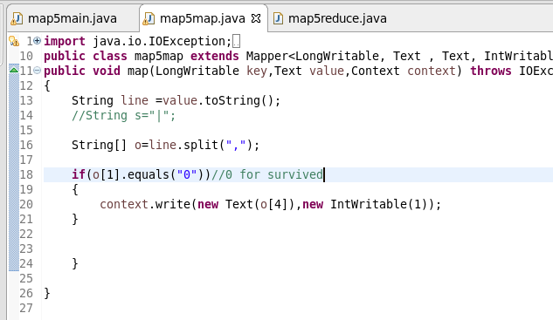

REDUCER

Counting the number of male and female

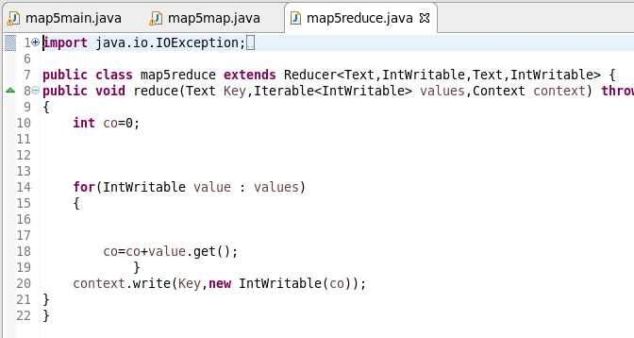

RUNNING JAR

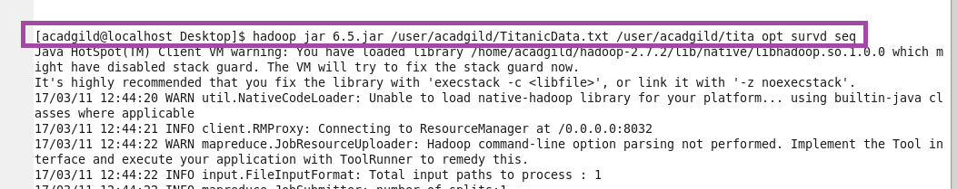

OTPT

USED Hadoop fs –text and opened the sequence file

