● Using Distributed cache join the two datasets and find out the number of temperature variations in each country using mapreduce

Driver

In driver use Distributed Cache to put small file which wil be taken to all nodes in which mappers is running by setup method

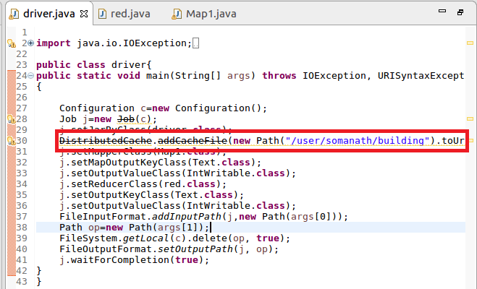

Mapper

**Step1:Overriding Setup Method**

In Mapper override setup method and use Distributed cache.get local and iterate over the path to get the file to get the building

Split the building file by comma and store a hashmap containing Building Id as Key and country as value

**Step2:Overriding Map Method** In this checked for variation(actual temperature not equal to targeted temperature) and then sent the country as key by using (hs.get for corresponding Building Id) and a count of 1 as value

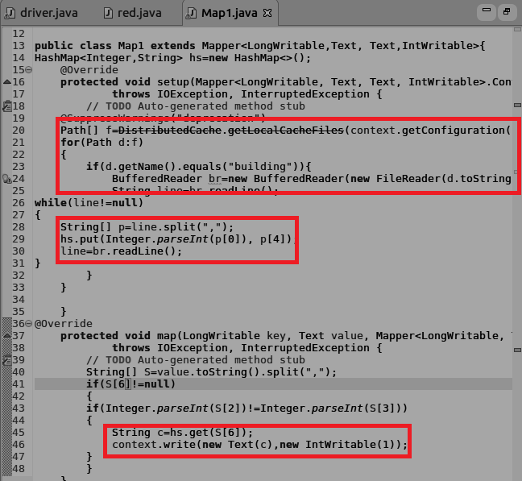

Reducer:

In reducer the total count of variation is made by iterating the values

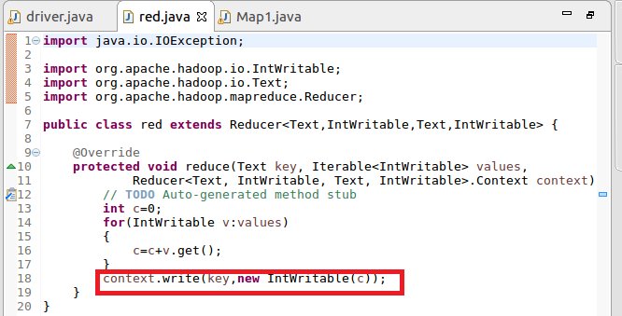

**Running jar**

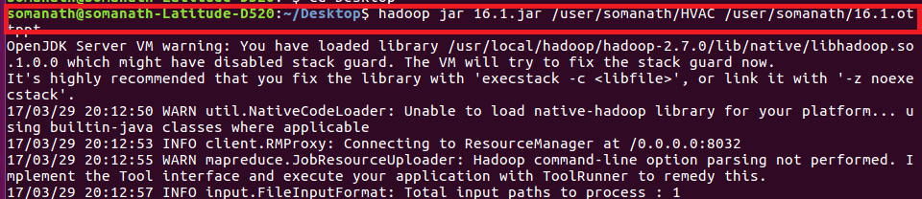

**Output**

