**1. Write a map reduce program to join the below given two datasets using Reducer side join.**

**DRIVER**

Used multiple input to get multiple inputs

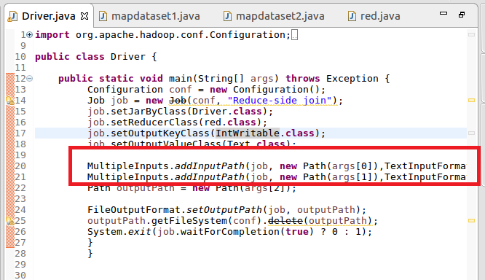

**MAPPER1**

Sent Id as key and value as value as I want simple join of datasets which I will join in reducer

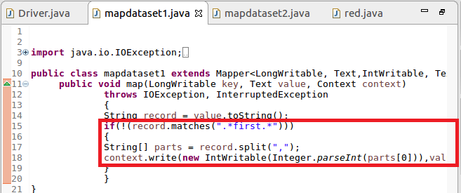

**MAPPER2**

Sent Id as key and value as value as I want simple join of datasets which I will join in reducer

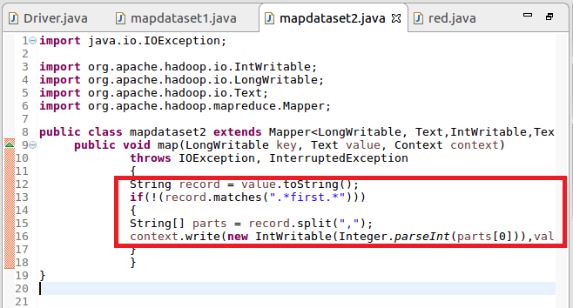

**REDUCER**

Joined both values and separated it by comma

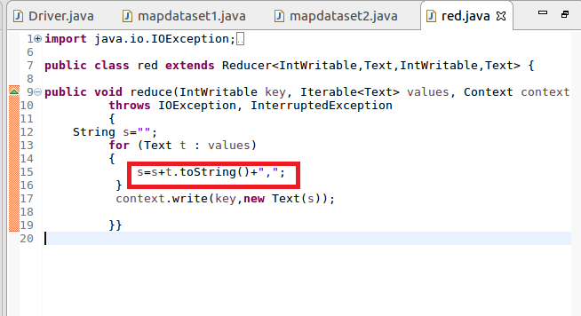

**OUTPUT :ATTACHED(PART-R-0000)**