**Qn1. Write a MapReduce program that takes the output of Task 5 (refer session 7, assignment 1) as input, and produce output which is sorted on the total units sold. You may use a single reducer for the sorting. Use Sequence File formats as an output of Task 5 and as input for this task**

**Sequence File Input**

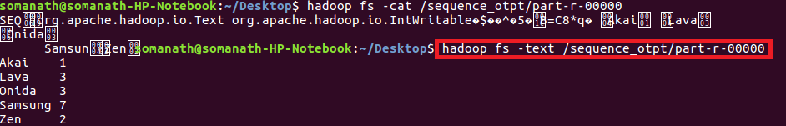

**As we want to order the company based on size I will define a composite key which contains company and size and sort based on units sold**

**Driver**

**Set composite key class as Outputkey class and nullwritable as value**

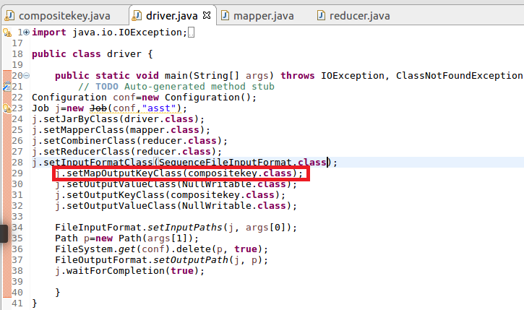

**Mapper**

**Read the sequence file input and send composite key(consisting of company and size) as Key and nullwritable as value**

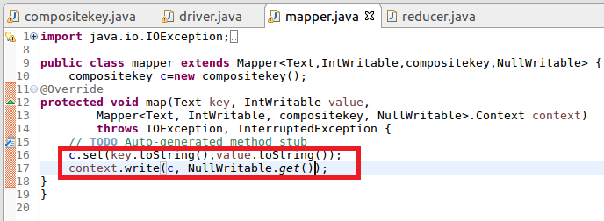

**compositeKey**

**Step1:Override compare to method and sort the key based on total units sold in Descending order**

**Step2:Override ToString Method and display the output in the way we want want to display**

**Step3:read field and write fields is for serialization and deserialisation**

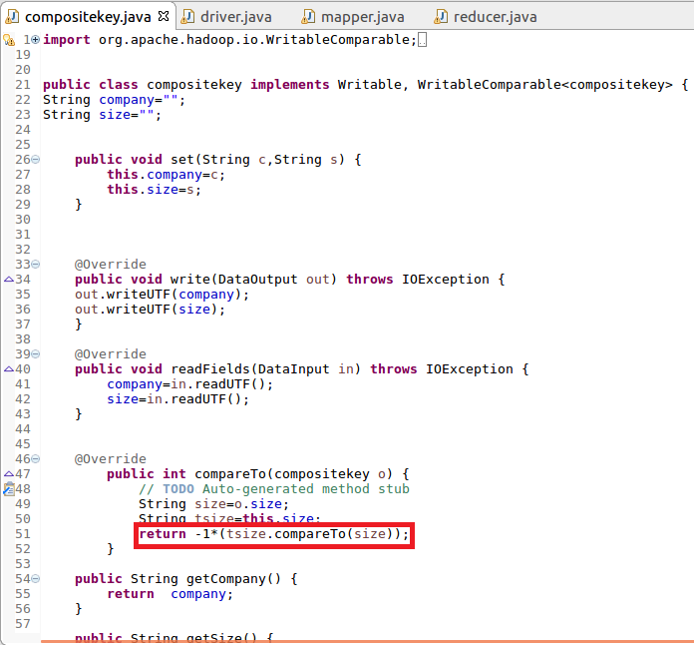

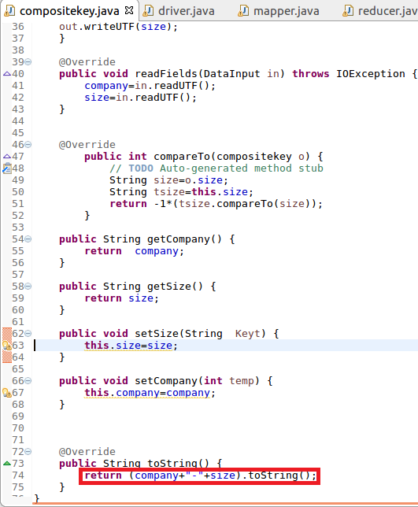

**Reducer**

**Writing the composite key and value**

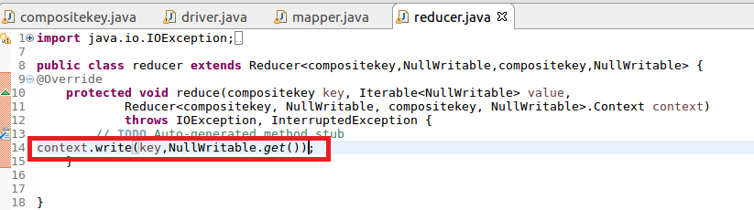

**Running Jar**

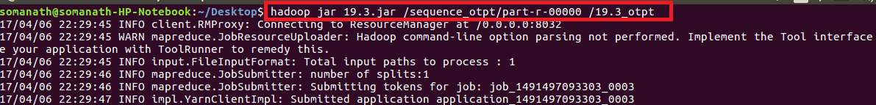

**Output**

**Inference :company sorted based on total Units sold**

