Qn1. Write a MapReduce program that takes the output of Task 5 (refer session 7, assignment 1) as input, and produce output which is sorted on the total units sold. You may use a single reducer for the sorting. Use Sequence File formats as an output of Task 5 and as input for this task
Sequence File Input
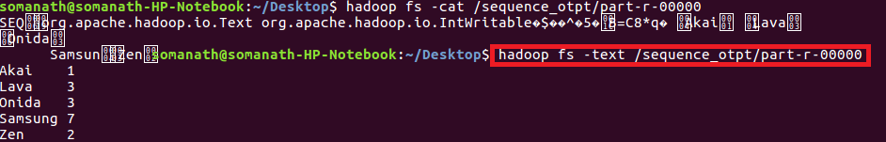
As we want to order the company based on total units sold I will define a composite key which contains company and sold count and sort based on units sold
Driver
Set composite key class as Outputkey class and nullwritable as value
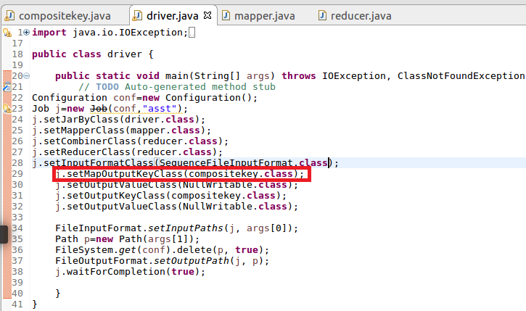
Mapper
Read the sequence file input and send composite key(consisting of company and count) as Key and nullwritable as value
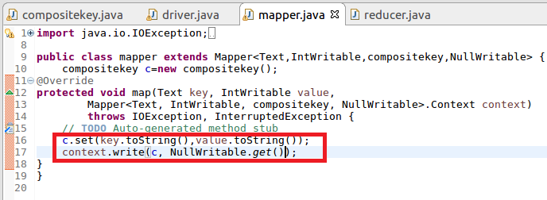
compositeKey
Step1:Override compare to method and sort the key based on total units sold in Descending order
Step2:Override ToString Method and display the output in the way we want want to display
Step3:read field and write fields is for serialization and deserialisation

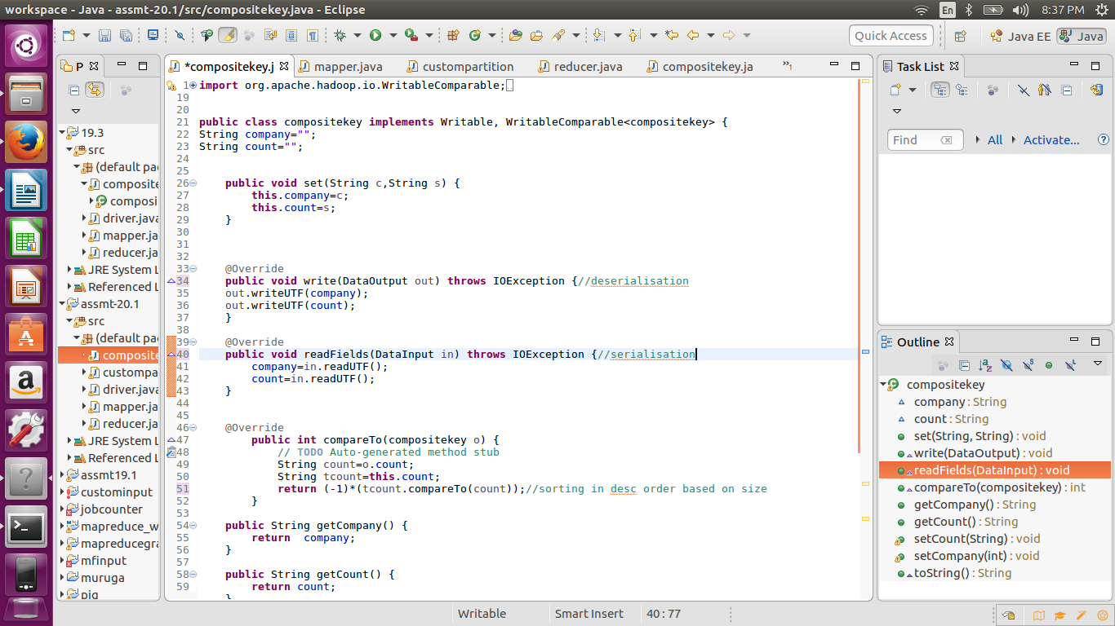
Reducer
Writing the composite key and value
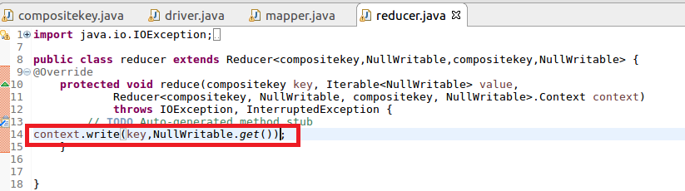
Running Jar
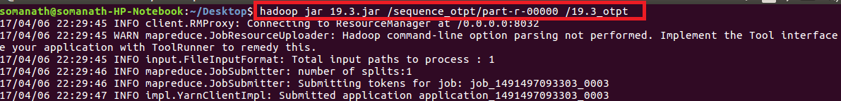
Output
Inference :company sorted based on total Units sold


