DRIVER CLASS

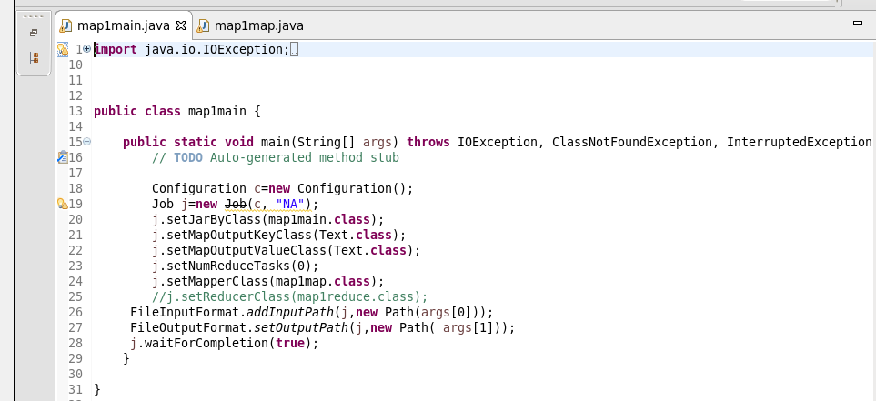

LOGIC : used mapper splitting each line read by using “|” and storing the output as shown

Mapper class

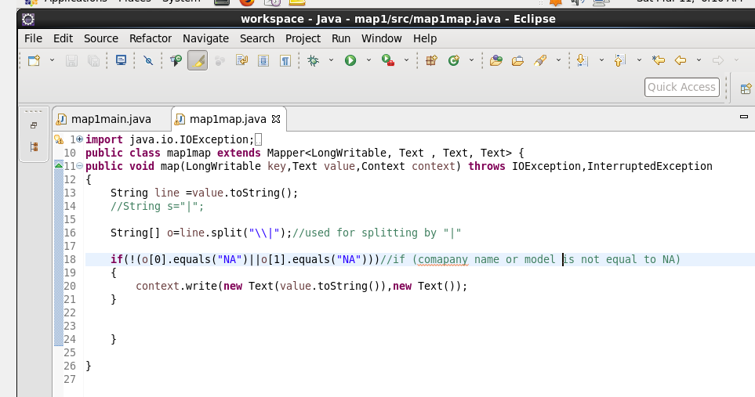



OUTPUT

