DRIVER

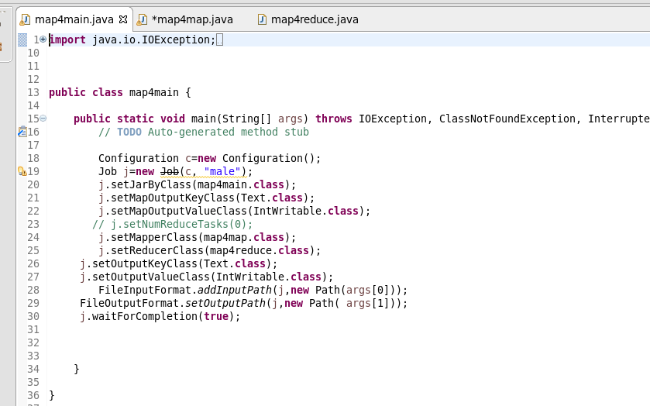

MAPPER CLASS

LOGIC:

Filtering the died and sending the sex as key and a count of one as value

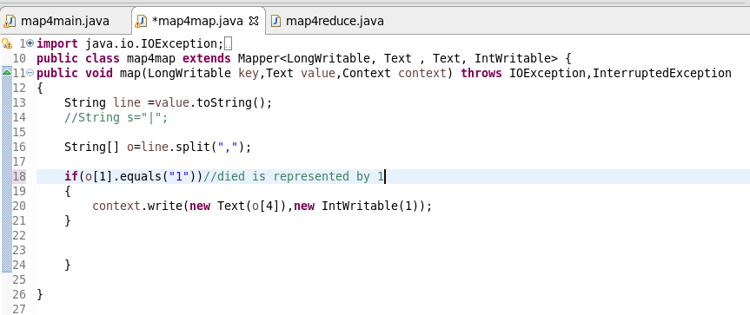

Reducer Class

Counting the number of male and female

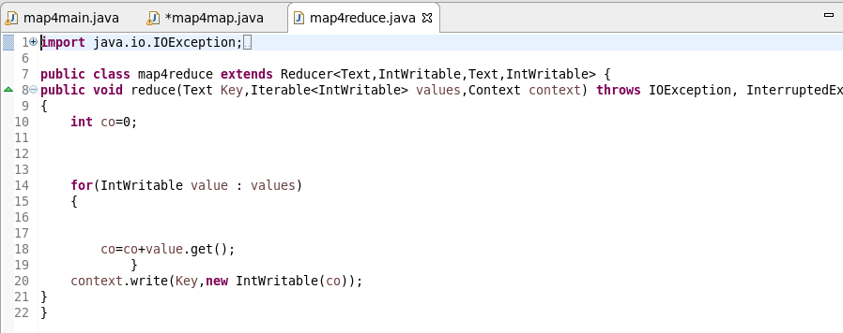

RUNNING JAR

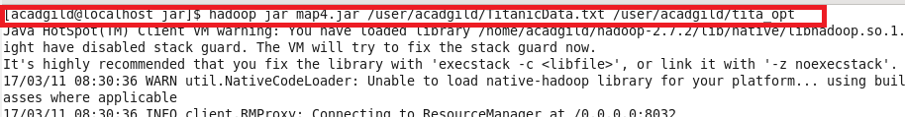

OTPT

