DRIVER

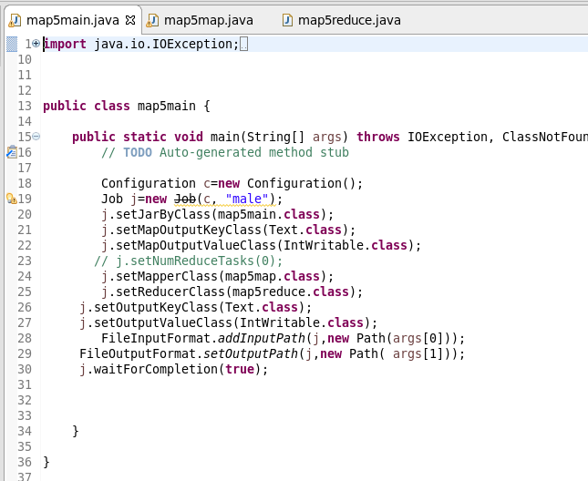

MAPPER

Filtering the Survived and sending the sex as key and a count of one as value

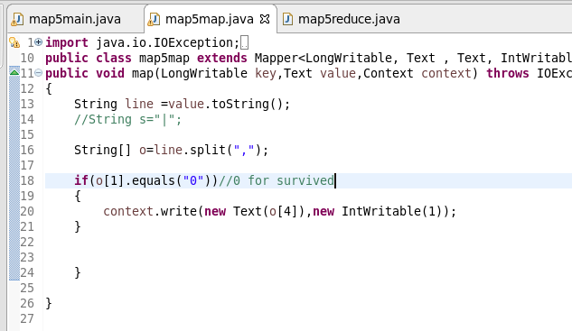

REDUCER

Counting the number of male and female

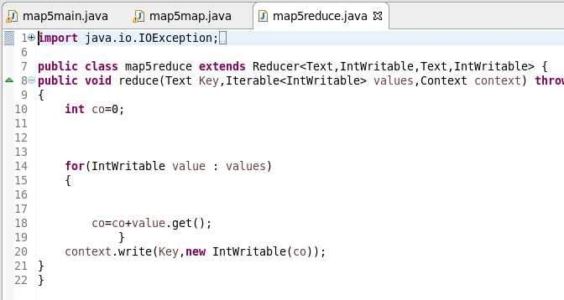

RUNNING JAR

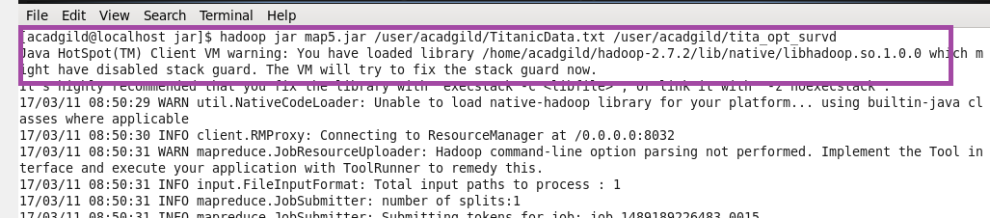

OTPT

