DRIVER

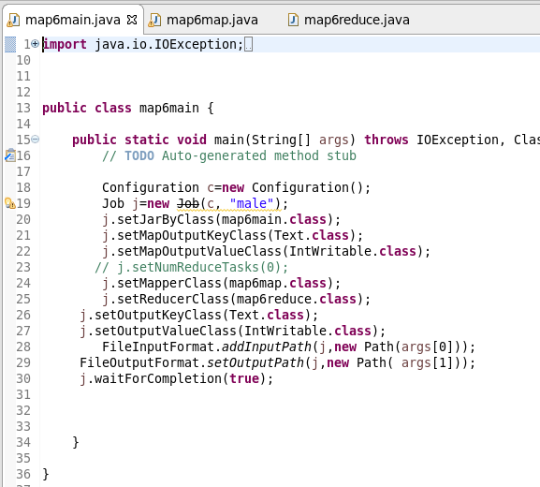

MAPPER

LOGIC : Since we want the number of passenger survived,I check the passenger Id is not null and for each valid passenger Id,I am sending a common key as “TOTAL SURVIVED” and a count as 1 as value

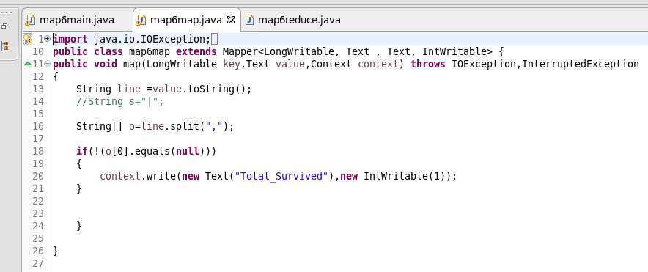

REDUCER

Count the Total no of survived by iterating the values

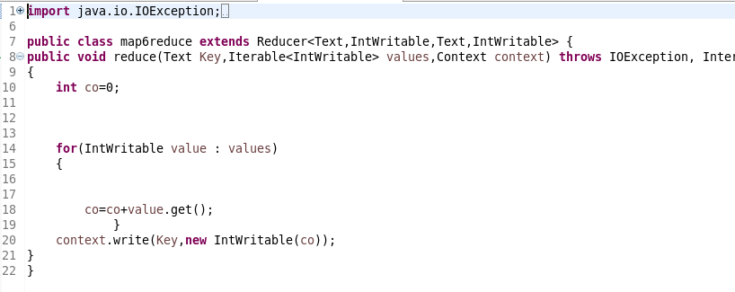

RUNNING JAR



OTPT

